Ashley, Raven, BrolyVA (and others!!)
For the best optimisation, it’s recommended that you use a computer to read this document. Thank you all for your understanding!
This document contains the following: CyberBullying (heaps of it), Threats, Impersonation of MULTIPLE PEOPLE, Suicide Baiting, Racism, Distribution of CSAM, Grooming and more. If you are sensitive to any of the topics listed, I suggest not reading this document.
⚠️PLEASE DON’T HARASS ANYONE MENTIONED IN THIS DOCUMENT!⚠️

People in the document are colour-coded for the sake of convenience. The following people that will be writing in the doc are:
- Frix - (Black)
- Bingus (Purple)
- Oli (Light Blue)
- NX - (Red)
- Doniboy - (Green)
- Whisky (Colour TBD)
- Slick (Orange)

Open transparency, when writing NX’s segments in this document, I (Frix) had assisted him with writing since he experiences difficulties with writing.

2019 - 2021
Unfortunately, this segment of the document is very scarce in terms of evidence because of the curse of time. I was very young when this stuff had taken place, so screenshotting evidence didn’t come to my mind - however testimonials from people that ere there will be added when appropriate and any evidence found will be added (of course).
EVERYTHING IS ALLEGED.
I met Ashley and her friend group in mid October of 2019, on Amino, at the time I was 11. There were 10 people I met in this group: Dovah, Bulla, Ashley/”Ashion”, Rose, Gosui, Dark Rose, Yang, Matt, Broly and Bingus. At first it was on an Amino called ‘Dragon Ball Z’ and after a few days of talking to this group, I was invited into another amino by Dovah and it was called ‘Planet Hybrid 2’. Everything was fine for about the first month of being in Planet Hybrid 2 (which from now on I will refer to as PH2).
I remember the first incident that occurred like it was yesterday. I was 12, November of 2019, and one day there was a voice call between Ashley, Ashion, Gosui, Matt, Dovah and Dark. I joined them in the chat (I was texting) and I noticed something that was a bit strange. It was Ashley and Ashion’s voices. They sounded very identical, almost as if they were the same person. When one of them talked, the other would mute or in some cases one of them would leave the voice call altogether.
After a bit of time, I had said something along the lines of “Hey.. are you guys the same person?” Ashley AND everyone in the call had all started yelling at once, calling me names (in which I don’t remember), kicking me out of their chat and the dms harassing me about the issue had happened once things had settled down a bit.

Times like this were common over the next couple of months, but it got even weirder when I started dating my ex, Gosui. When me and Gosui dated he was 17 and I was 13. Obviously at this point in time I was very young and didn’t understand the massive age gap, but soon after me and him got together we broke things off because he realised he was too old for me. As there were many adults around who were in their 20’s and a few also in their early 30’s in the group, they didn’t really think this sort of thing was that bad, but it got so much worse.

When I was also becoming friends with Bingus, things only increased in severity. Matt was someone who had closely associated with Ashley at the time (around mid 2020 to early 2021 in this instance) and Bingus had told me that Bingus had been alone with Matt and he was saying very explicit things to Bingus when he was very young (about when he was 11). When I had tried to contact Dovah, Ashley and a few other people about what I’ve heard I was met with explicitly ignoring the issues around the grooming that had occurred.

At some point I was banned from PH2, but came back on an alternate account. I had come back and met my other ex, Zero. There was some plotting that had happened between me and Zero to get back at Dovah, for a few days while we plotted I laid low so they wouldn’t find me. I came out of the woodwork a few days after by telling a few people I was back: Gosui, Broly and significantly to this case: “Ashion”/Ashley. It broke the entire scheme that I was planning because she snitched on me to Dovah and when Dovah had found out he immediately came to me and started cussing me out in voice call with the aforementioned people also being present.

There was also a day where Ashley was suicide baiting for attention and Zero had also started saying “I’m gonna kill myself” and such as well. The fighting then began. Ashley threw jabs at Zero by saying things along the lines of: “You aren’t actually suicidal” and “you’re faking it!” just to name a few things. I was personally really stressed when this had happened, so I tried to take Zero away from the situation because he was panicking like crazy. But things had only gotten worse when Ashley threatened to call 911 not only on herself but on Zero as well. He panicked like crazy and I didn’t hear from him for about a day or two after the event had occurred. Getting in contact with him again after the incident, he was thankfully ok.

After this day, it had become really awkward between me and Zero. But there was so much worse that HAD happened.

I was in DM call with Dovah and we were talking about things in our (quite frankly weird) family role-play and we were discussing our characters' relationship - I was his roleplay daughter at the time. He said something that caught me off guard. “What if we weren’t in a daddy daughter relationship?” and the words shook me to my core that I pretended to play it off before leaving. I went to Ashley to try and confide in her and seek her support because I was very scared. She went snitching to Dovah once again and Dovah, Matt, Ashley, Rose and Dark all attacked me at once. They had called me a liar, a manipulator and so many more hurtful, offensive and genuinely harmful things (again, I wish I could remember). It was also bothering me at the time because Dovah had gone to me after and threatened my life by saying: “If you tell anyone about this, I will kill you and your entire family”. I stayed silent once again, becoming friendly with everyone until my 14th birthday (1st Of November, 2021).

November 1st, 2021, was the day that Dovah had a live stream on youtube. It was titled: “Final Fantasy stream (and birthday for friend). This stream was about Dovah playing well- Final Fantasy. He shouted me out on my birthday and he had me on his stream briefly to sing happy birthday to me, but then he decided it was a great idea to pry into my love life. At that point I wasn’t dating anyone and as a then 33 year old man I found it creepy that he was asking me about my dating life.
So like so many times before I had asked for help from who I thought were my friends; Ashley/Ashion, Rose, Gosui and others (in which I don’t remember). They once again didn’t believe me.

In other circumstances they would also pit me and Whiskey against each other

I (Bingus) met Dovah on Amino when I was 9. I was originally in a “server” or whatever it’s called for Undertale, I was messaged privately by Dovah where he reached out and asked if I knew anything about DBZ. I said I did and he invited me into his own “server” thing called Planet Hybrid 2. He was mid role play with other people and I inserted myself. This is how I met Dovah, Matt, Ashley, and eventually Frix.

I experienced many issues with these people, but in the beginning, things weren’t so bad. Role playing with them was fun for a nine year old who had nobody else to hang out with, I became incredibly invested in their lives and personal business. Dovah would vent and complain about his life, role playing in the middle of serious conversations that I pretended to take seriously. I would give advice to him and talk about my personal life. Dovah even spoke to my younger sister (who was five at the time) and sang to us while playing on his guitar which is something he does a lot. When I met Frix, we instantly clicked because we were both young kids watching adults behave in an immature manner.

My first negative experiences with them was through Frix. Often in the background while people argued with each other, I would side with Frix and everyone would say that I’m “innocent” and pretty much “stupid”, unable to grasp complex conversation and such even though I personally believed that I was the most mature in the group (other than Frix). For context, I would roleplay as Asriel from Undertale, everyone called me “Azzy” and it seemed like most people (specifically Dovah) were unable to separate the person behind the character and the character itself.

The first real “bad” thing that happened to me was with Matt. Matt and I were alone in a group chat, nobody else was online and we were just talking about pretty much anything. The conversation darkened real quick as he began to talk about how “mature” I was and how kind I am, and as a nine year old, I felt kinda good about that and would thank him, returning compliments. He soon began to complain about his love life, how he felt like if he had someone like me that he would be so happy. He said that he loved my voice and personality, even though I’ve only spoken in VC very few times before and was currently typing to him rather than speaking. He said that I was perfect “girlfriend” material and that he would “love to have [me] as a partner.”

Matt asked me if he thought I would like someone like him as a boyfriend, and I told him that this was wrong. That I didn’t like how this conversation was going. Instead of agreeing with me, he said that nobody would believe me over him. If I told anyone what he said, they wouldn’t believe some kid over someone they care about. He began to delete all my messages and soon left the call, I could only watch helplessly as all the evidence I could’ve had was now gone and he was probably right, nobody would believe me without proof.

I told Frix what happened after she came online and she was quick to inform Dovah and a few others (I don’t remember it clearly), but they shut it down and brushed it off. Nothing much came of it and I chose to simply avoid talking to Matt altogether, but I remained in PH2.

The next bad experience I had was with Ashley. She kept saying how my voice was girly and kept calling using she/her pronouns on me despite me telling her to stop. She said I was being dramatic, that she was just joking around and I didn’t have to make such a big deal about it. I didn’t really care that much, but it made me mad because she gets upset whenever Frix and I mess up on the Ashley/Ashion personas she has and, as a kid, I tried my best to please everyone there only to be met with disrespect. She would literally blow up at us if we slipped up, even on accident, and cause huge problems if anyone even so much as suggested that maybe Ashion wasn’t a real person.

Most of my experiences I had were with Frix by my side. We would fight racism with Bulla together, we would watch Dovah crash out and scream at people together, and we would confide in each other. For the most part, Frix was the target for their attacks because she doesn’t try to please them, while I was essentially a doormat for these people because I was desperate for their approval and affections. Despite everything, I would be the one telling Frix that these things weren’t normal and that they were wrong for what they’re doing. Though, a part of me still cared about how they perceived me and I would tiptoe around them.

Because I was so easy, they were blatantly mean to Frix specifically while treating me as if I were perfect and unable to understand how “bad of a person” Frix was. Whenever I defended Frix, they believed that I was being manipulated and I didn’t really mean anything I said because I’m just a cute little kid who doesn’t understand real world situations. Which is crazy because Frix wasn’t that much older than me and their behavior toward her was everything but good.

2022-2024
In early 2022 people from PH2 had moved onto an app called Project Z through a link that Dovah had sent around to everyone in the group. By the time I had gotten the link I had found out that everyone in the group had moved onto that app. So I joined the app too.

Allegedly, in 2022 (I sadly don’t have a huge recollection of exactly when this occurred) Broly had started being in contact with me on a frequent basis. We had started discussing things to do with our roleplay characters at the time, which was at first a very harmless thing, which over time had turned into him allegedly finding out details about me that weren't known by anyone - intimate details. He gained my trust by listening to me talk about things like being unable to trust anyone in PH2, things about my school - this also turning into me telling him where I went to school at the time, along with other personal identifiable information that he didn’t only get from me, but from finding out from other people too.

He had asked me about intimate details about myself and started making romantic comments toward me, as if giving off the intention of flirting with me. As a 14 year old being told these things by a 19 year old at the time, this struck me as odd, but from the other alleged stories that were told, this was a pretty normal thing. It only got worse with him, however. He had asked me to ERP with him and because I had a crush on him I would erp with him. He’d ask me to very explicit things, some of the following include: asking me if I had a “toy” that I could play with and if i didn’t if I had something like a “toy” that I could use, begging to see me both clothed and unclothed (all the time) and also for me to see if I could steal lingerie from my mum.

When his insistence had gotten too much for me to handle anymore, which was about a month after the begging began, I had sent a picture of myself in an very explicit way. Little did I know that it immediately got sent to a group chat on Project Z called “Casa Del Sol’. Of course a group that I wasn’t personally a part of.

Casa Del Sol consisted of these people: Dovah, Ashley/Ashion, Matt, Rose, Gosui, Broly, Dark, Bingus and Whiskey. The picture was sent in the group chat and most of everyone in the group had started making fun of me for the way I looked, Rose commenting that I looked like a 30 year old woman when I was in fact 14 years old. Promptly after being told by someone who was in that gc that I “didn’t look my age due to my chest being too big” I was kicked out of their circle entirely for a good amount of time.

At some point I was brought back into their group, however nothing significant of note really happened for the rest of 2022 (this period of time isn’t the best for me to remember)

At a certain point in time in 2023, Raven had come into the picture (I don’t remember how or when he did specifically). Ashley and her friends were quick to accept him into their group, from the minimal that I remember he was working with other people (the unimportant Star, Toby and Naruko - I don’t remember what happened between them well enough to write about them). They had been conspiring behind the scenes and then they seemingly had pictures of me from the aforementioned story about the “Casa Del Sol” section. (Screenshots below):
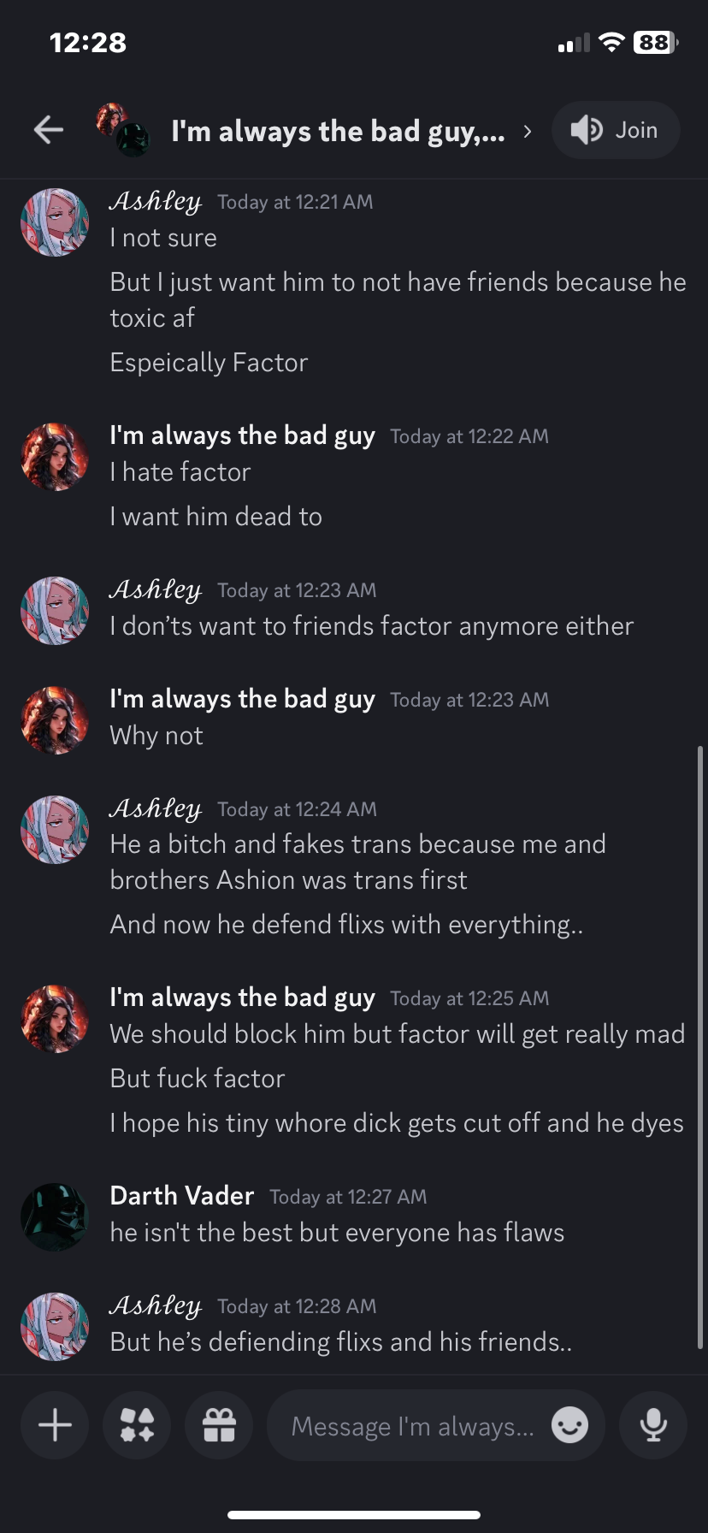
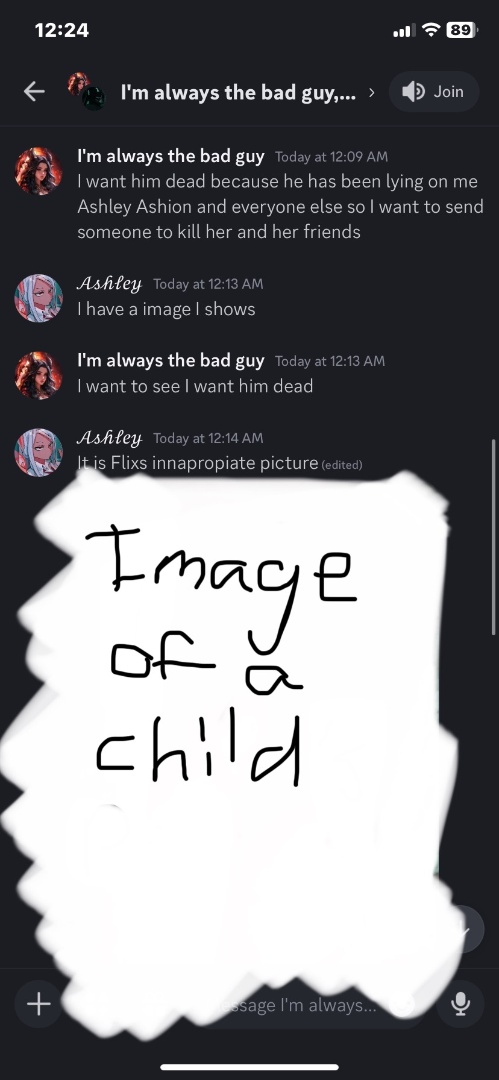
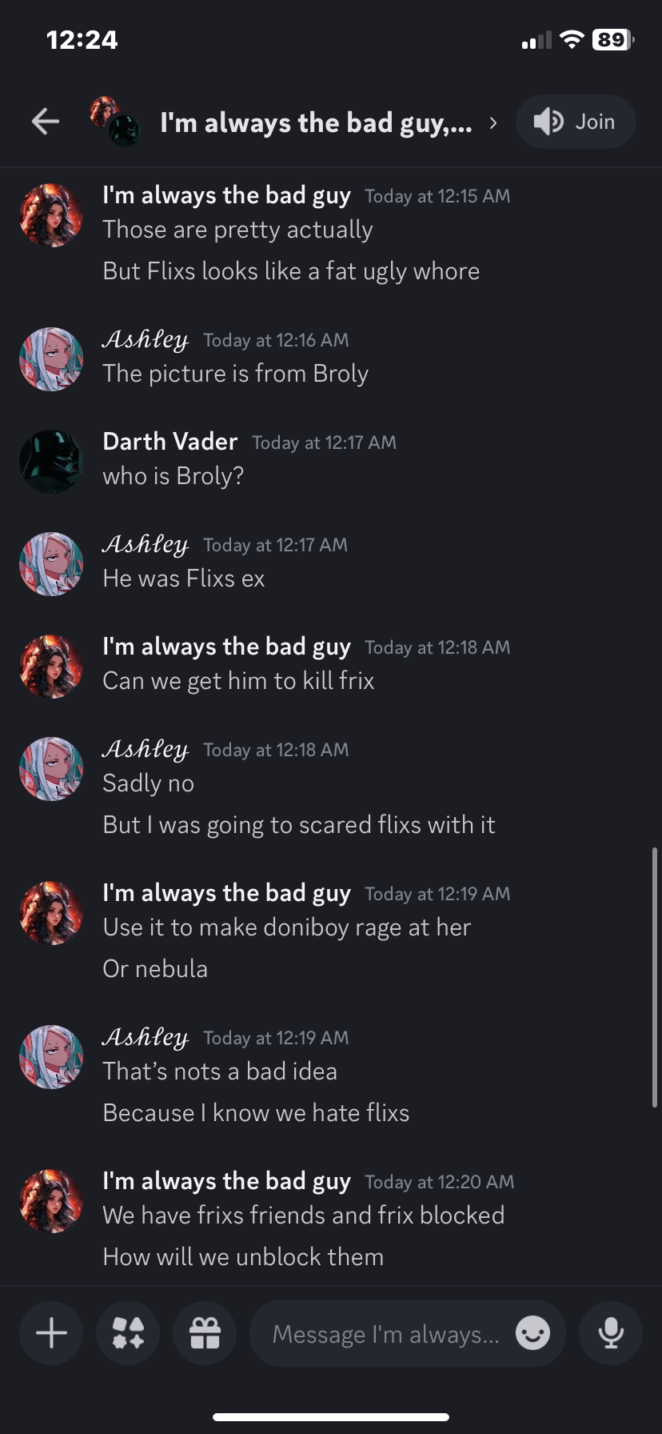
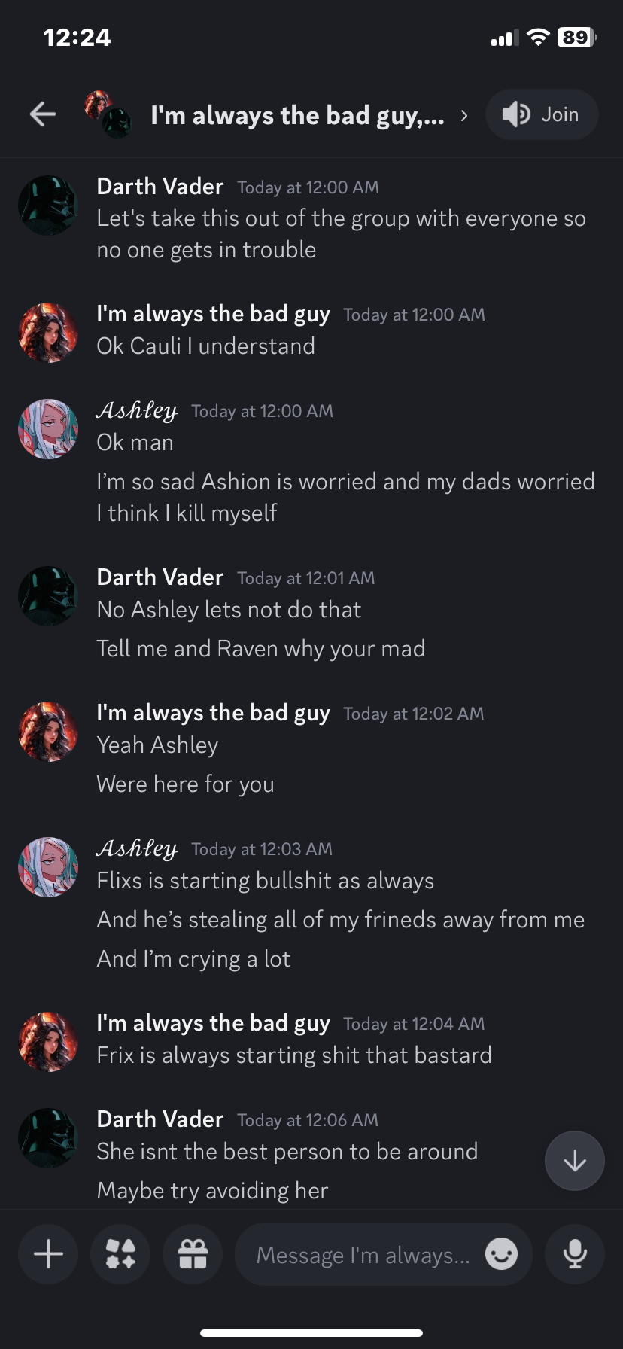
Allegedly a bit of time after the screenshots above they had gotten me into a group call in which they had shown explicit video content to me as well as watch me also Self-Harm on call.

This set of screenshots was when an issue arose from when I was spiralling one day in 2024, but this evidence was them celebrating the idea of me committing suicide (see below):
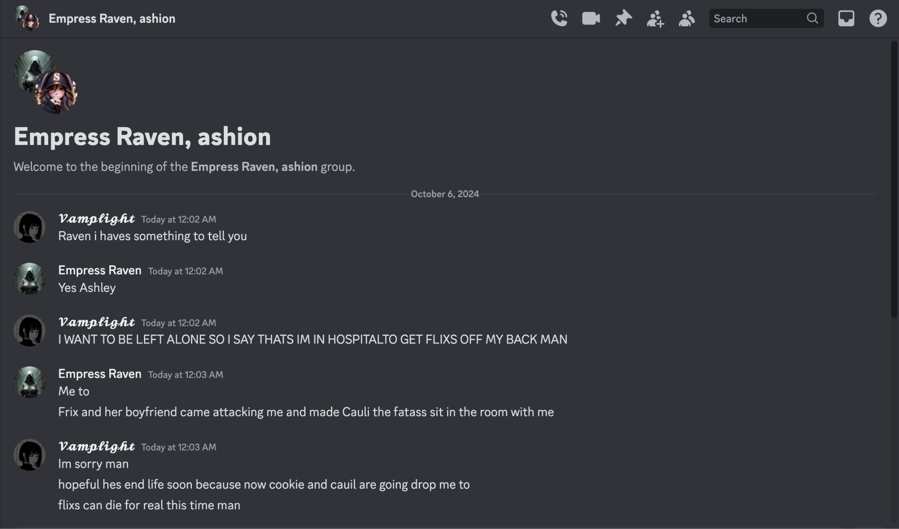

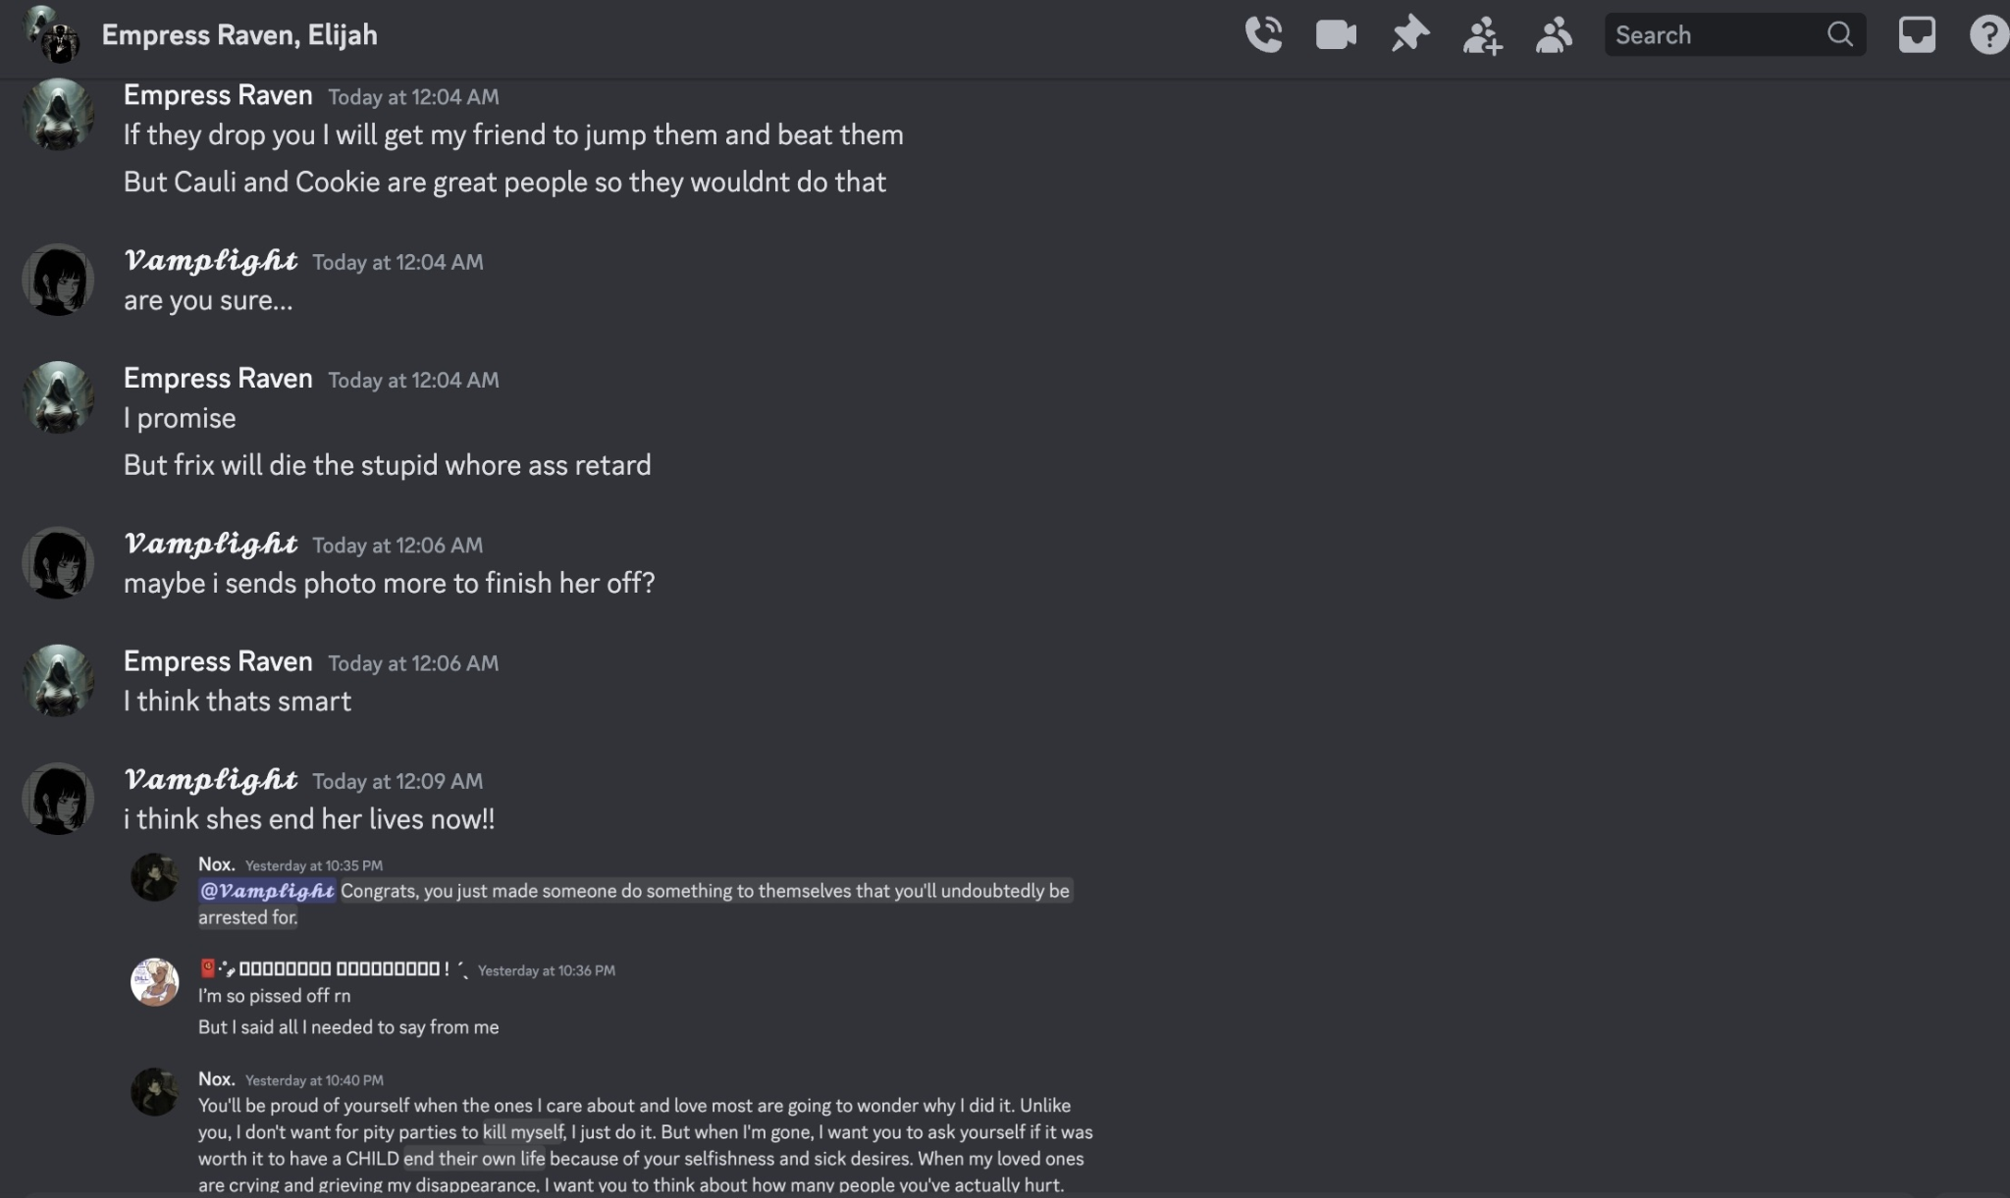
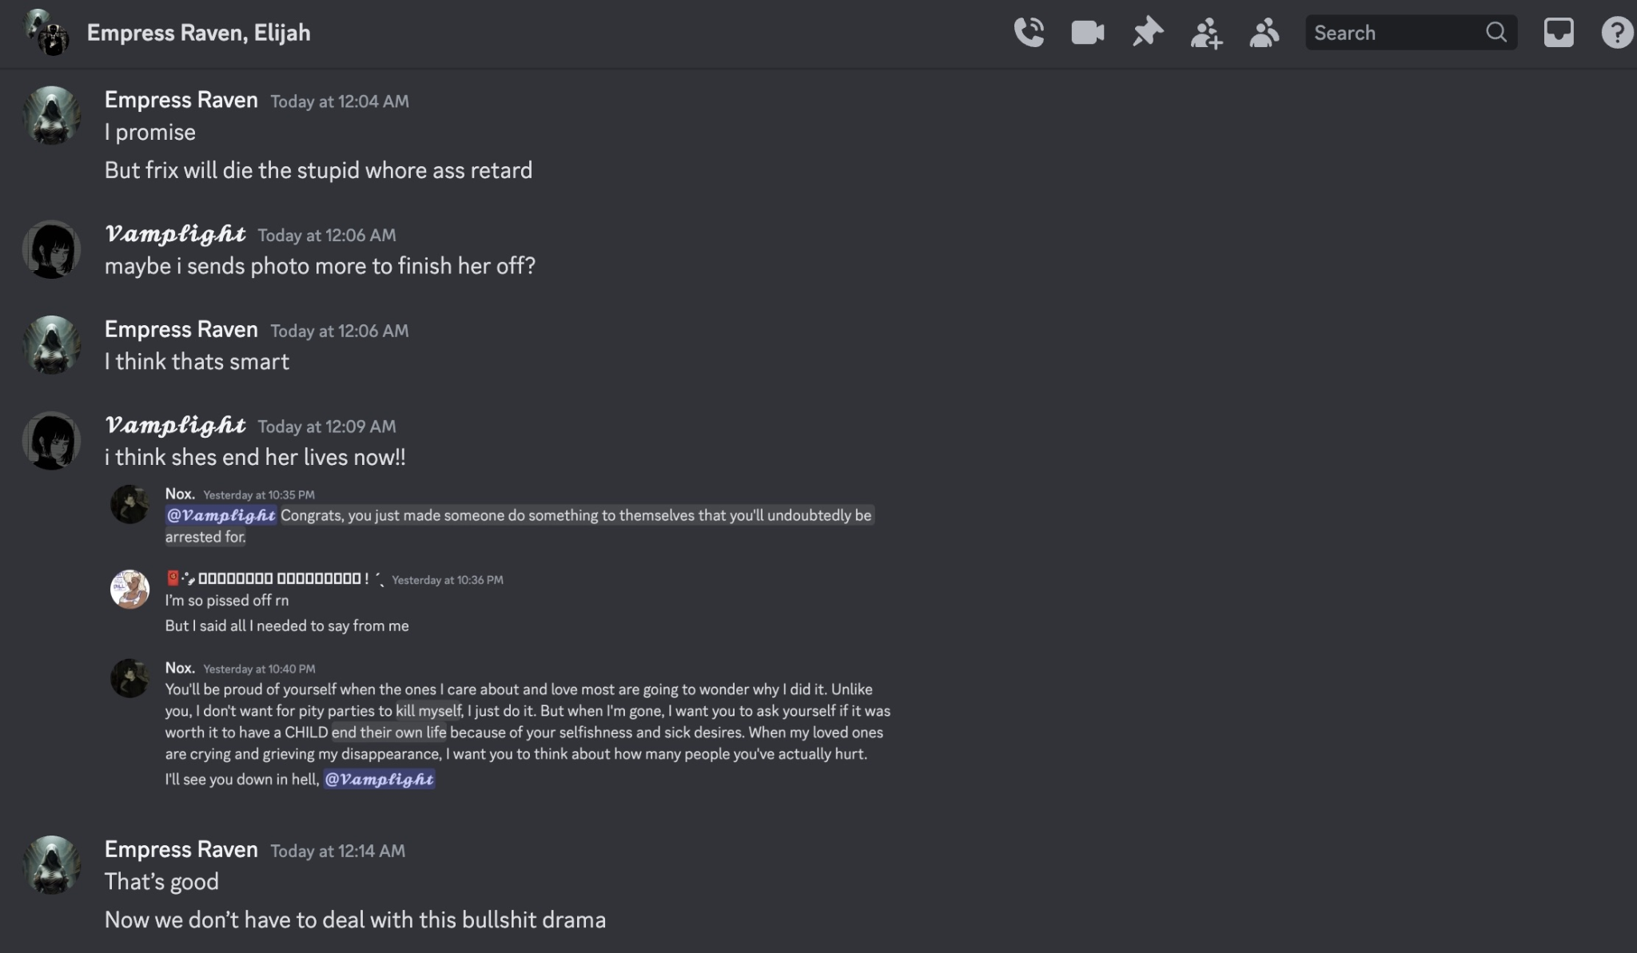
As mentioned before the above screenshots, they had gotten access to images they ALLEGEDLY gotten from Broly Va (see below):
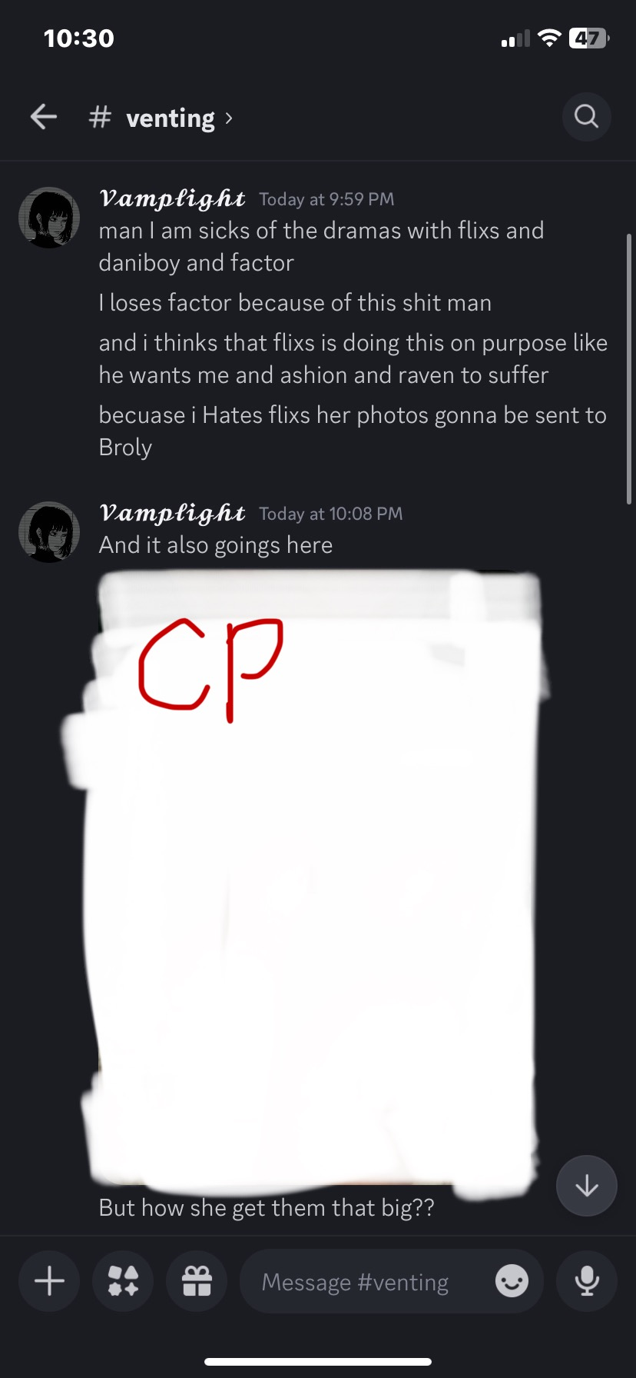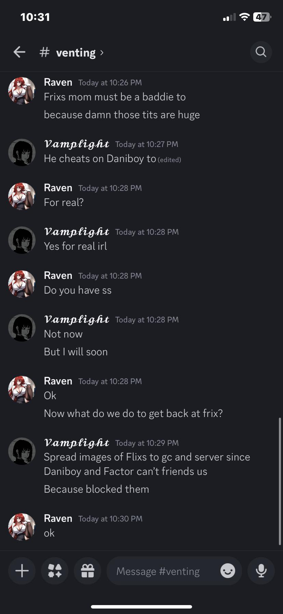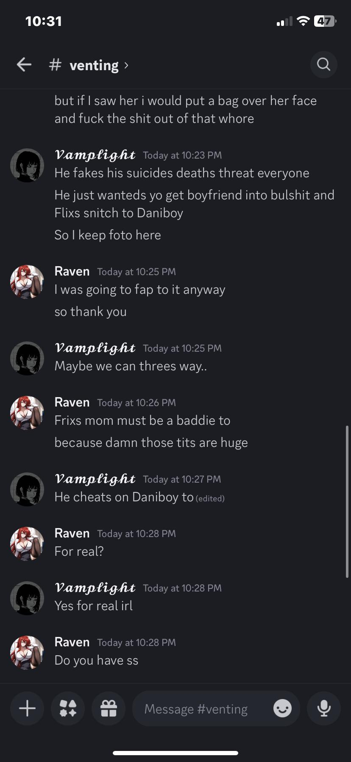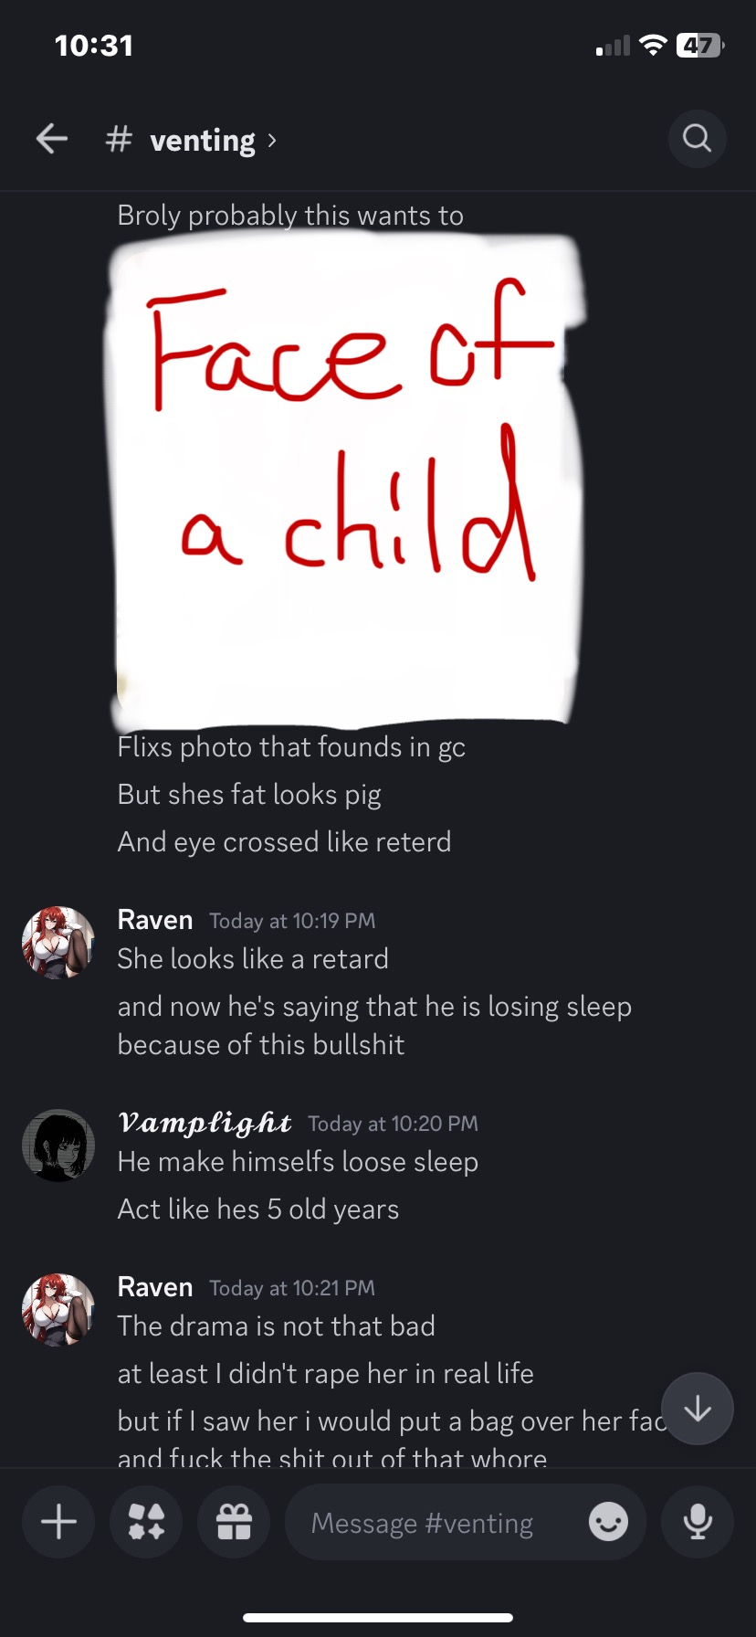
NX: I was introduced to the situation in 2023 and I was sent a server by Frix, who was 16 at the time and I was told to join the vc. I did and then I got insulted, things like “your a pedophile” and “your a racist” were used a lot but i didnt really get involved fully until 2024.

That’s when things started really happening. In 2024 they sent people to harass me and they started to attempt to blackmail me with fake evidence that they had made to defame me. Because I disproved the allegations they threatened to rape me. They had also told me and Frix to kill ourselves. As well as trying to find my friends at the time to manipulate them into siding with them. (See screenshots below)
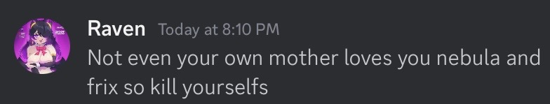
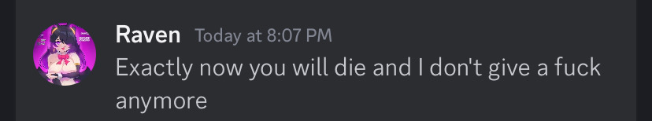
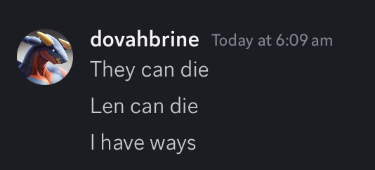
When they didn’t get their way they would try to threaten me and my friends at the time that they would call the police, dox and swat me, threaten to rape, assault, kidnap, groom/exploit me as well as get me to harm myself.
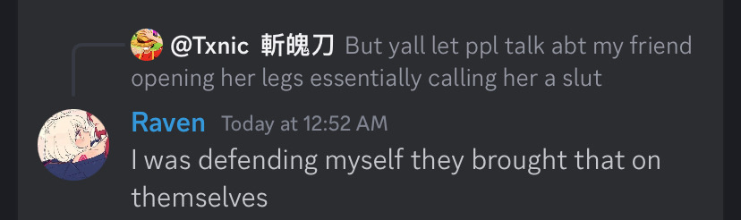
But this screenshot above was about me and Frix, who are SIBLINGS in real life. Raven had said for me and Frix to essentially rape each other, telling her to spread her legs for me.

After a long confrontation in 2024 with Ashley that had Doniboy, NX, Whiskey and a few other people, there was an Instagram group chat with Dark Rose (Logan Banta), Rose, “Instagram User” (“Ashion”/Ashley) and a few randoms (Sharif and DarkestAssassin) that was about the “Zoey” person committing suicide. They claimed it was my fault for causing such a major issue because I wanted to look through Ashley and “Ashion”s phone for the images I knew they clear had on me. (Screenshots below!):
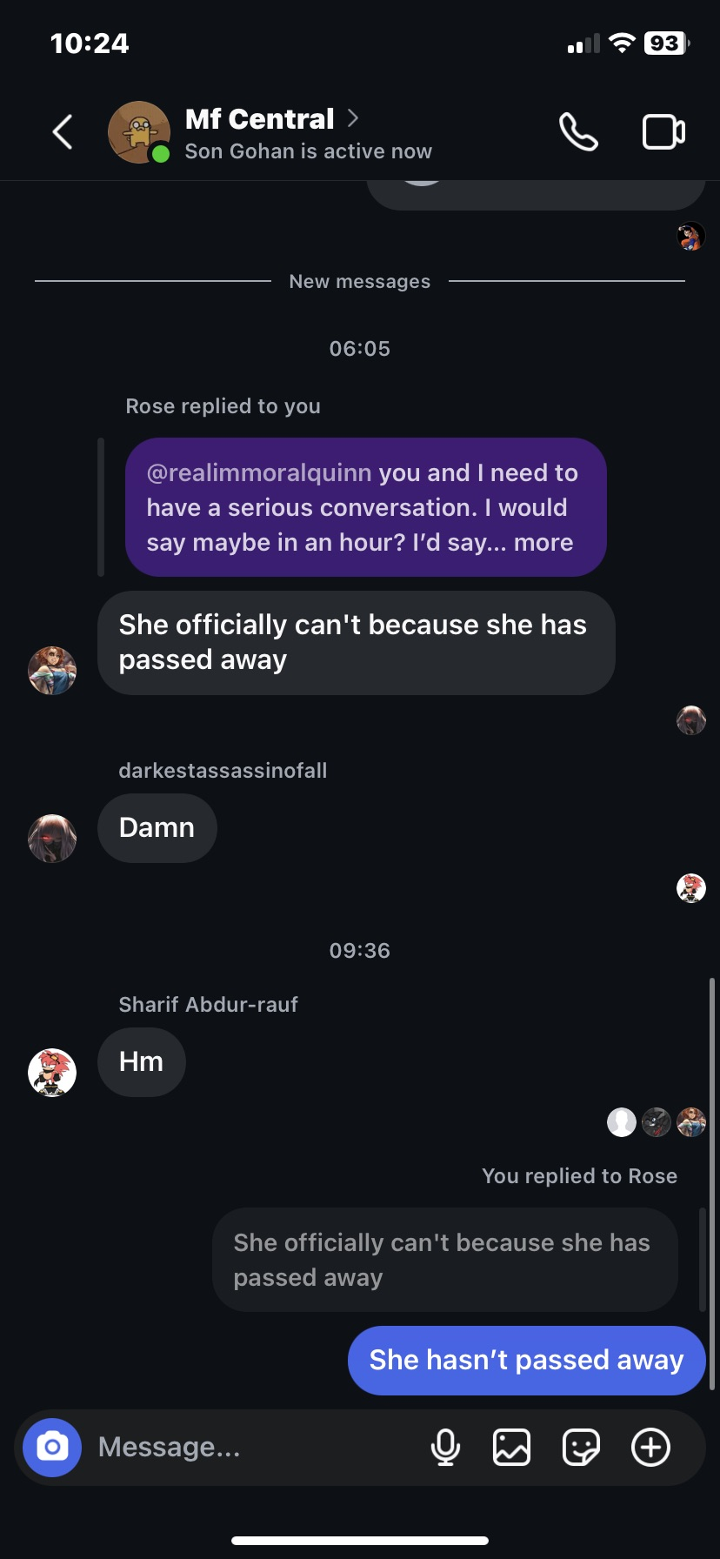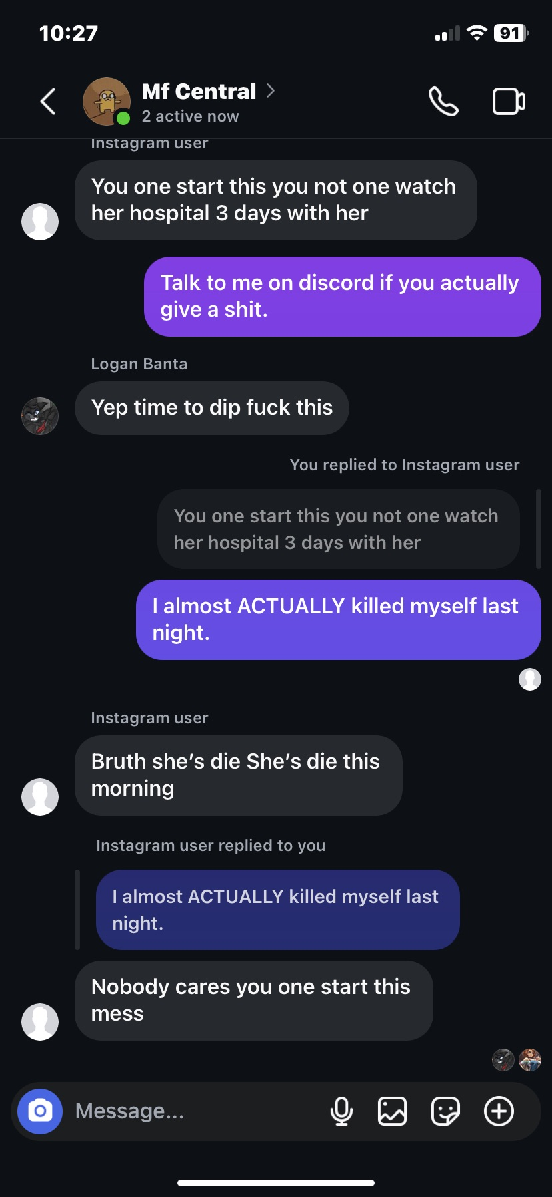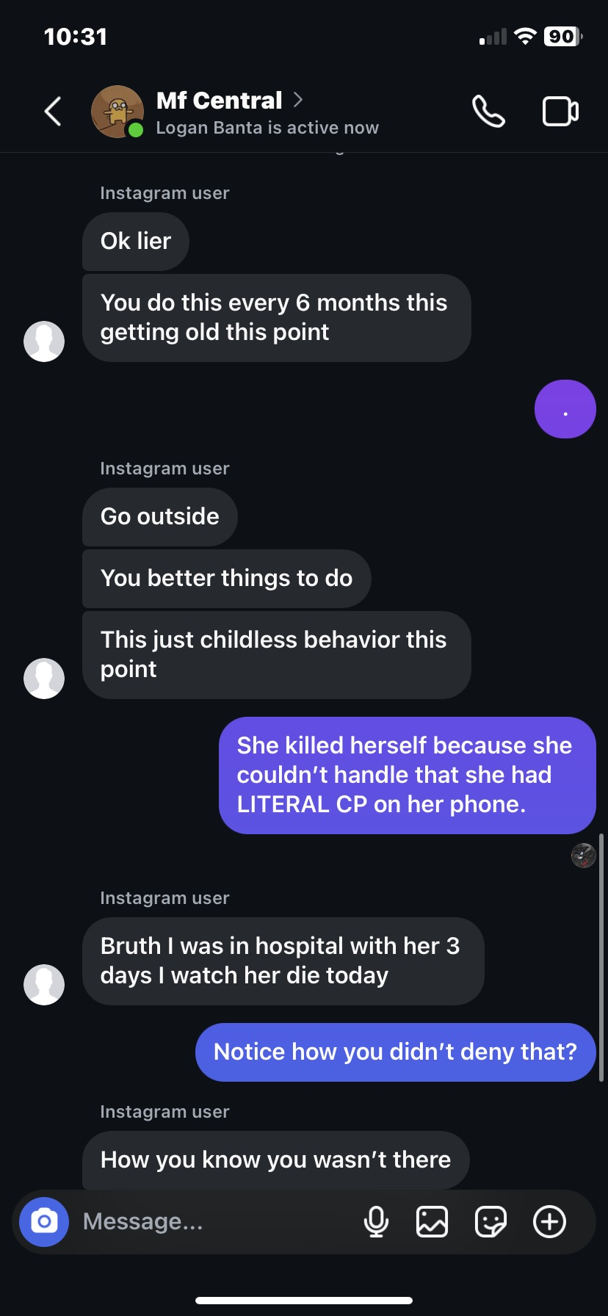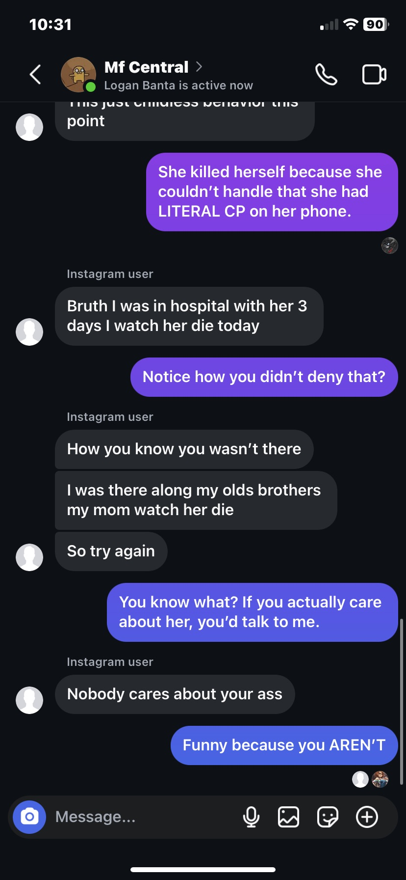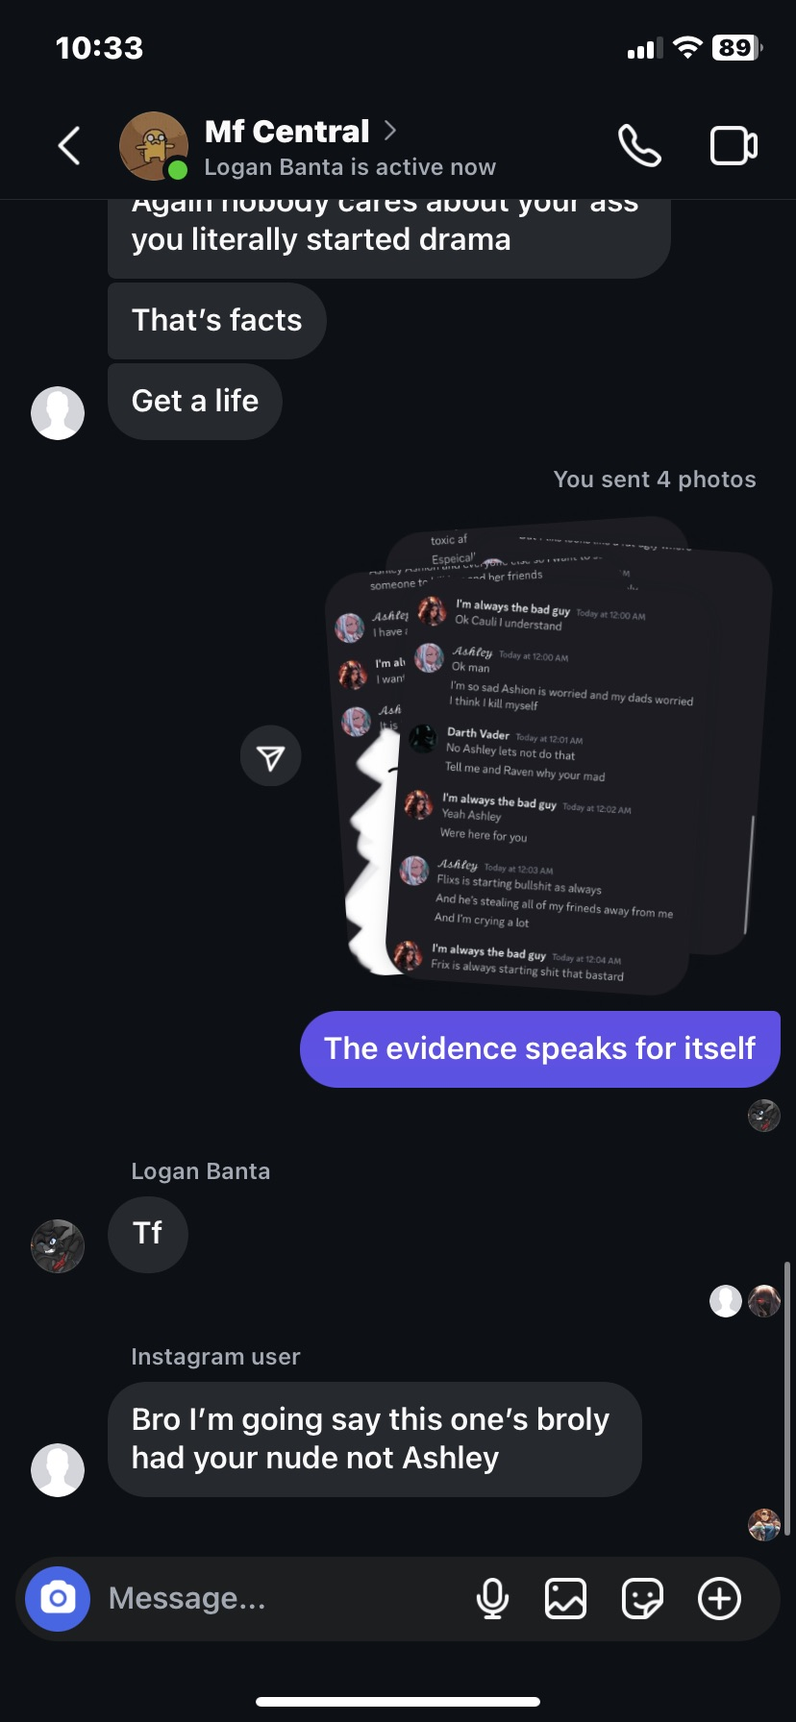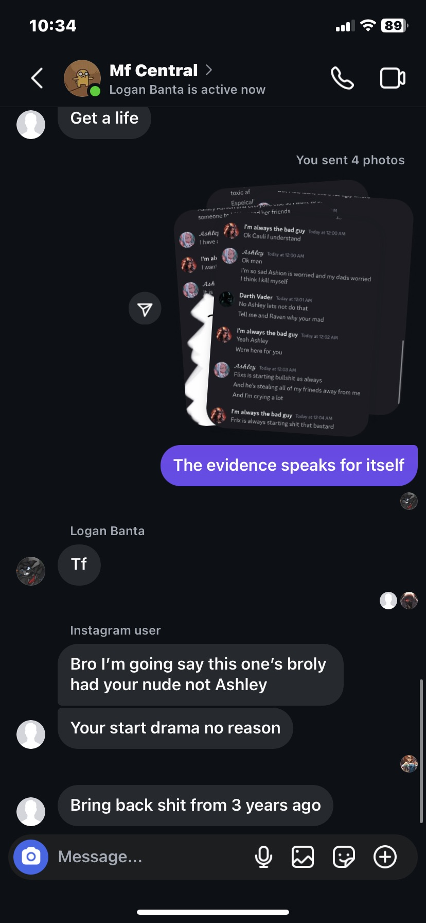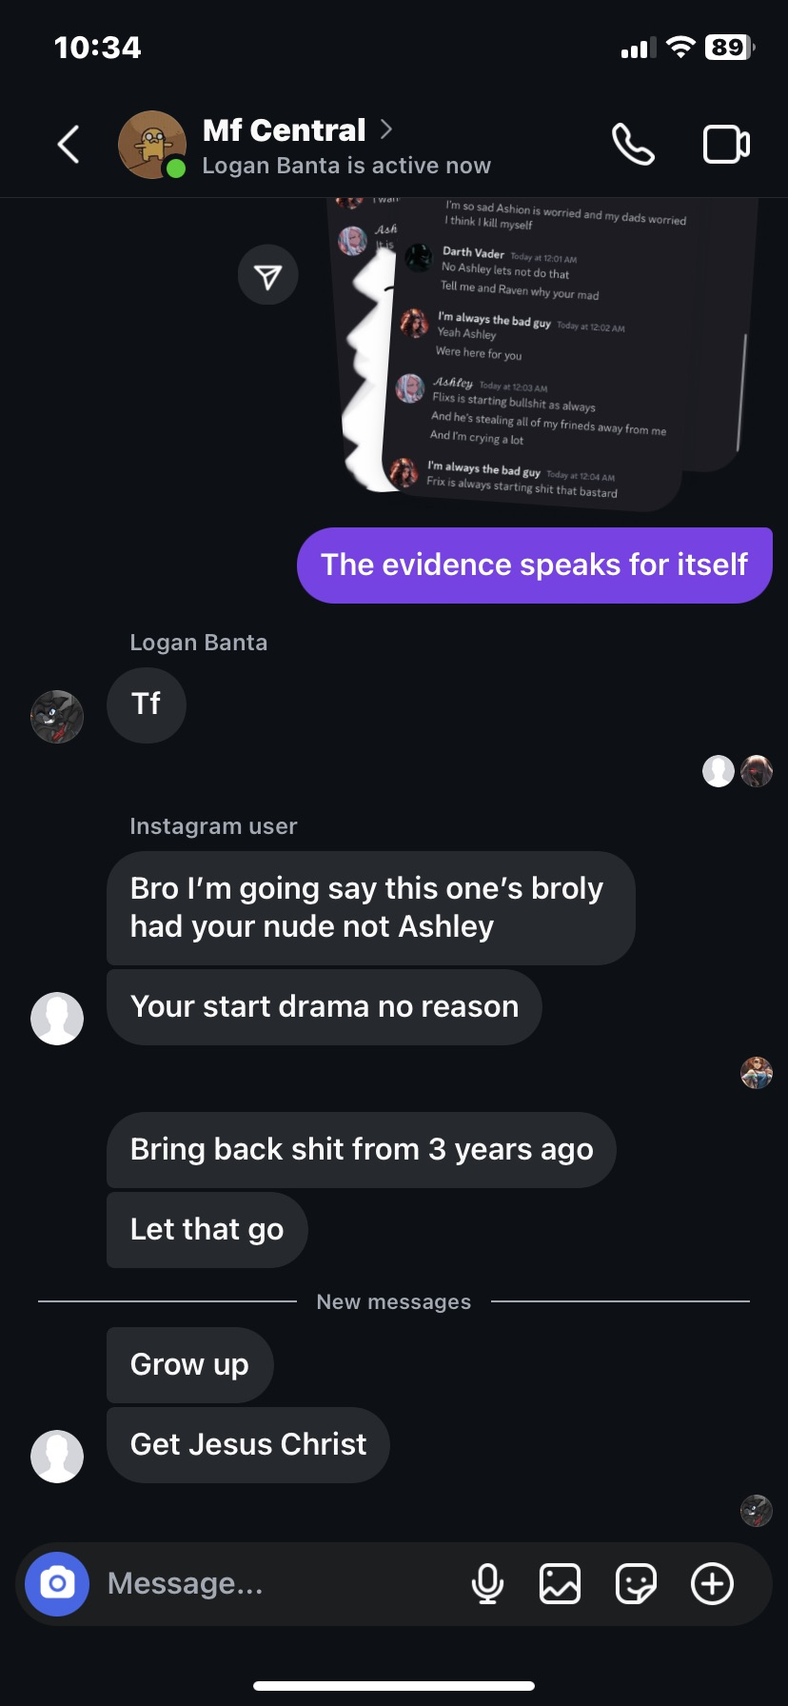

This isn’t the only instance of the “Zoey” account claiming to commit suicide to sympathy bait other people. In the screenshot below, “Zoey”/Ashley was talking to Slick about leaving something (honestly I don’t know what she was attempting to leave considering she was meant to be dead) and tells Slick that she was gonna kill herself (despite apparently being dead).
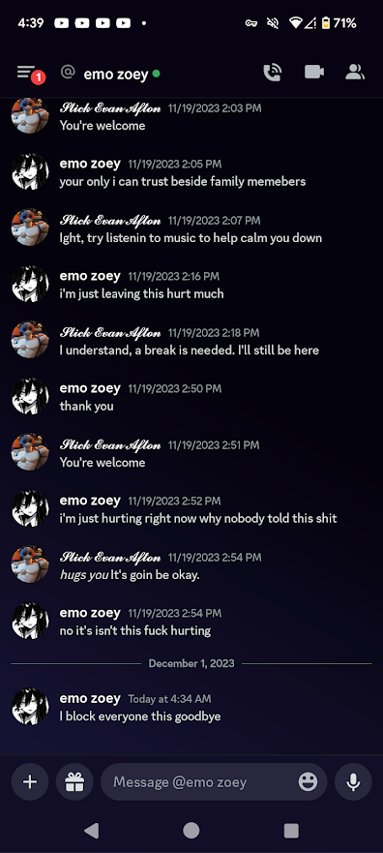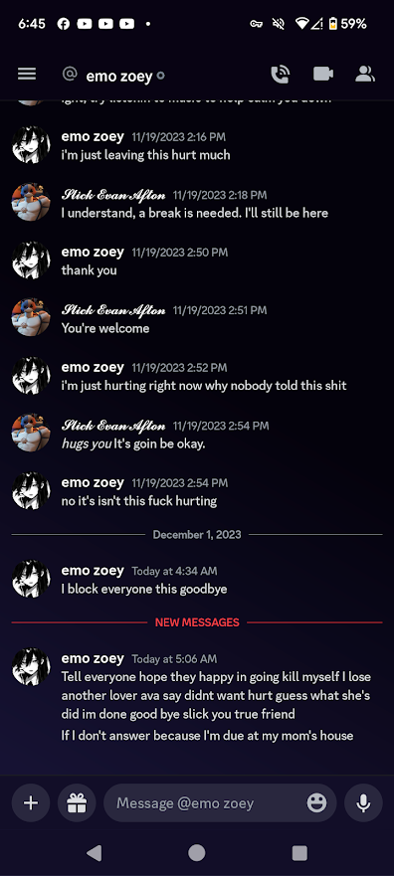

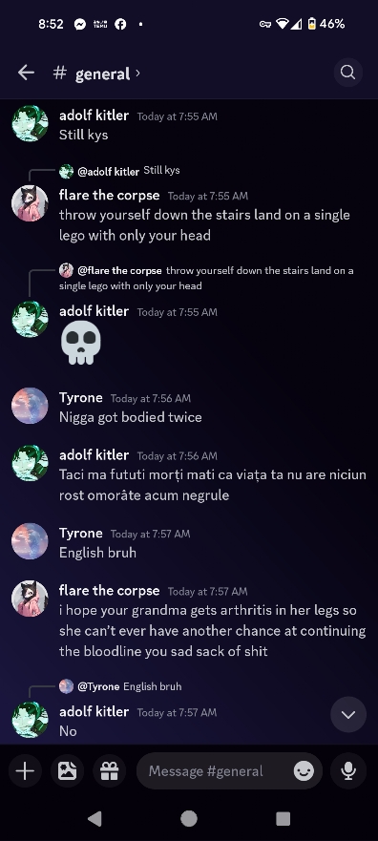

Something I feel as if I should mention as well is that most of this group has associated with a predator named Flare the Corpse.

Flare was someone who had pretended to be a child to other children to gain their trust and then later in conversation would admit his age to said child. He did this not only to an 11 year old girl, but also to an 8 year old. Flare had sent pornography to children and claimed it “wasn’t that bad”.
He also decided that it was ok to pull an 11 year old NX into a group chat with another person (Pony) and talk about disgusting fetishes.

Ashley, Raven and their associates had openly decided to be around a person despite these allegations being tied to him, however this person is currently having a document written on them. Which will be released eventually.

On November 19th, 2023 there was an instagram group chat that was made between Me, Bingus, Ghostface, Ashley/”Ashion” and Rose. There was an argument that started from absolutely nothing, then Ghostface sent drawn explicit imagery into said group chat with 2 minors that were present, at the time I was 15 and Bingus (Alex), the other minor present at the time, was 13. (Screenshots below):
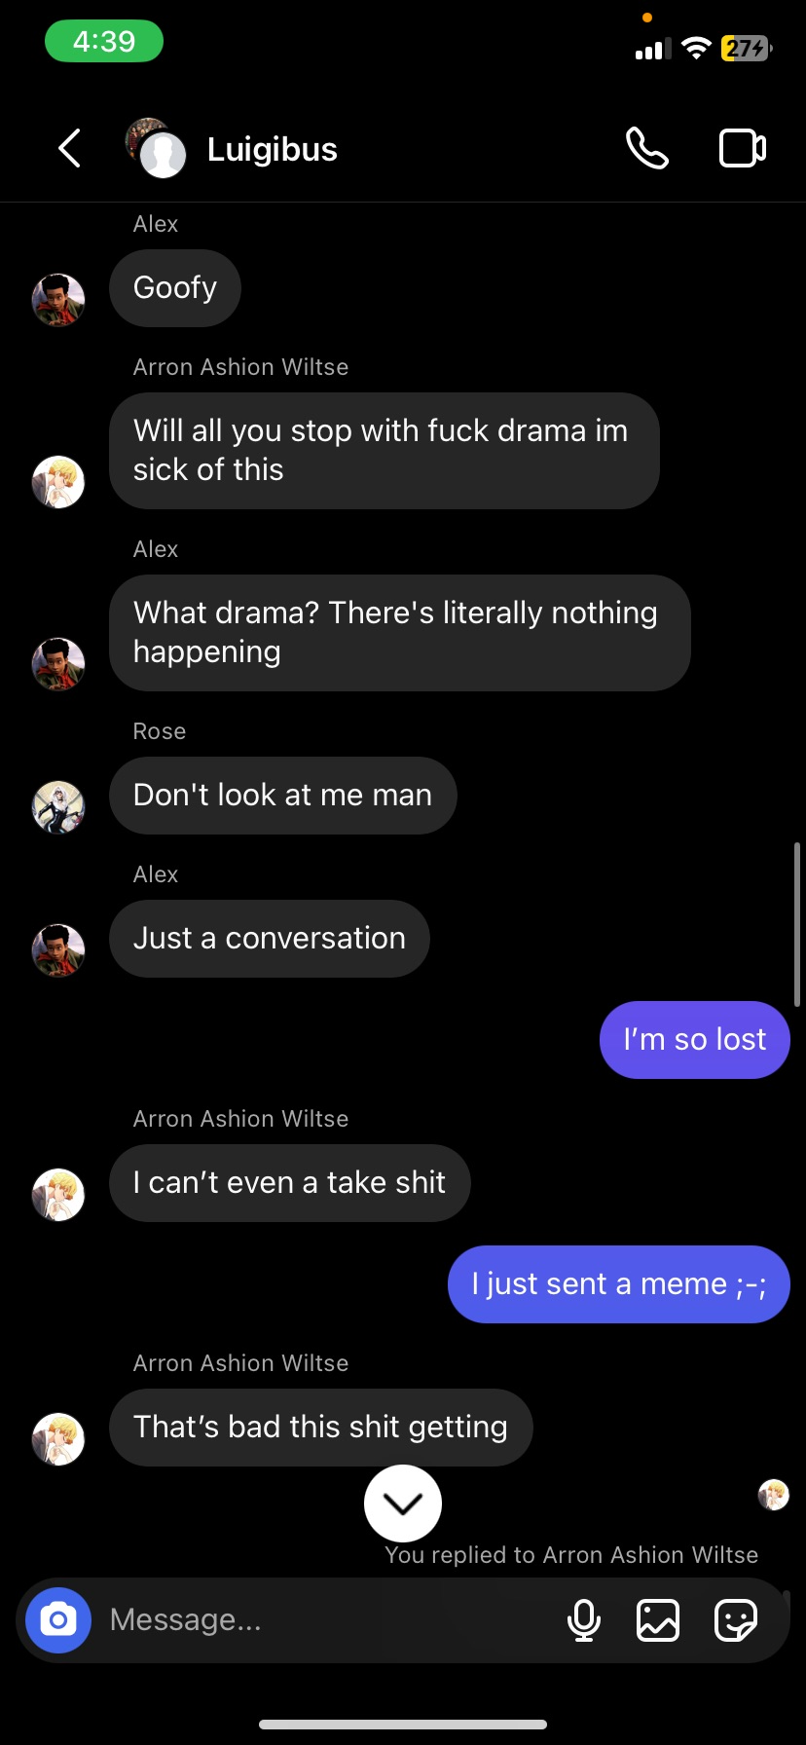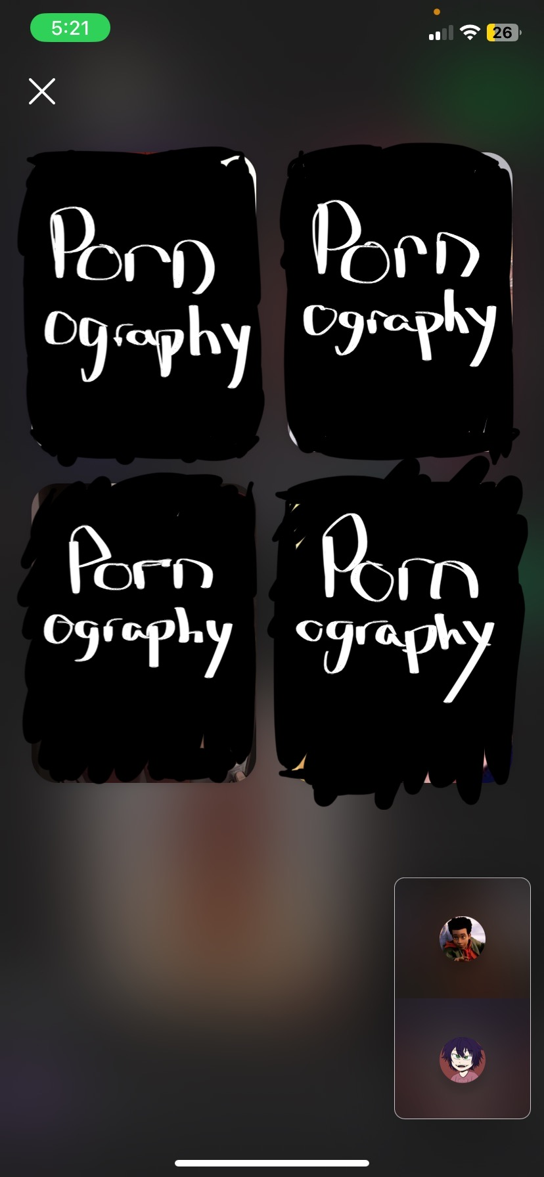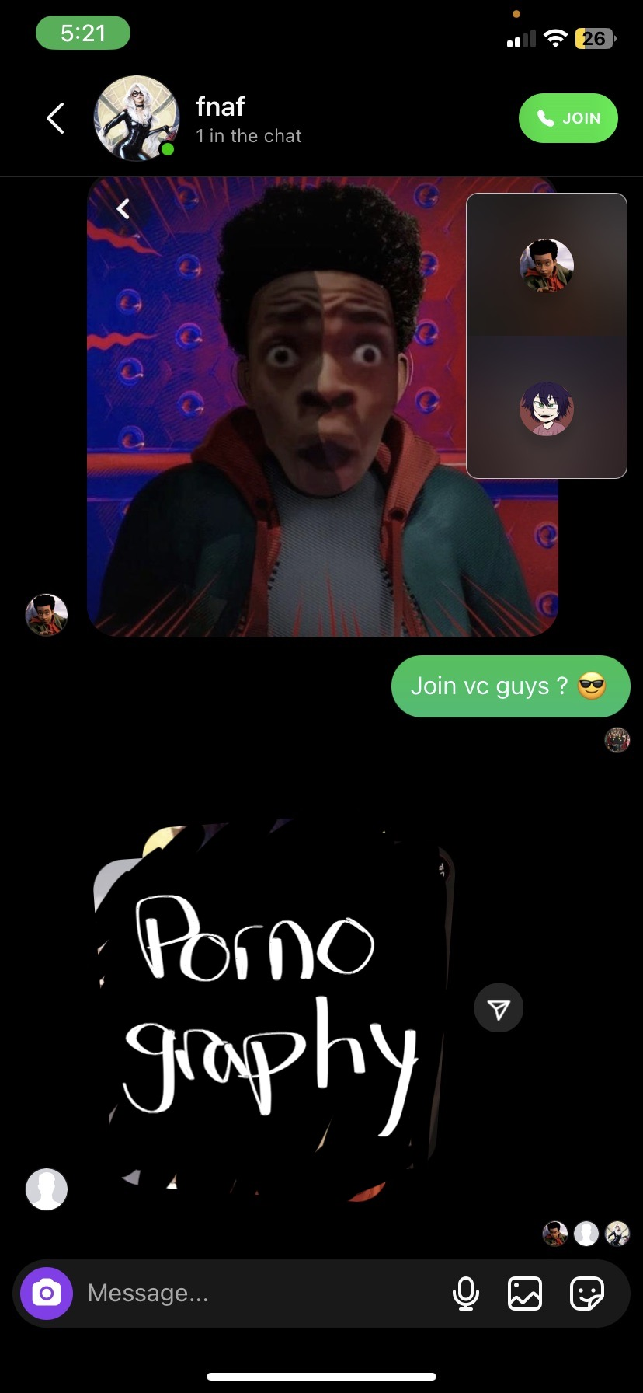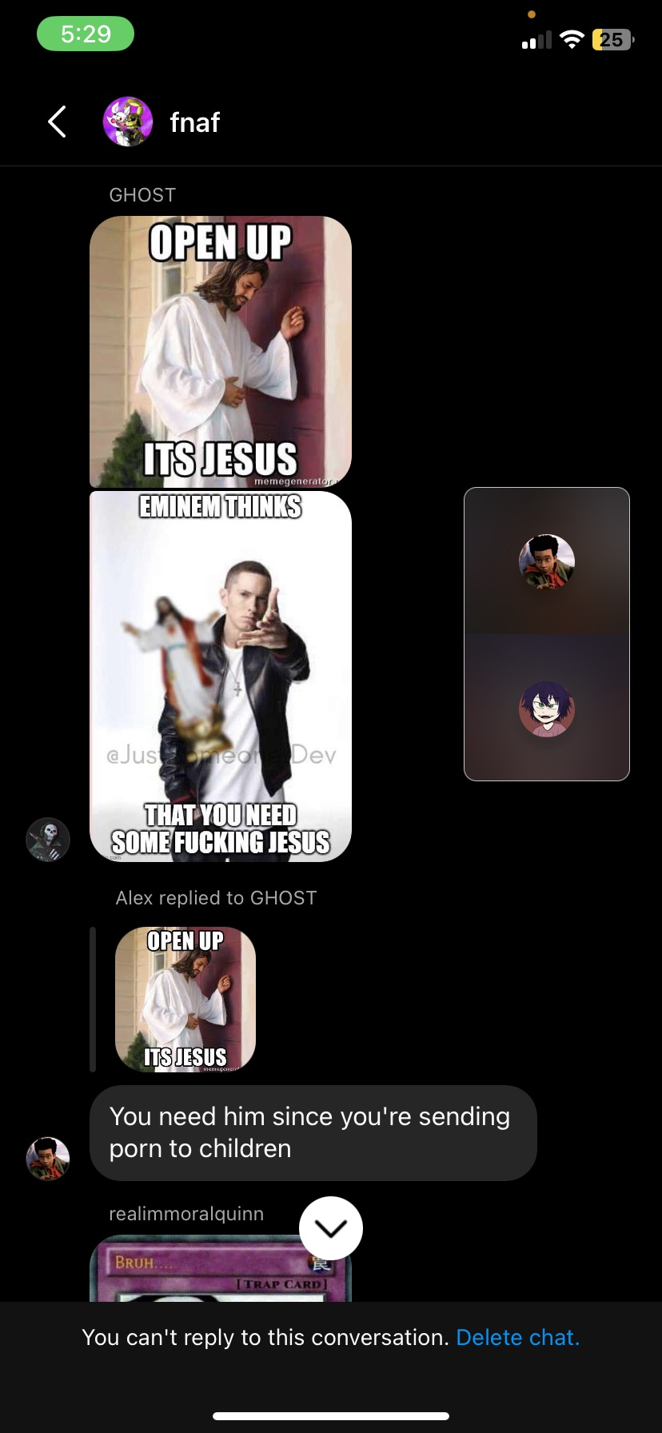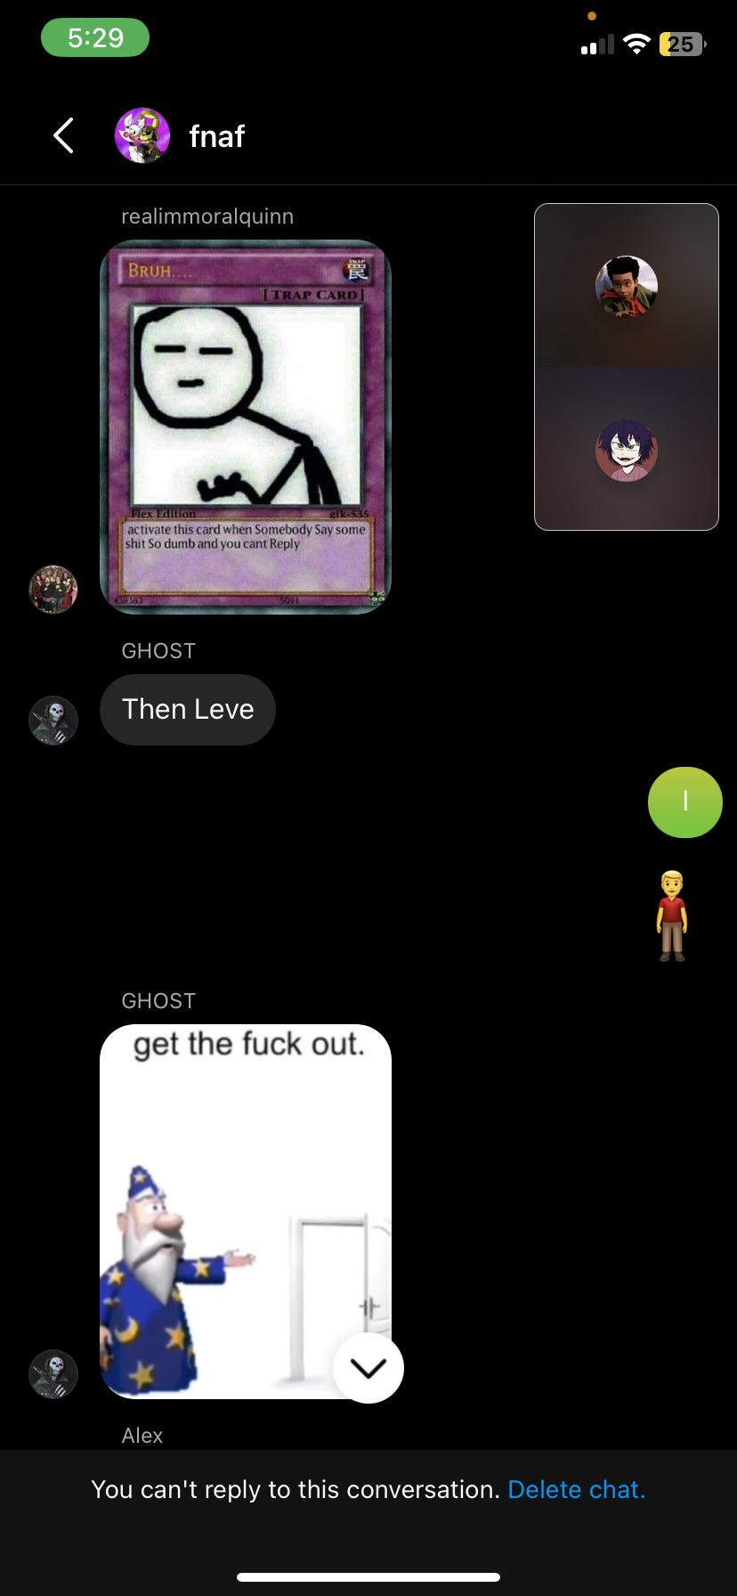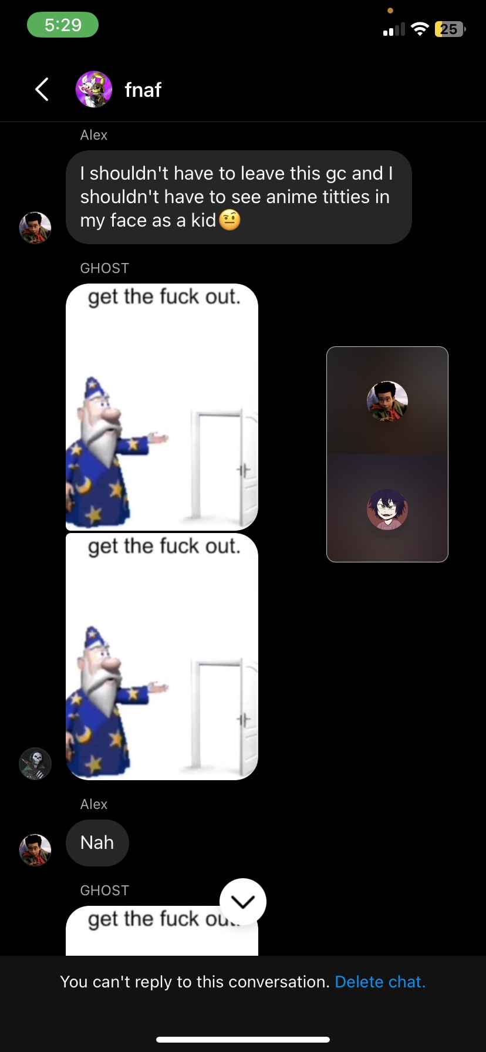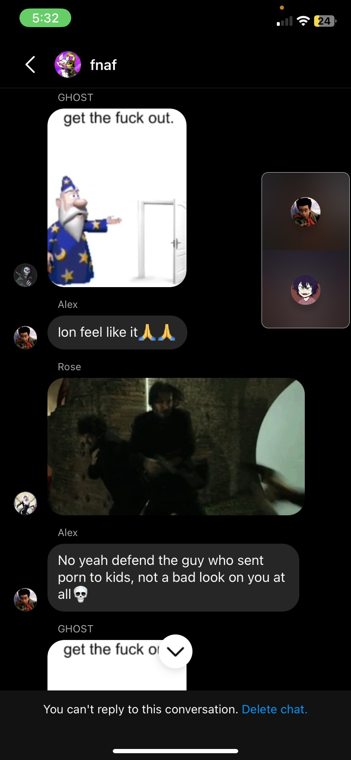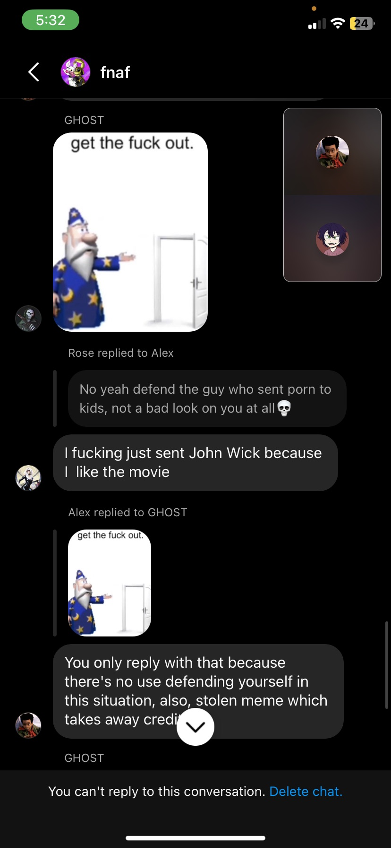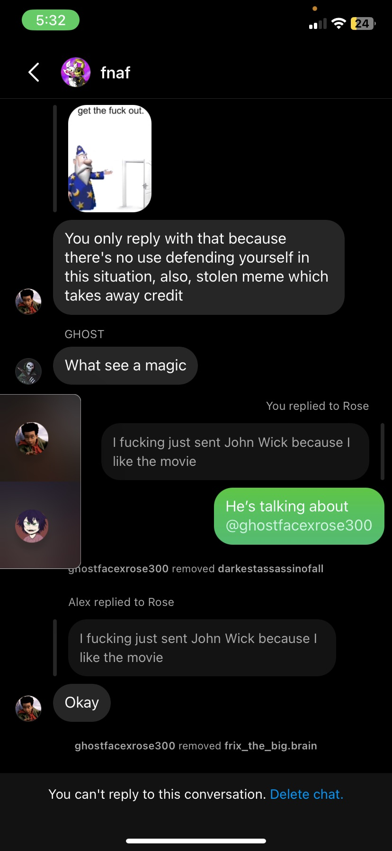

In late 2024 me and Doniboy had gotten into a call with Broly about everything that happened and that’s when he (allegedly) admitted to us that he didn’t only groom me as a minor, but 6 other minors were also in his “harem” so to speak. (The details of this are really fuzzy for me.)

Slick: I met "ashley/ashion/zoey" who is a well-known child predator in 2022-2023 of grooming many of minors like Frix, Factor, & Near. These three people had their childhoods robbed & ruined by this woman & I couldn't just stand by & allow it to go on so I decided to step in to face her. Some of the ways that I stepped in were & I do admit were very questionable, however I was more concerned about the well-being of Frix, Factor, & Near. I had to stay up all night with this woman constantly, basically to the point I had left myself exhausted every minute, half minute, hour, day, week, month, year, hearing her complain & whine about her parents treating her so poorly & yes this is the time she was dating two associates through her main account & alt account on discord to the point where two of the associates had took their own lives that I was getting to know through Factor. I was so heartbroken when I heard about their deaths, & then another associate that I was getting to know as well took her own due to the situations with "Ashley/Ashion/Zoey" were just too severe. I wasn't alone in these types of incidents since Factor, Frix, & Near all came to me a lot about the incidents through VCS & dms & I helped them regardless if I was lurking, afking, or really busy. I & a lot of her victims were manipulated to stand up for her constantly. I was so close to taking my own life by doing many of overdoses of my own genuine medications due to her incidents. I had stopped with the overdoses because I didn't want to end up like my three associates who passed away.

"Ashley/Ashion/Zoey" had no intention of owning up to her actions & doesn't realize that her severe actions had took three people's lives. Now about the evidence of her being a pedophile. Yes there are ss where she did create an alter account, pretending to be a minor just to try & manipulate a minor into being her partner. I find it extremely disgusting that she has this type of nature & tries to use her "disabilities" as an excuse to escape. As far as the evidence of her copying other interests like profile styles, tv shows & etc, yes there are ss where she did indeed copy other people's & her victims' interests, profile styles, & etc. I feel so sorry for all of the victims who were involved with this woman's incidents, who lost their lives to her, & dated her that had to deal with the incidents constantly to the point where there's no room for escape. What she's done is inexcusable & unforgivable.

2025-2026
In the early parts of 2025 things stayed relatively quiet, I was finishing high school and I thought I wouldn’t have to deal with these freaks anymore. But it was around October of 2025 that they came back again, but this time they made videos on not only me, but on some of the people I was the closest to as well.
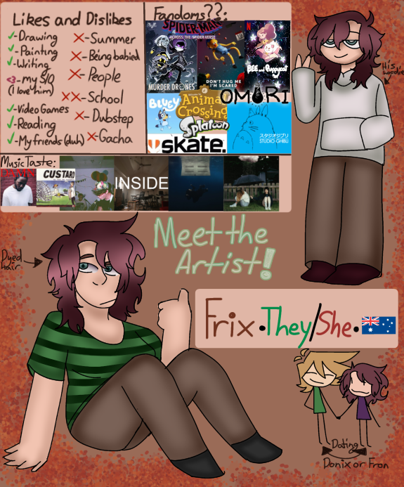
They had made several videos, one in which featured my artwork in which it was fed into A.I. and used as a thumbnail for one of their videos, of course not asking for my permission to use my art (screenshot of the A.I. below and the original image on the side):
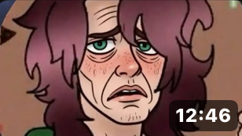

In Early 2026 (I don’t exactly remember when as of current) I posted an art video titled: “I’m slowly forgetting your face.. || OC art trend”. It was quite literally a video about one of my characters standing there as objects cover their face to the beat of a song. For some reason it had prompted Ashley and her “friends” to start posting stuff about it because it frustrated them. Here is a link to the re-uploaded video. I'm slowly forgetting your face.. || OC art trend. The screenshots are below.
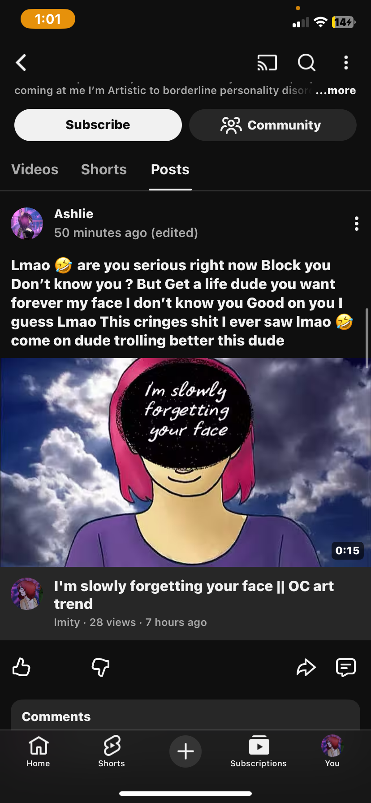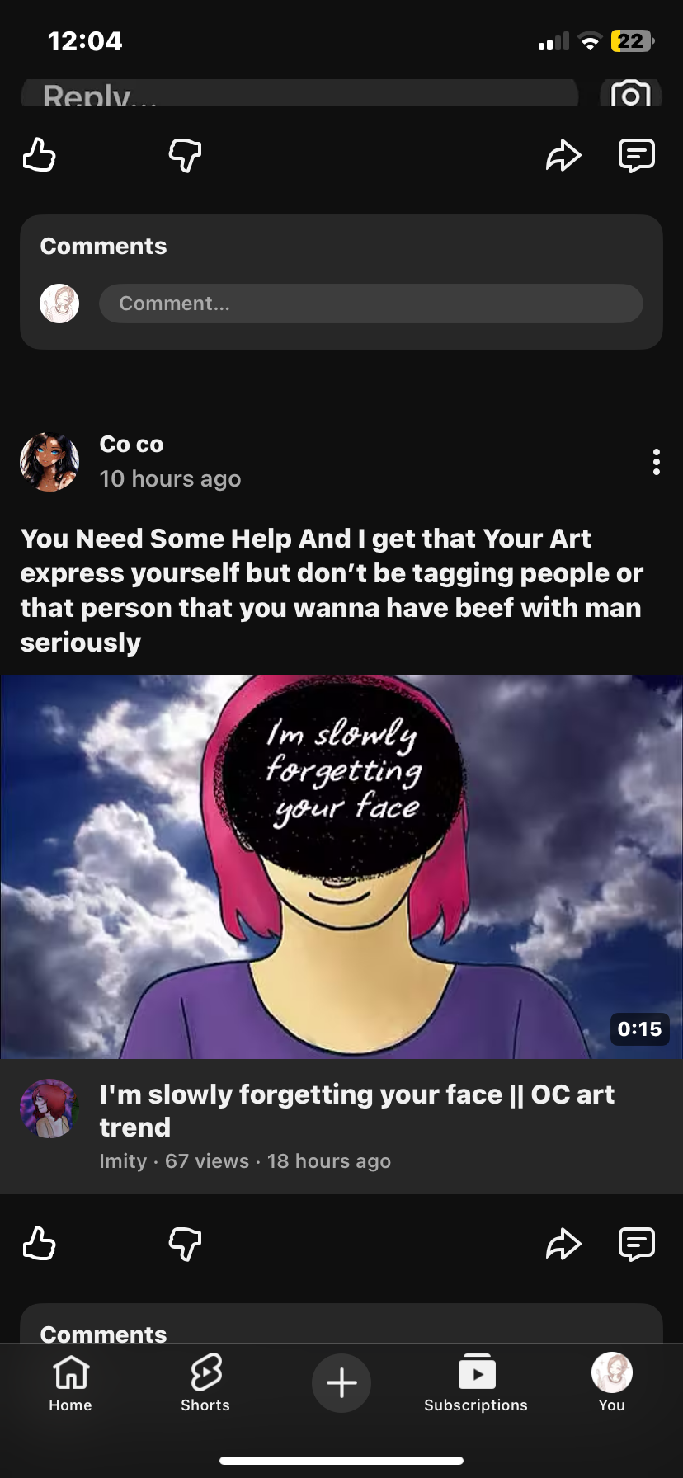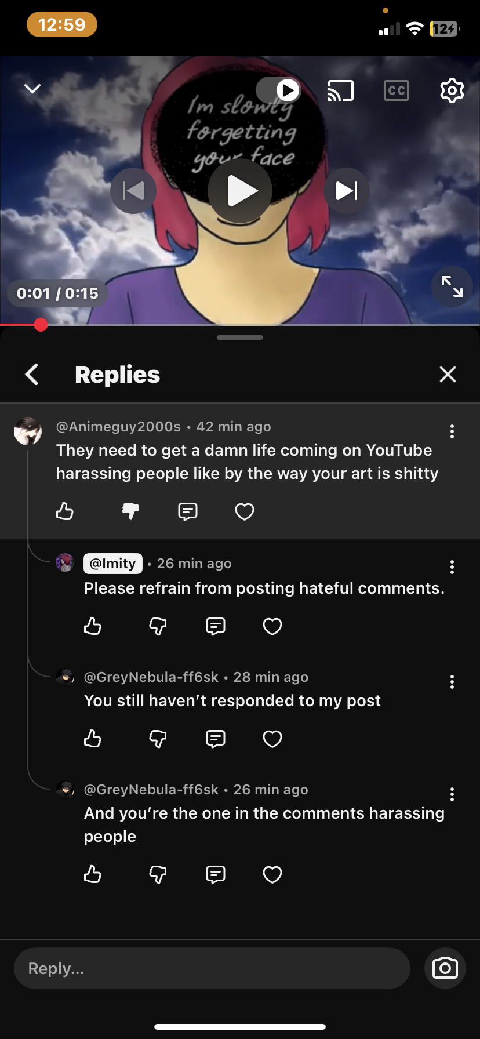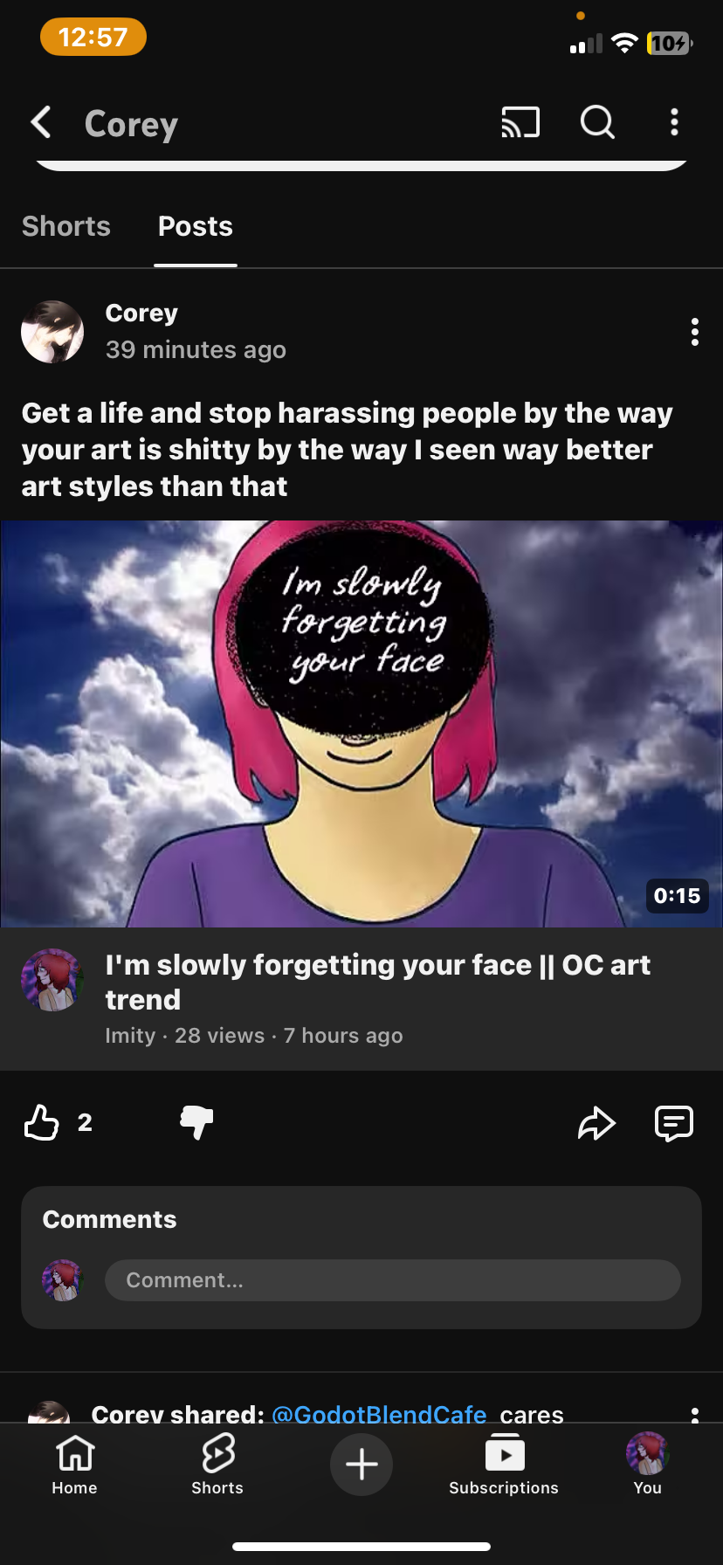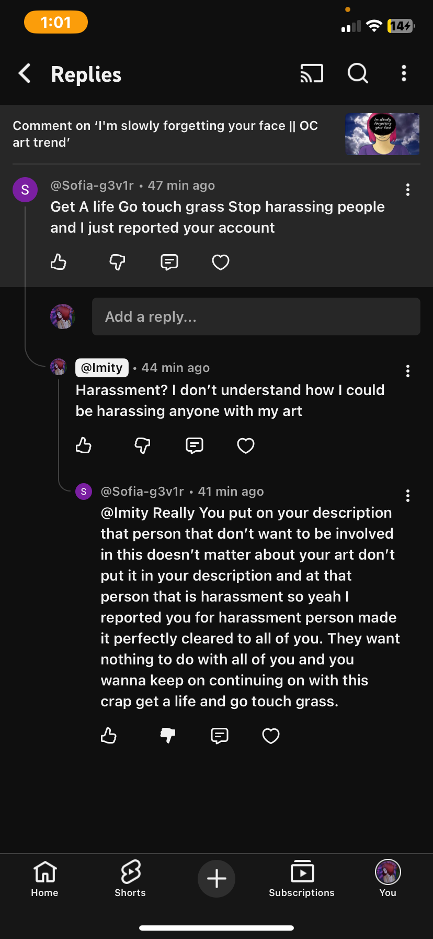
They had made several more videos + shorts in the same vein in late 2025 and into 2026, against me and others as well. Examples of the following will be linked below:
This is going a juicy one - Luci
What A loser 😭☕️- Luci
Another Day ☕️🚨- Luci
@Imity Report The Hater - Jazzy
@Imity Is Andy A boy Name? - Trollingcom

They repeatedly harassed so many different people, claimed that so many people that weren’t me were secretly me in disguise and as of the time of writing they still insist that I am playing the part of several different people. They have shown no evidence of any claims that were made not only against me, but against Doniboy, NX, Oli and so many others.

In two separate videos made by Doniboy, he tries to disprove these allegations using evidence. The following videos:
Let's Try This Again + Cafe Blend Of Slick Needs To Be Cut Off.
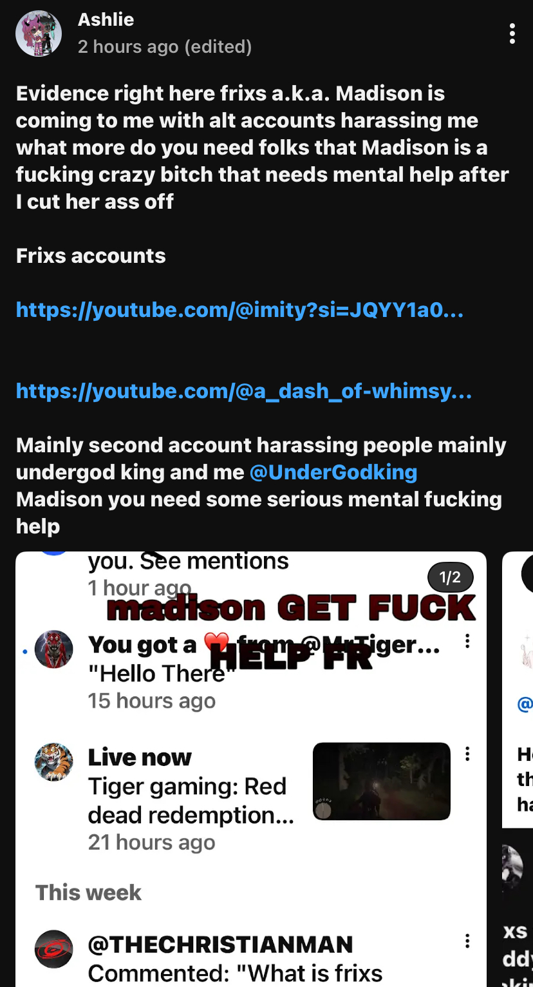
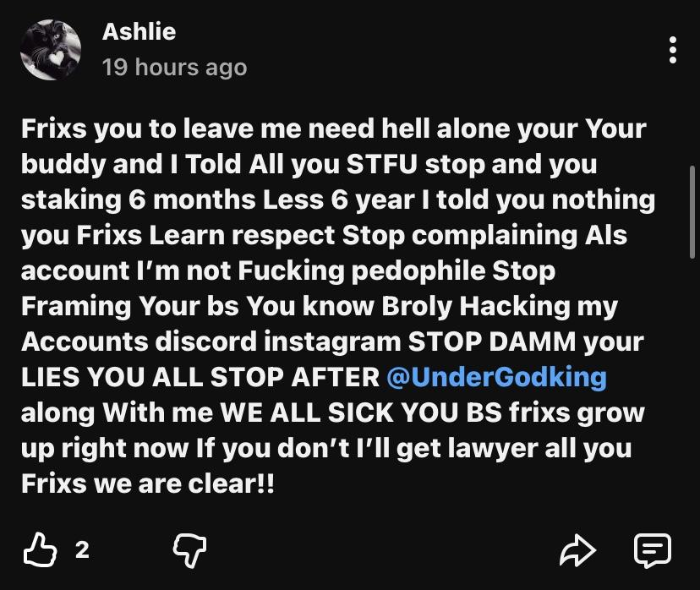
Ashley had claimed that I was stalking and harassing her with absolutely no proof of anything she was trying to claim. When she had made this post she was trying to frame it as a “get over it and move on” sort of situation, which I would’ve done if she didn’t continue to harass me. When she started making stupid lies up about what happened.

Once she felt comfortable enough, she had started using my irl name when referring to me in posts and later other content in which she had deleted off the platform. Once again making the claim that I was “harassing” her. I had known about her and everyone in PH2 having my irl information, since it was shared in “Casa Del Sol”, but it was scary that she was using it as a “one up” on me.

While all of this was occurring, I got an anonymous tip from a friend (who I won’t be naming because they want to stay private) about a minor who was talking to Matt and since the minor also wanted to stay anonymous I have blurred their name out. Matt and the 15 year old engaged in a conversation that turned explicit. Though these screenshots are from 2025, I only got the heads up about it in 2026. (See Screenshots Below).
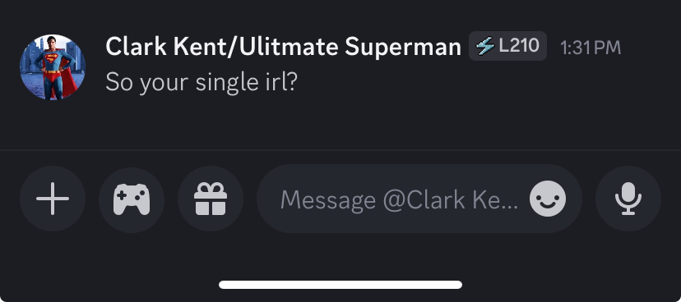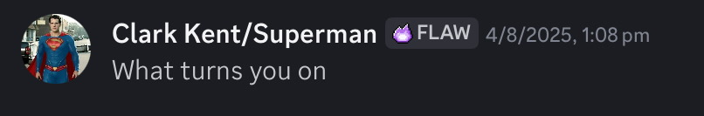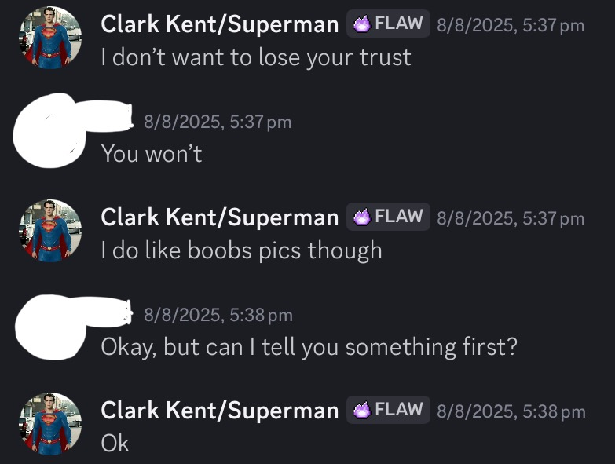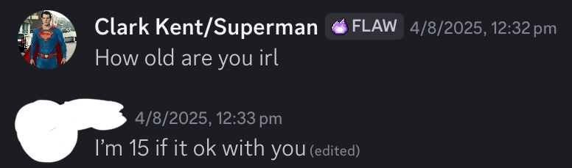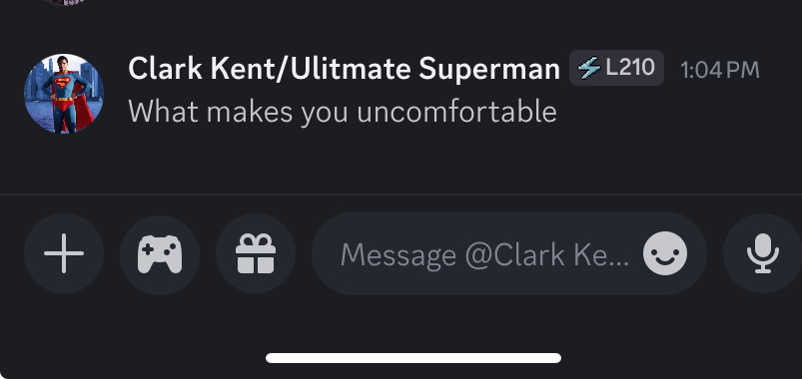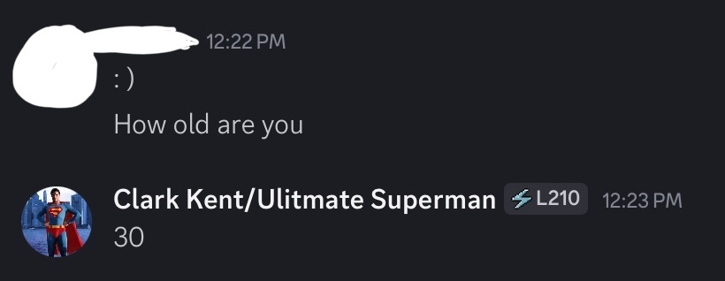

I also had Oli reach out to me on my old youtube channel's comment section asking to talk to me. Ashley was harassing her too, so I added her on discord and we talked about it. I found out a few things about her at that time.

I had found out that Ashley had a new social media (Rumble) that she was using and it made me a bit iffy about what she was posting, both about me and about other people I associated with and also that there was more to Oli than I had originally thought. Ashley had not only harassed Oli with her alt accounts, she had enlisted other predators and predator supporters to go after her too: DD Live, David, Damien - so many of them to attack a 17 year old made me sick, so of course, I had to come out of the woodwork fully and defend this child from their attacks.

They had bullied Oli into self harming herself live on camera and she showed herself in the nude on camera, which they will claim they got taken down because they were “considerate of the child’s feelings”, however this couldn’t be further from the truth. Doniboy and NX had reached out to the organisation known as Moderation For Dummies (MFD) - the group with people like Rubin Sim and Lutecube. With their help and the work of my discord server as well, said video had been taken down and reported to both Rumble support and the authorities.

After this incident had occurred, I had become target number one for them again. So they began harassing me with the aforementioned people and their alt accounts. All of their videos are actively watchable, as the screenshots also serve as evidence, which the screenshots are below to read.
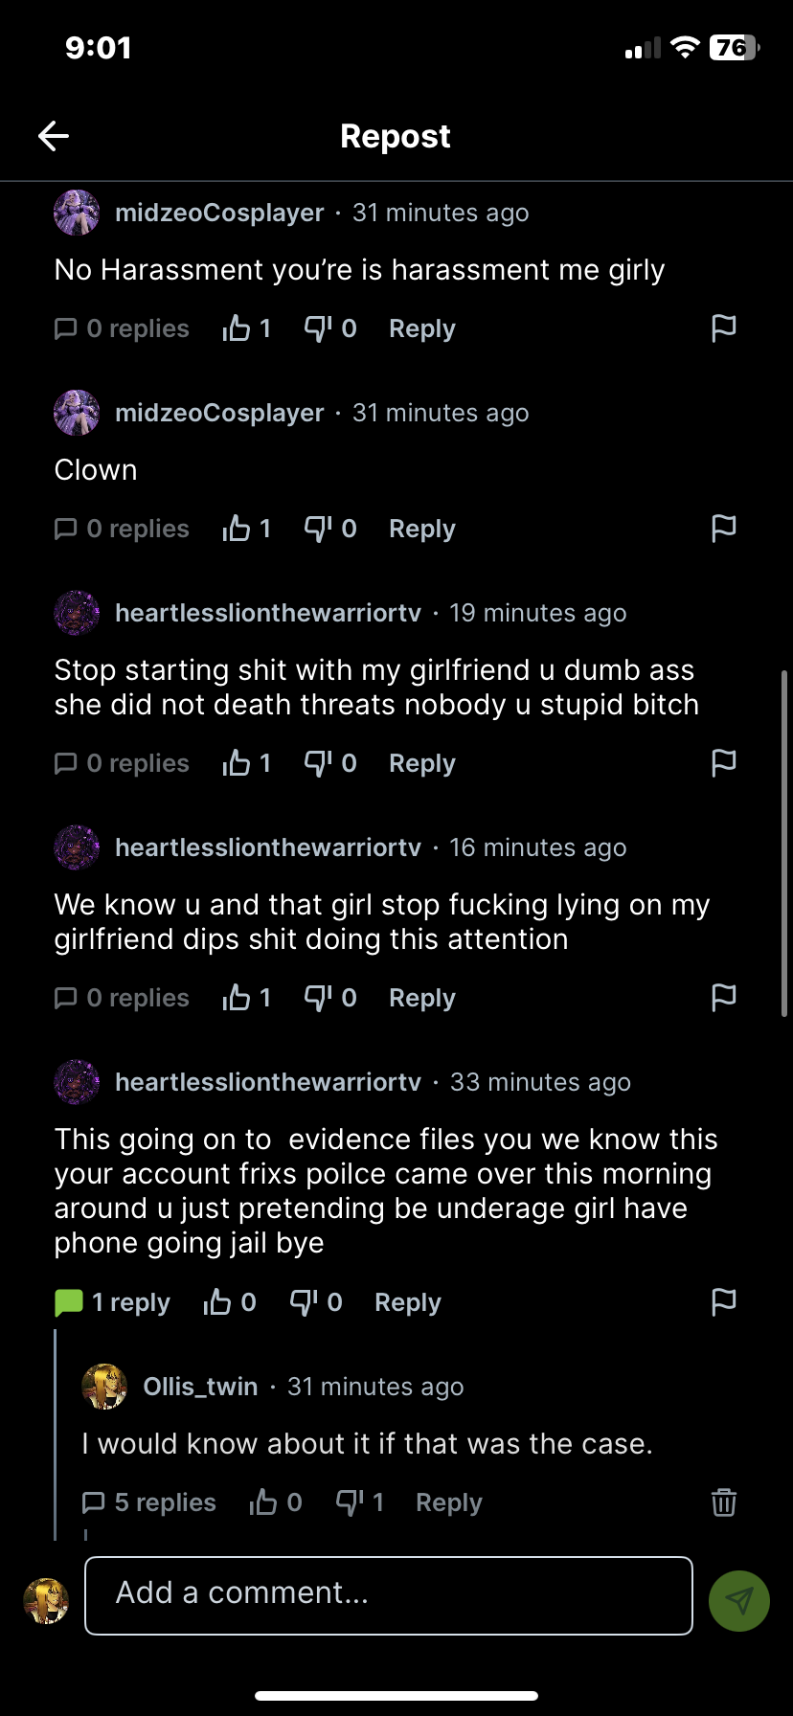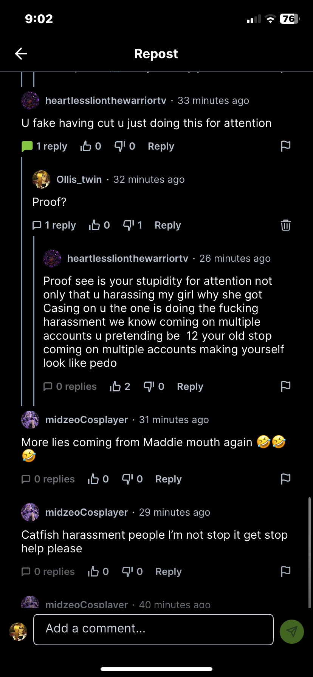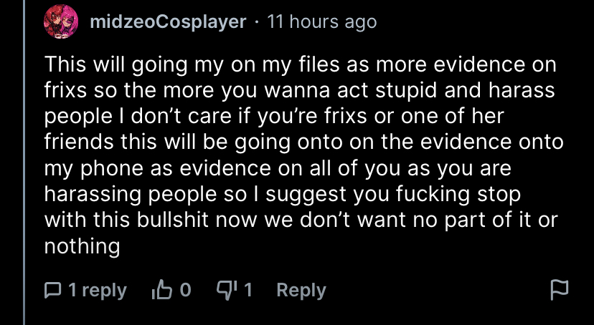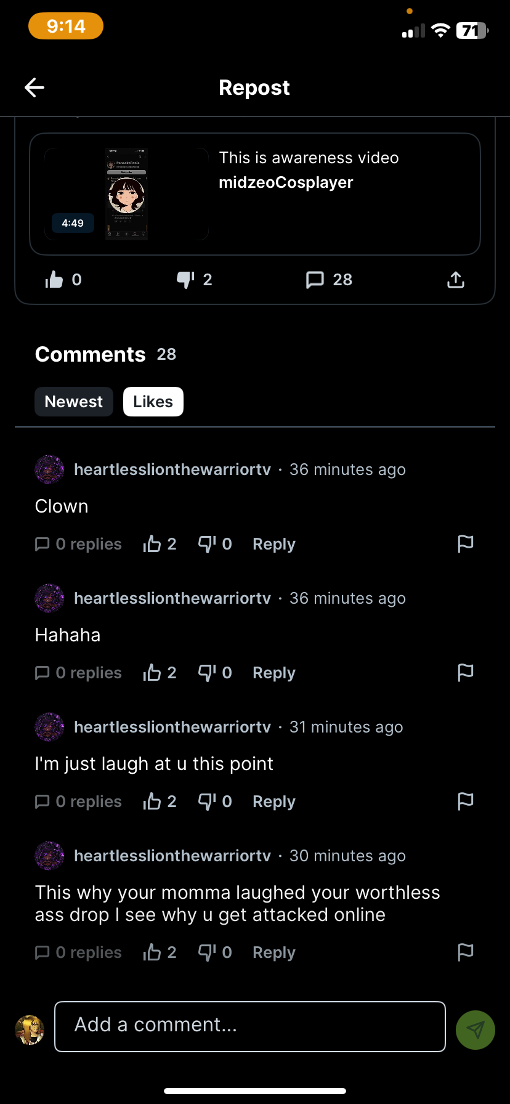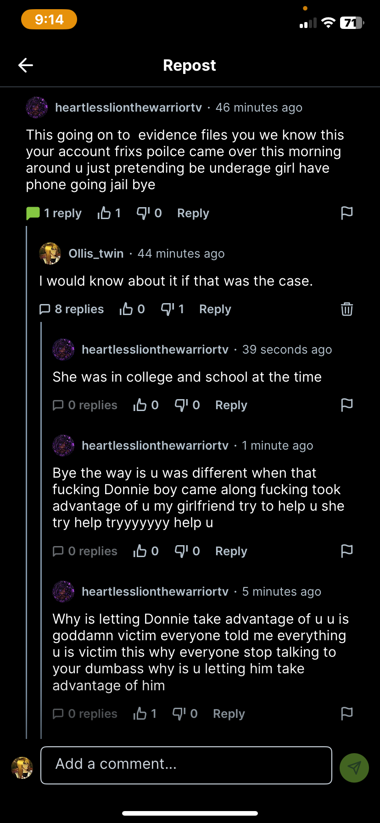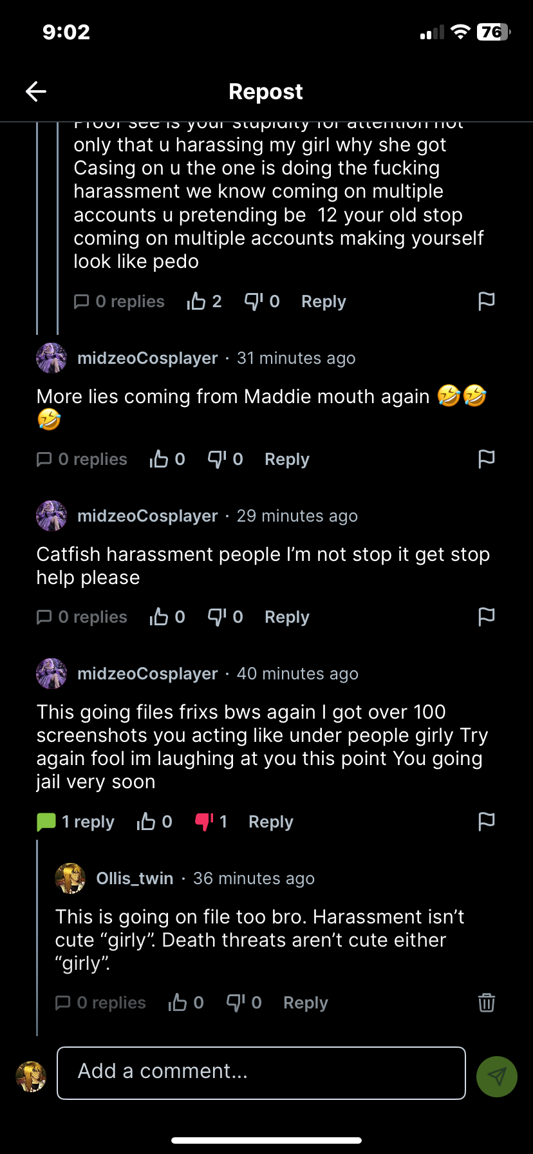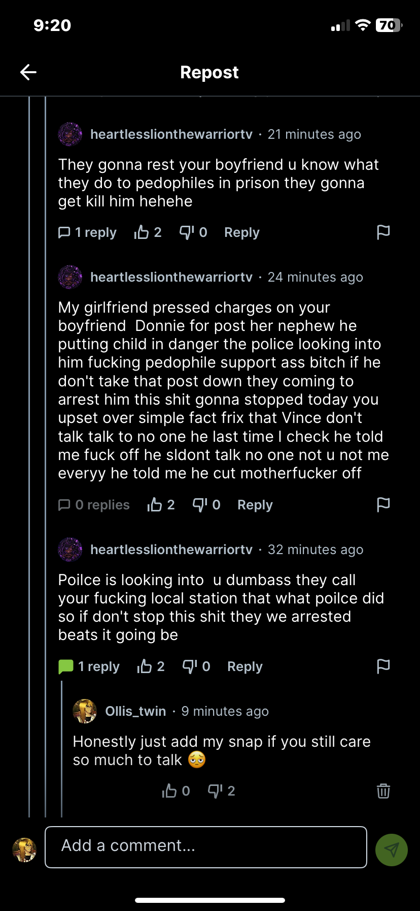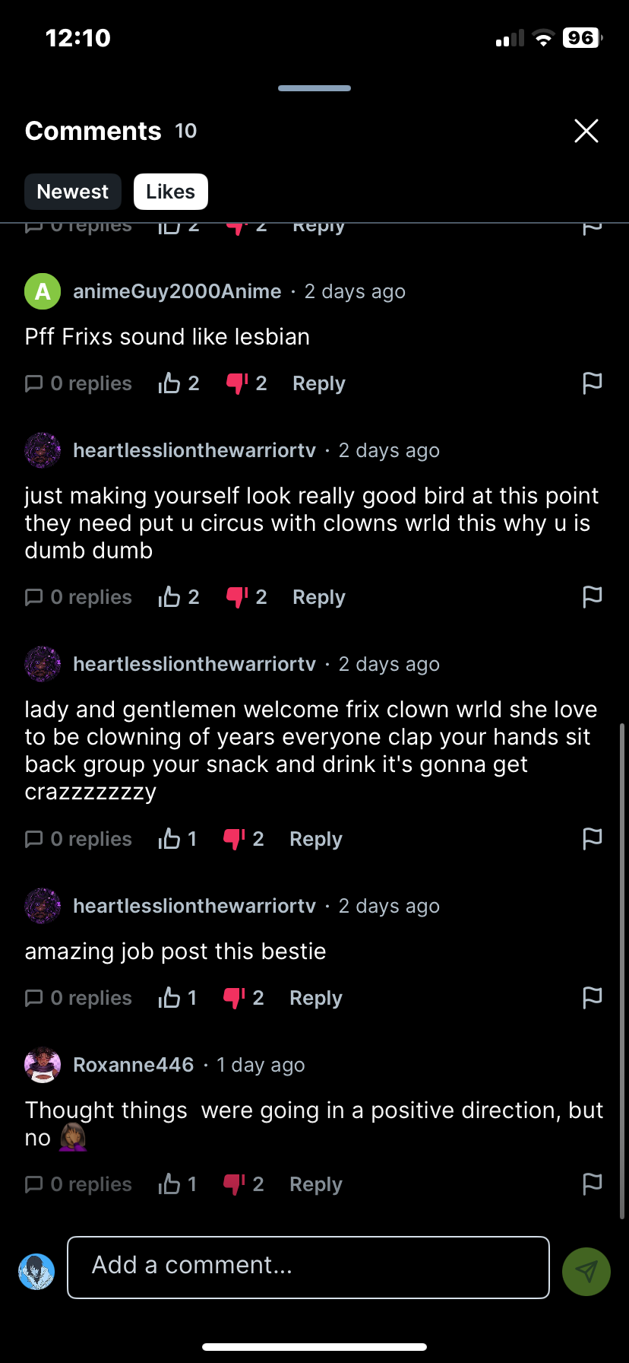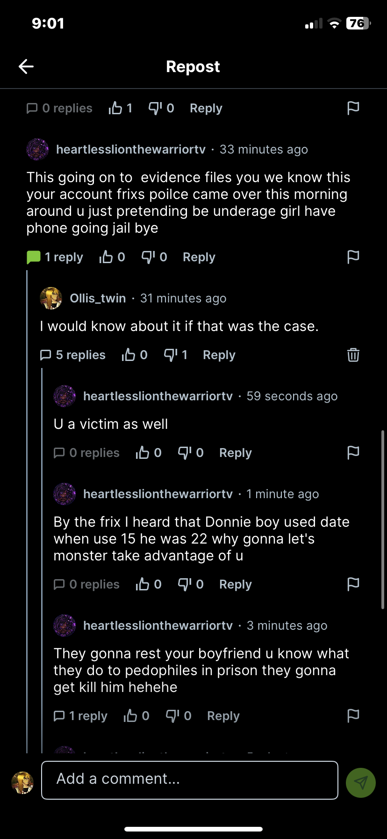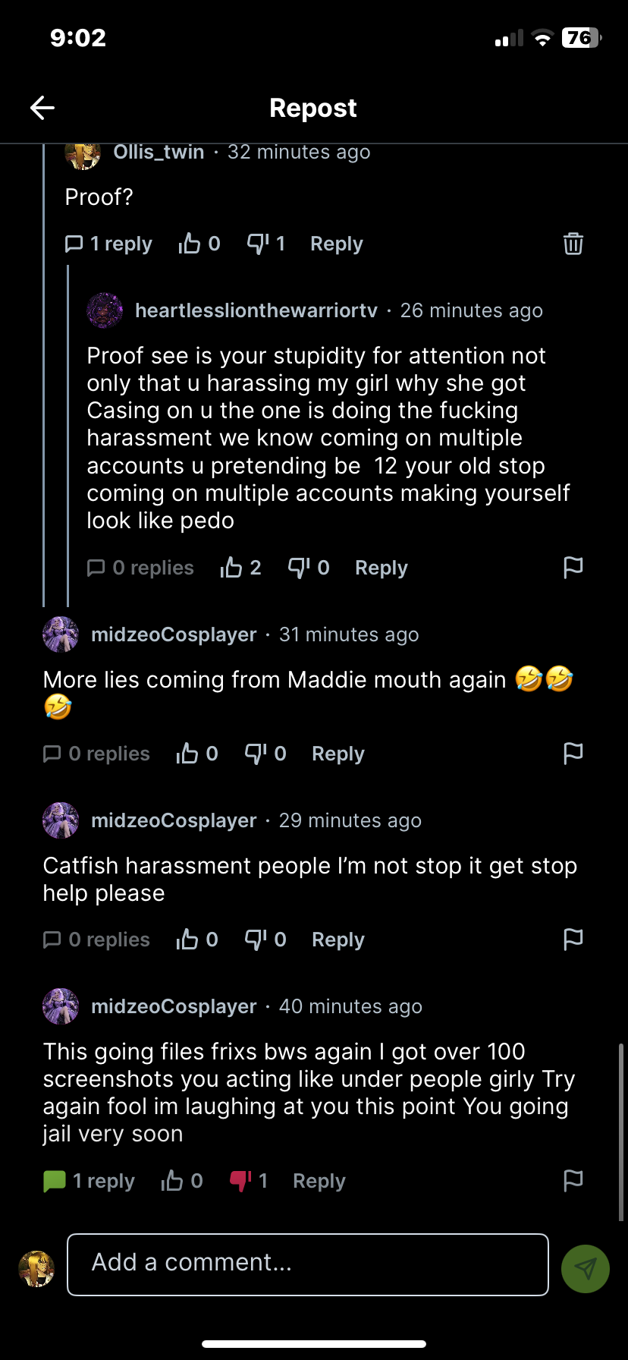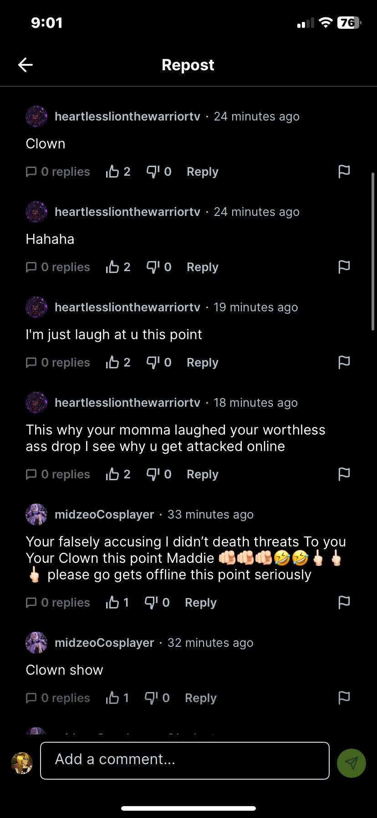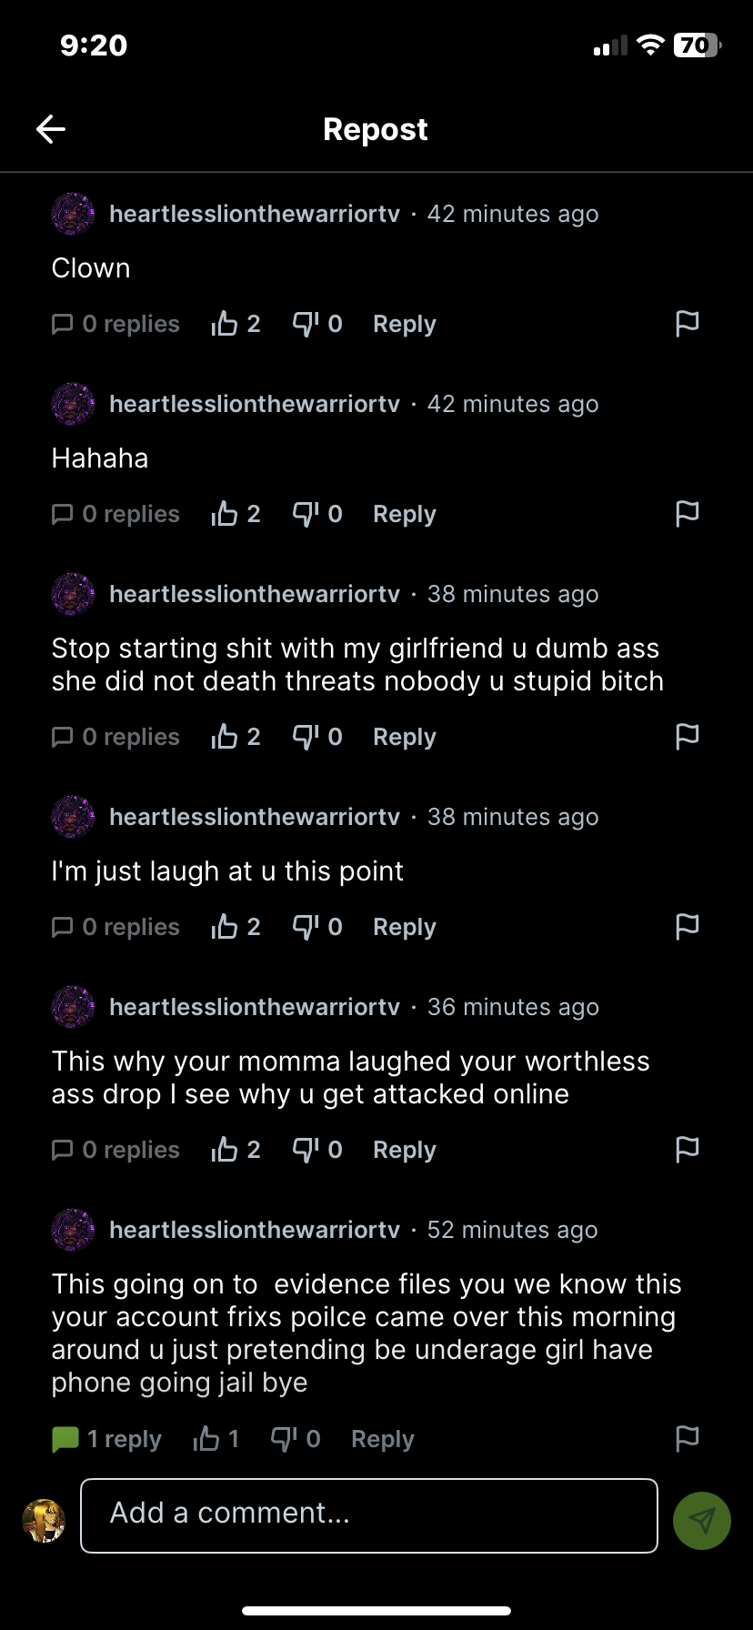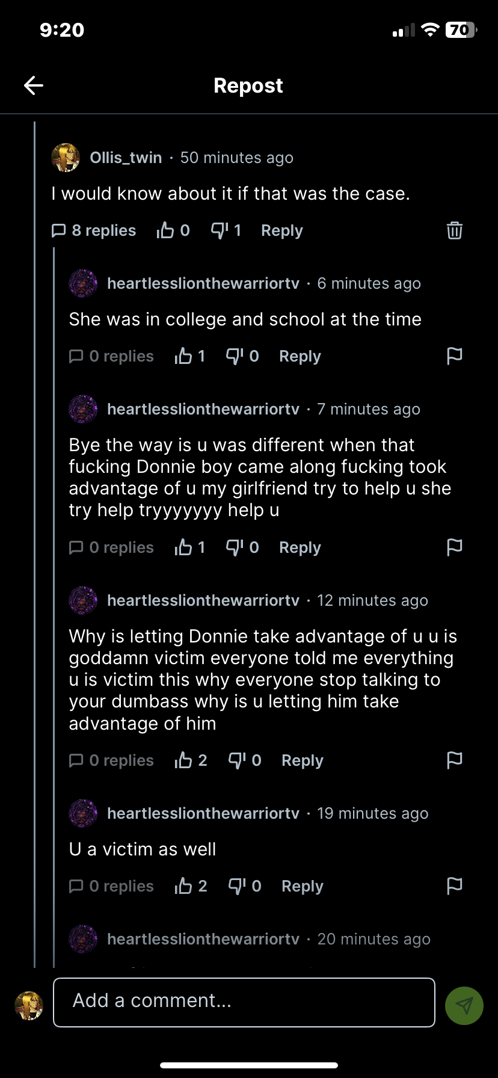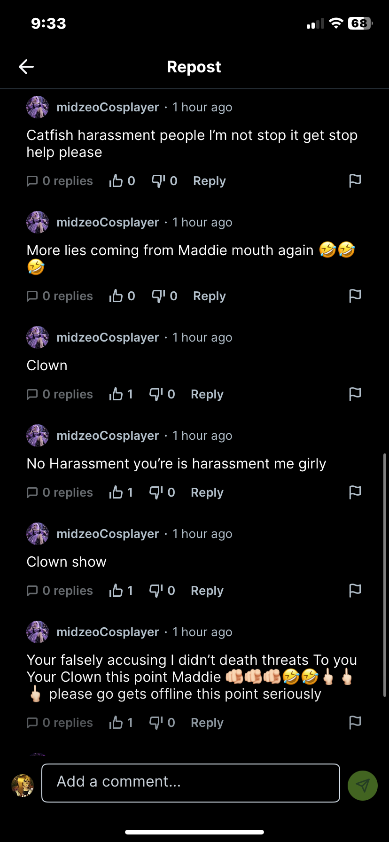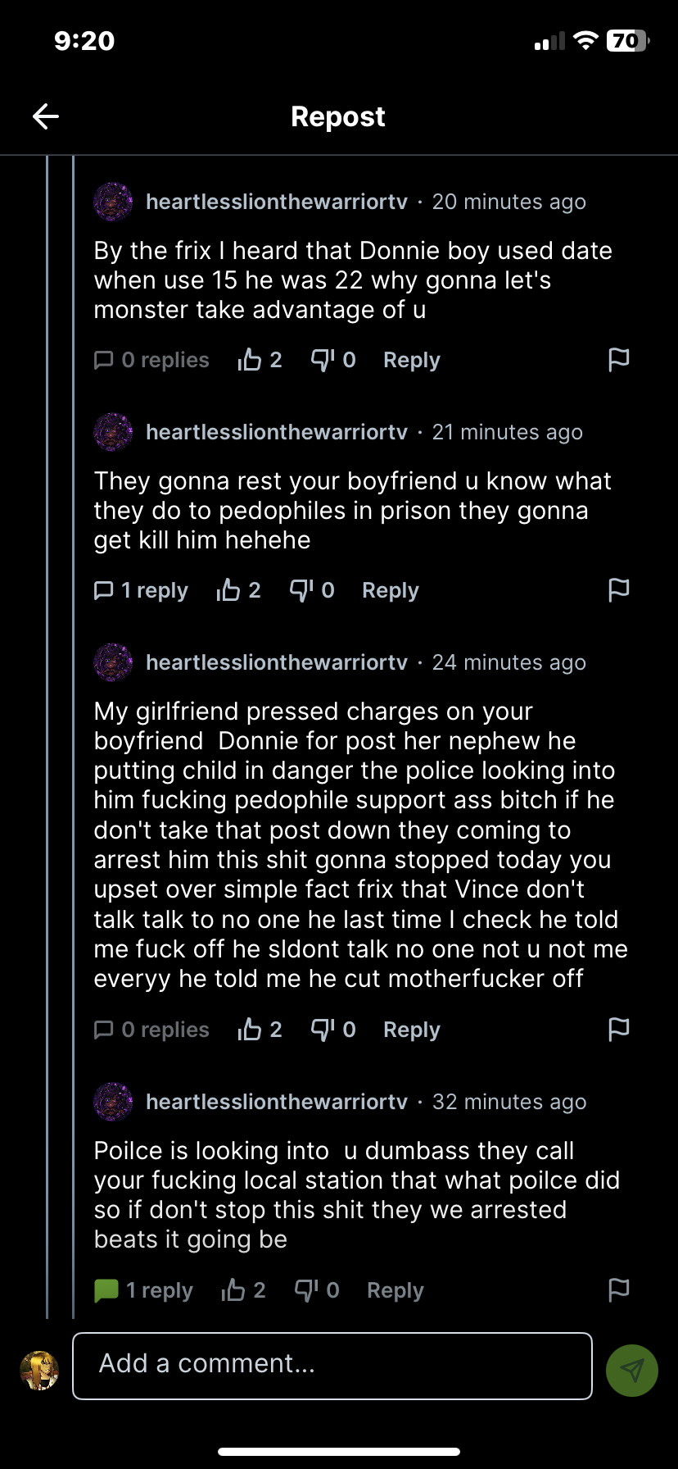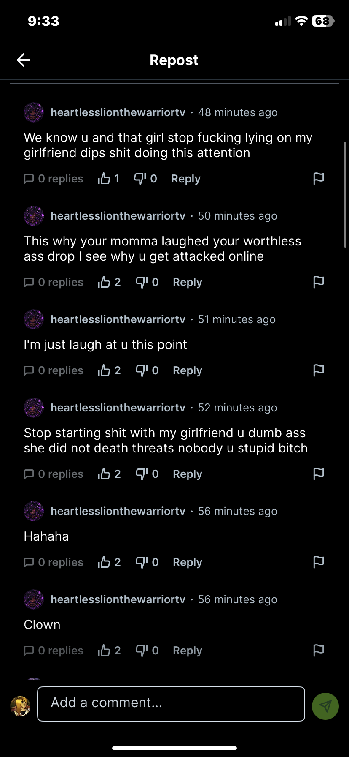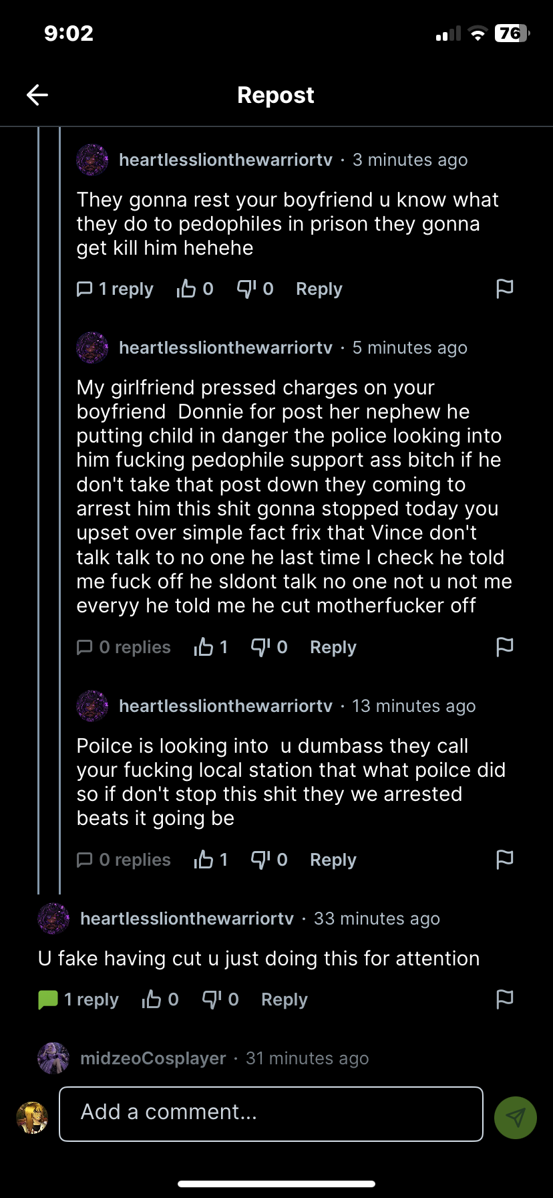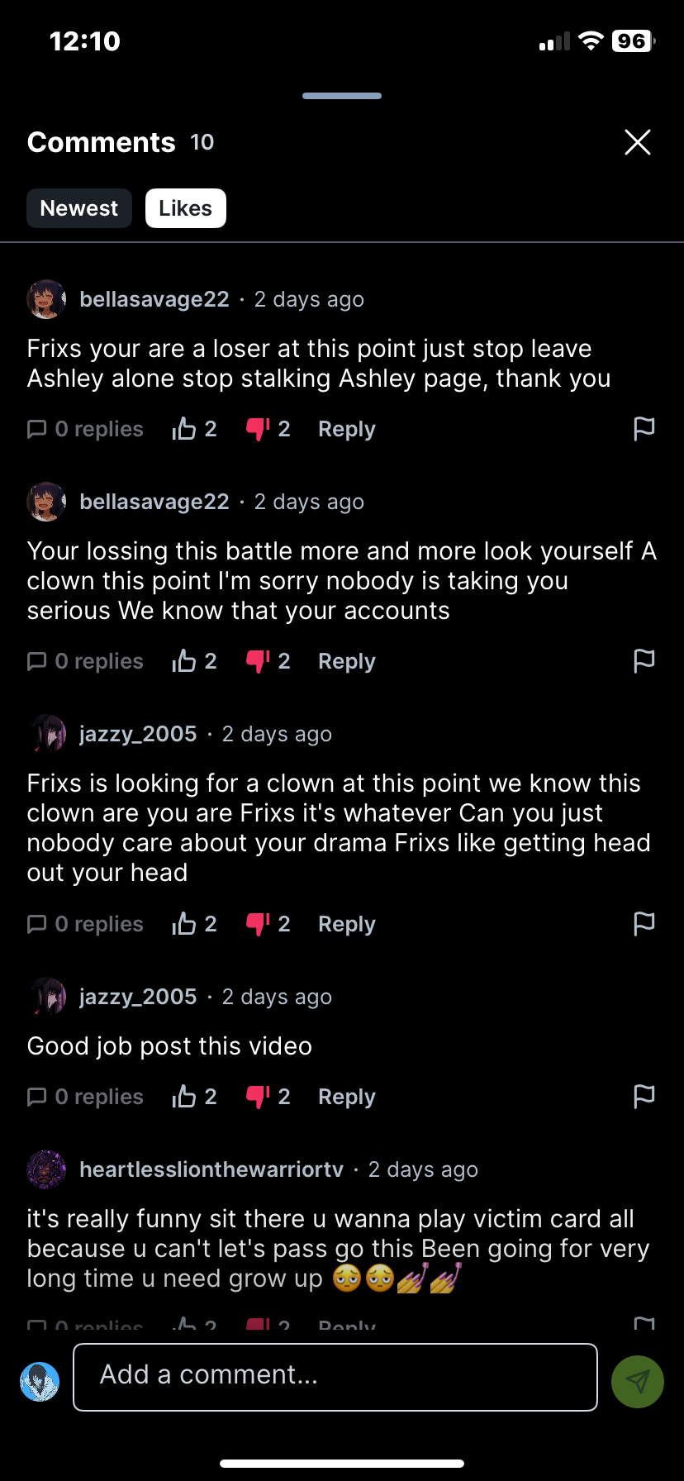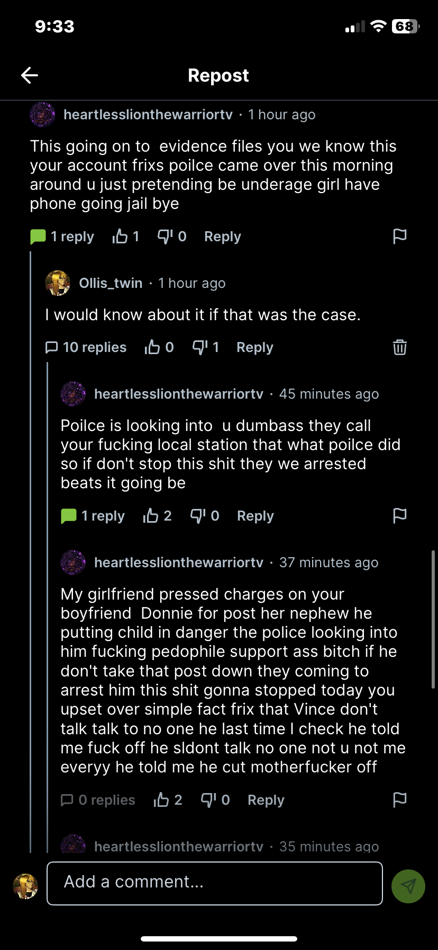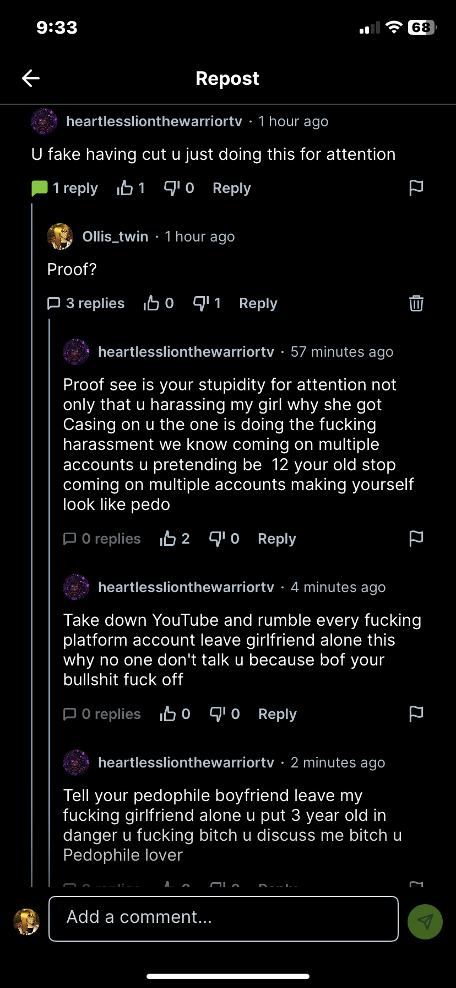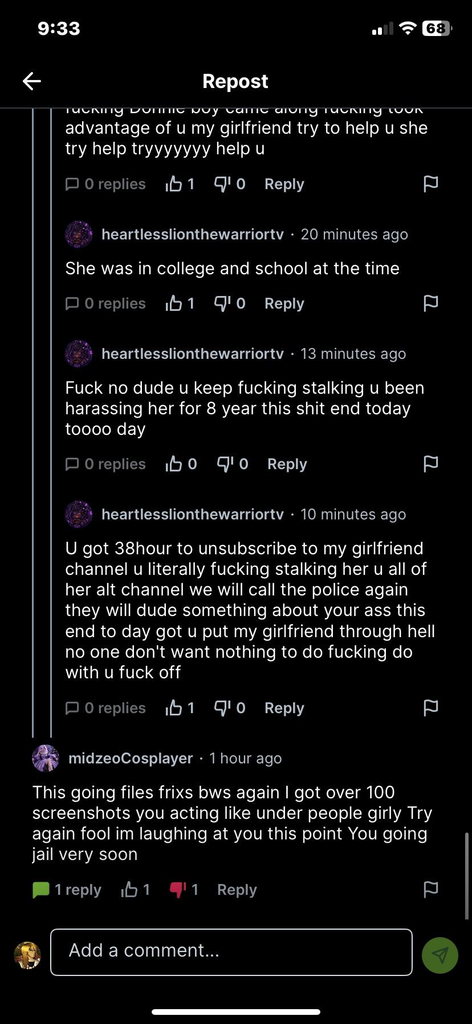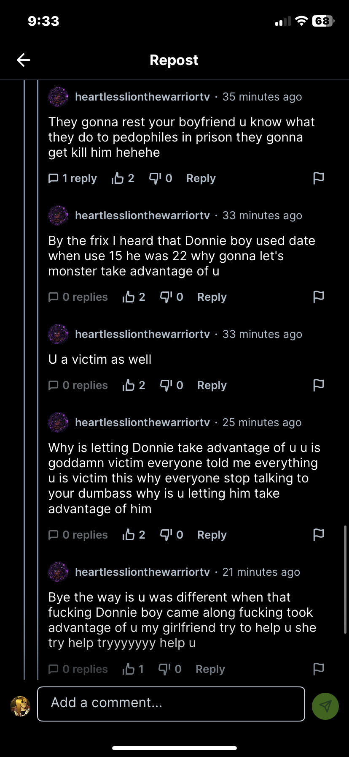

NX: I was sitting around playing games with my friends when one day I got a ping on youtube. When I checked the account it was someone I didn’t recognise at first and then they claimed I was a part of 764. Then Ashley’s goons started harassing me on their accounts and then they started to threaten to report me to the police. After I had gotten a friend request from Damien and I got in call with Damien, questioning him about his relations to Ashley and then he said that he was gooning to my voice. Then he left, blocked me on both of his accounts and then a week later he sent one of his goons to threaten me. After the goon added me he told me he was sent by Damien and then he tried to make a deal with me to leave Damien alone to get Ashley’s server.

Then I questioned both Damien and his goon in a group chat, which I got kicked from. Then they sent a video an hour later saying that they reported me to the police and then he blocked me again.

Doniboy here
I'm pretty easy to upset or frustrate in general in all honesty, but it's genuinely difficult to get me to truly hate someone, like not even wanting them to get better, just wanting to disappear from everyone's lives one way or another.

I'll set aside the predatory things Ashley Partin has done for the moment, as I'm not among the victims, so there's nothing new I can add. Instead, I would like to share my personal experience with Ashley. It isn't as fucked up as the experiences victims have had, but it gives you some insight on how Ashley is down to the fundamentals of everyday human interaction.

I'm not one to care about policing "problematic" language anymore, but I used to be strongly and vocally against it. I'm not entirely sure how long I've known Ashley since the event I'm recalling happened, but there was an account calling people the n-word constantly, and it was against the rules in Ashley's server. Despite our rocky acquaintanceship at the time, I informed Ashley about the situation and her friends attacked me for it despite my desire to help. Ashley then pretended to have a mental breakdown in the general chat, which only fueled more vitriol against me.

This is NOT the only time I tried to help Ashley only for my hand to get bit. I warned Ashley about two people calling themselves rose and ghostface, how they lied about everyone and constantly caused trouble. She would present herself in a way that seemed like she was hearing me out, but despite obvious red flags, she sided with them, and I would always get grilled. Ashley is not one to generally lead a charge in the general sense. She has before, but her method more often than not is to play victim in order to convince others to go after whoever she deems is responsible for her trauma.

Ashley also has a horrific tendency to create accounts and pretend that they're different people when she was operating them, and l've experienced this first hand. The real horror comes from when she has these fake people commit suicide to induce sadness in other people. I've spoken with Ashley, "Ashion" and "Zoey Jackson" multiple times, and each account's voice sounded the exact same. I was still in the group when both "Zoey Jackson" and Ashley "committed suicide" and I was nice enough to give the benefit of the doubt and be there for "Ashion" (keep in mind that I was not aware of Ashley's actions at that point). What's hilarious is that she ended up just bringing Ashley back out of nowhere. She's also used a voice changer to play another fake person on a YouTube channel that she targeted me for with harassment despite my minimal and truthful criticisms (both videos are still up).

Delving back into the predatory behavior, there is not a single person who has come close to having the colossal negative impact Ashley had on us. Our lives orbit around her to this day. I have personally spent massive portions of my life trying to get Ashley to just go away, and I've invested a lot of time trying different things in order to do so. Me and Frix's lives have essentially been pissed away just trying to recover. Even our relationship has been negatively affected by Ashley's chokehold on her. There are just so many domino effects. (AS OF WRITING) I have to wake up in four hours to finish packing and move out of the home l have lived in because I have a life that I can't separate myself from, and if it weren't for the fact that we're throwing everything at the wall to make Ashley in a desperate attempt to make Ashley go away, l'd be sleeping by now.

To sum it up, I have experienced Ashley's manipulation and harassment, and I'm picking up the pieces of someone I love dearly, which breaks my heart so much. I imagine that I'll be back on Ashley's menu for the next two weeks after she discovers my participation in the document, and I will not be responding to any shots aimed at me whatsoever.

Hi, my name is TheeFrixxtwin aka OliverLoon. Please call me Oli or karma. I heard of Ashley in 2025 when she was dating an old adult friend of mine Kilvix. Ashley at that time went by the name Suko. She hung out with Andrew Hamilton who groomed me for a year and dated Aubree live studios in 2024. Andrew, Ashley, Tara live, Kilvix, and Aubree all were in DDs friend circle including me and others. Ashley hung around dd live and Aubree and that's how i knew of her.

June 2026
In the beginning of June of 2026 i split from dds friend group. And when I confronted dd on his lies on his stream, he got his girlfriend and his friends to go after me. Braveheart (david Goodman) Greenranger aka FBI Agent ( Randy Mitchal) AubreeLiveStudios (Aubree Simpson) And there was Ashley Partin going by MidZeoCosplayer in his youtube chat kept saying that i was actually this person named Frix and that i was lying about being a minor.

I posted my story on the DD case and the fact that she was accusing me of being someone else. Ashley went after me, reposting my posts saying i was attacking her and harassing her and that I was pretending to be a minor to get sympathy.
. When I went to her page for the first time I saw a video that said "Awareness about Frix” or something like that. I saw her face and laughed. I mocked the video and posted it to my rumble and tagged her just trying to make humor that she believed I was an 18 year old that she was so mad at.. Next thing I knew i was getting attacked by David (ashleys bf).David Goodman aka Ashlys current bf started calling me fat,that i eat too much mc donalds and saying how i should kill myself. Ashalsy with her many profiles commented under her rumble posts mocking my weight and so on as well. I may have an eating disorder which causes me to think about my weight and to think about what I eat. So this affected me a lot. I was friends with David so seeing him betray me all bc i was speaking out against Randy Mitchal aka FBI Agent (Green Ranger) just stabbed me the wrong way. Every single day they would post Ai distracks, A.I my face into a clown or a pig and mock how I looked. And continued the fat talk. I think i told David that i was starting to develop some kind of eating disorder when we were friends i think so the fact that would use that against me to get me to hurt myself or to commit suicide bothers me.

COMMENTS (Screenshots Below):

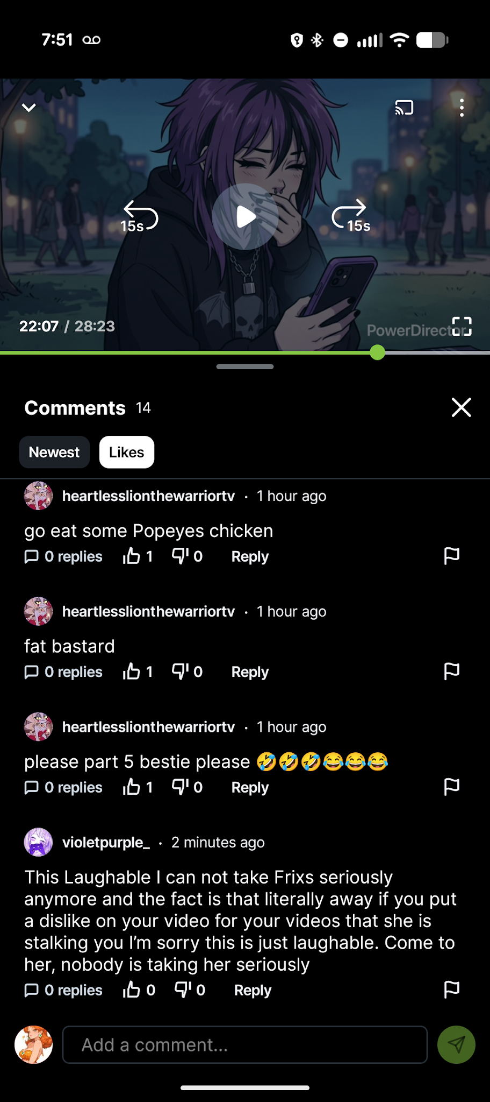
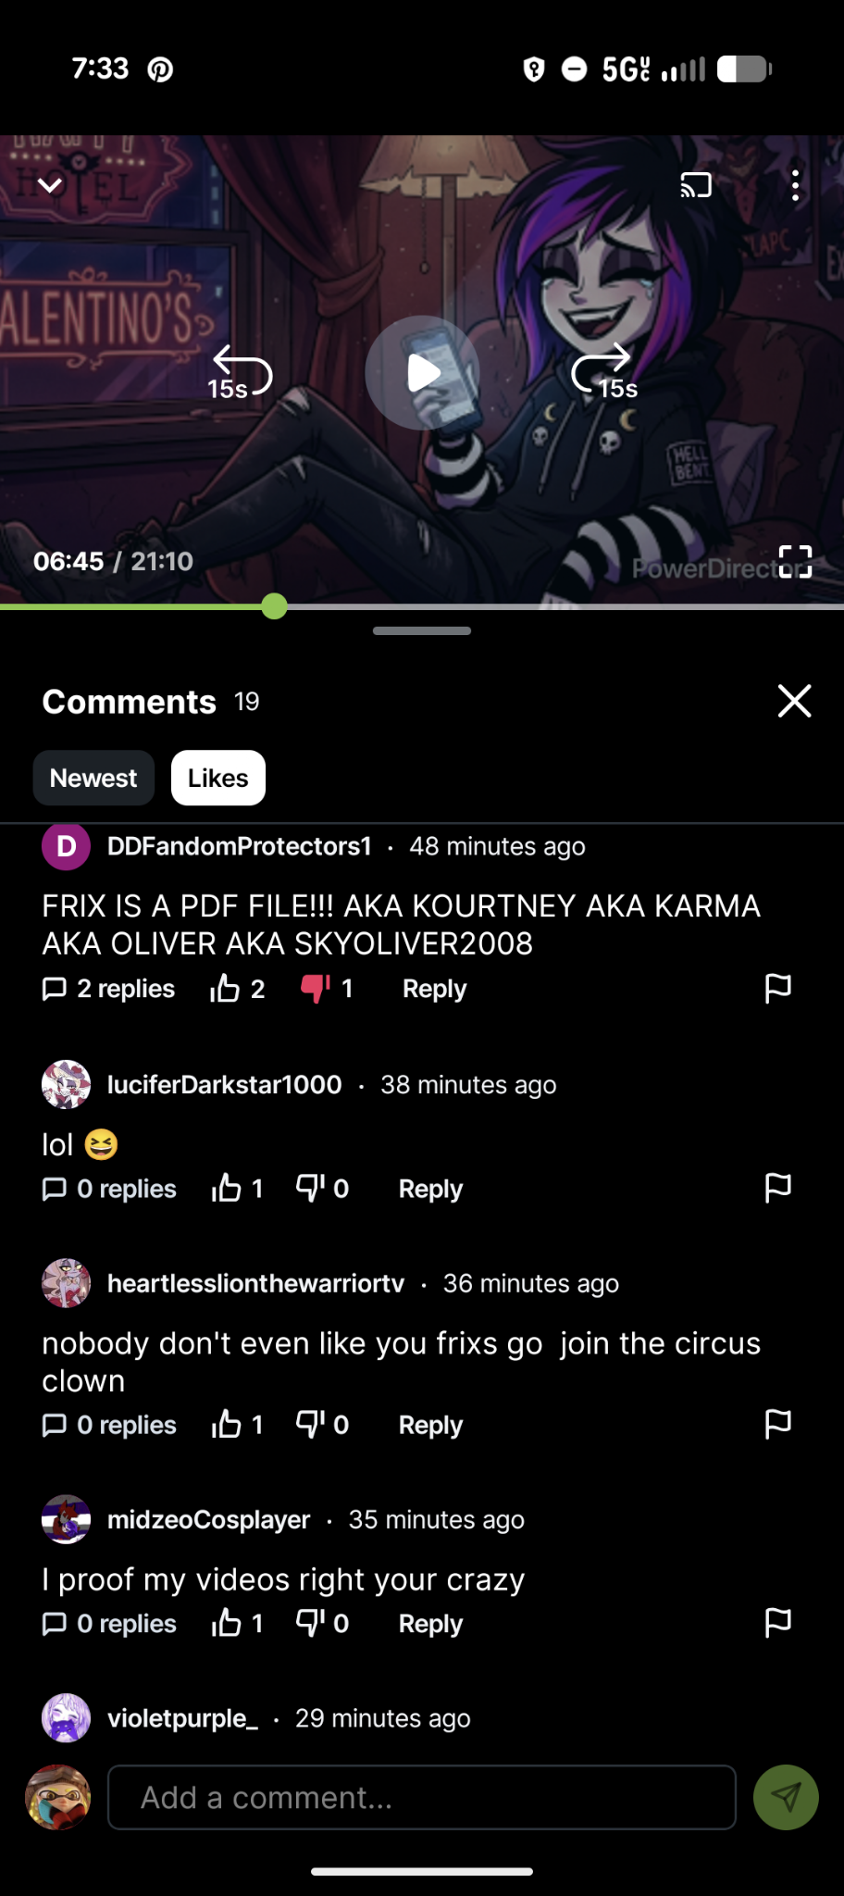
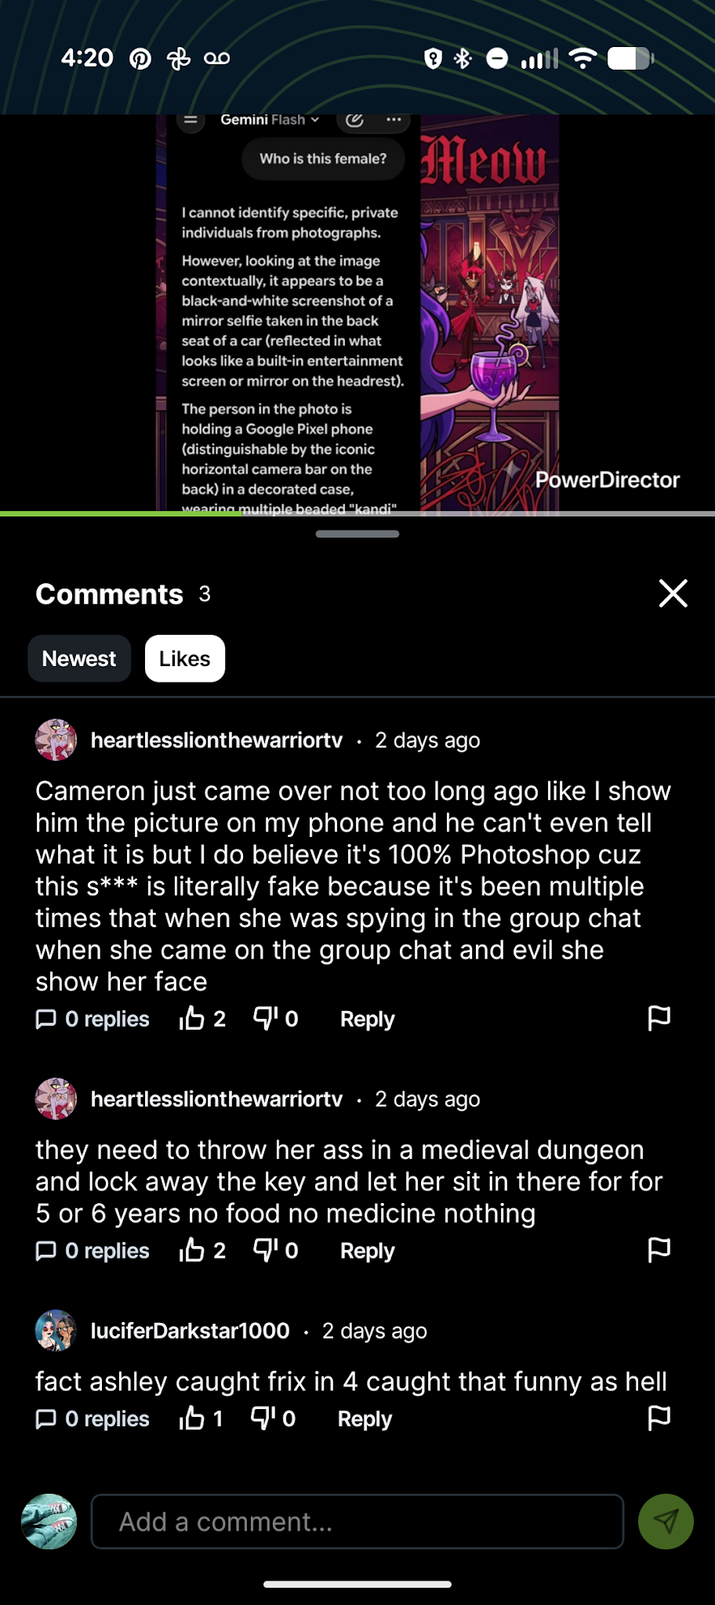
AI/ VIDEOS
(many more on rumble @MidZeoCosplayer (Ashley's rumble page)
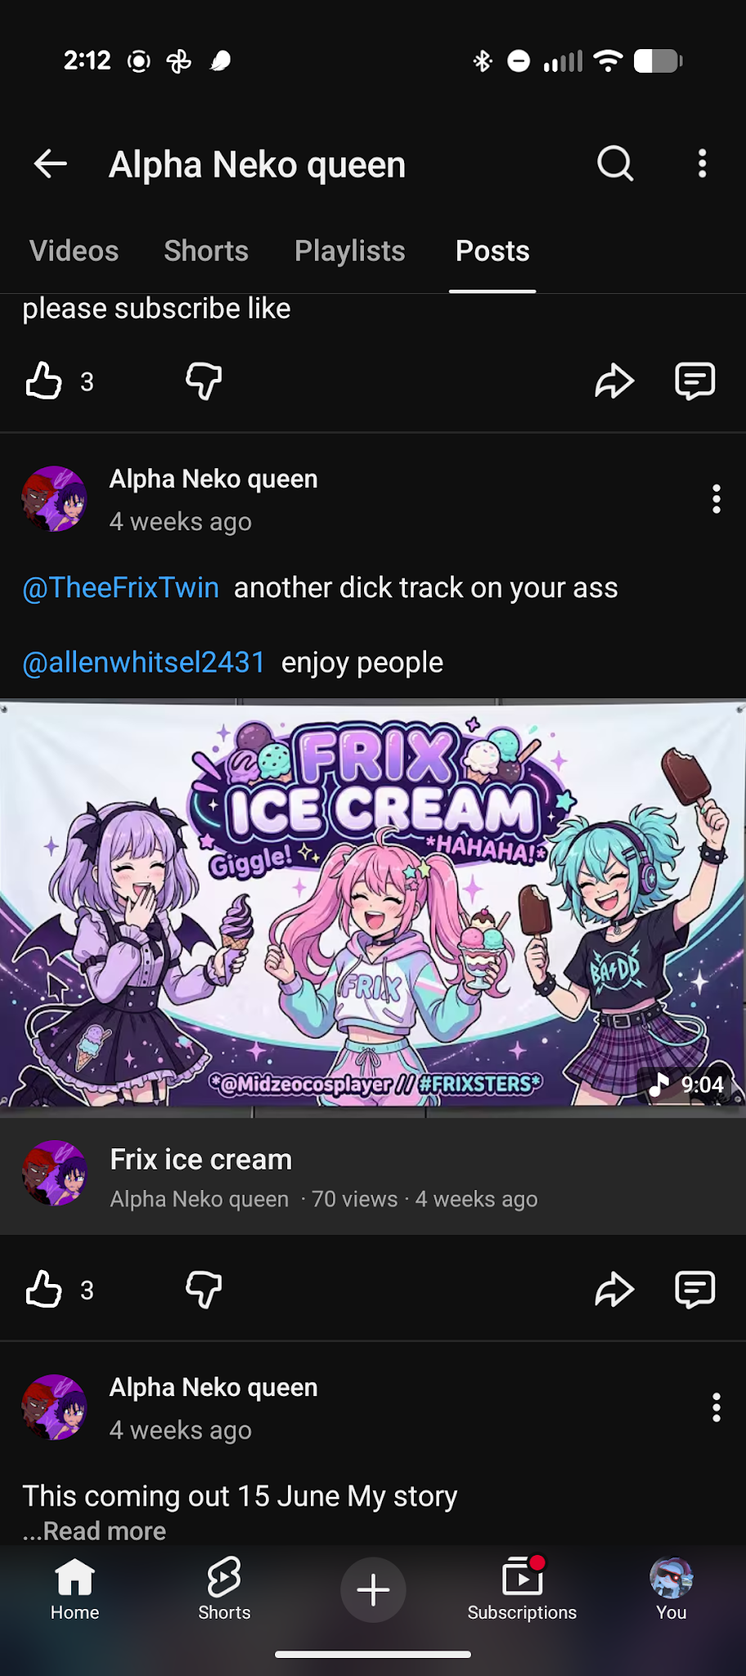
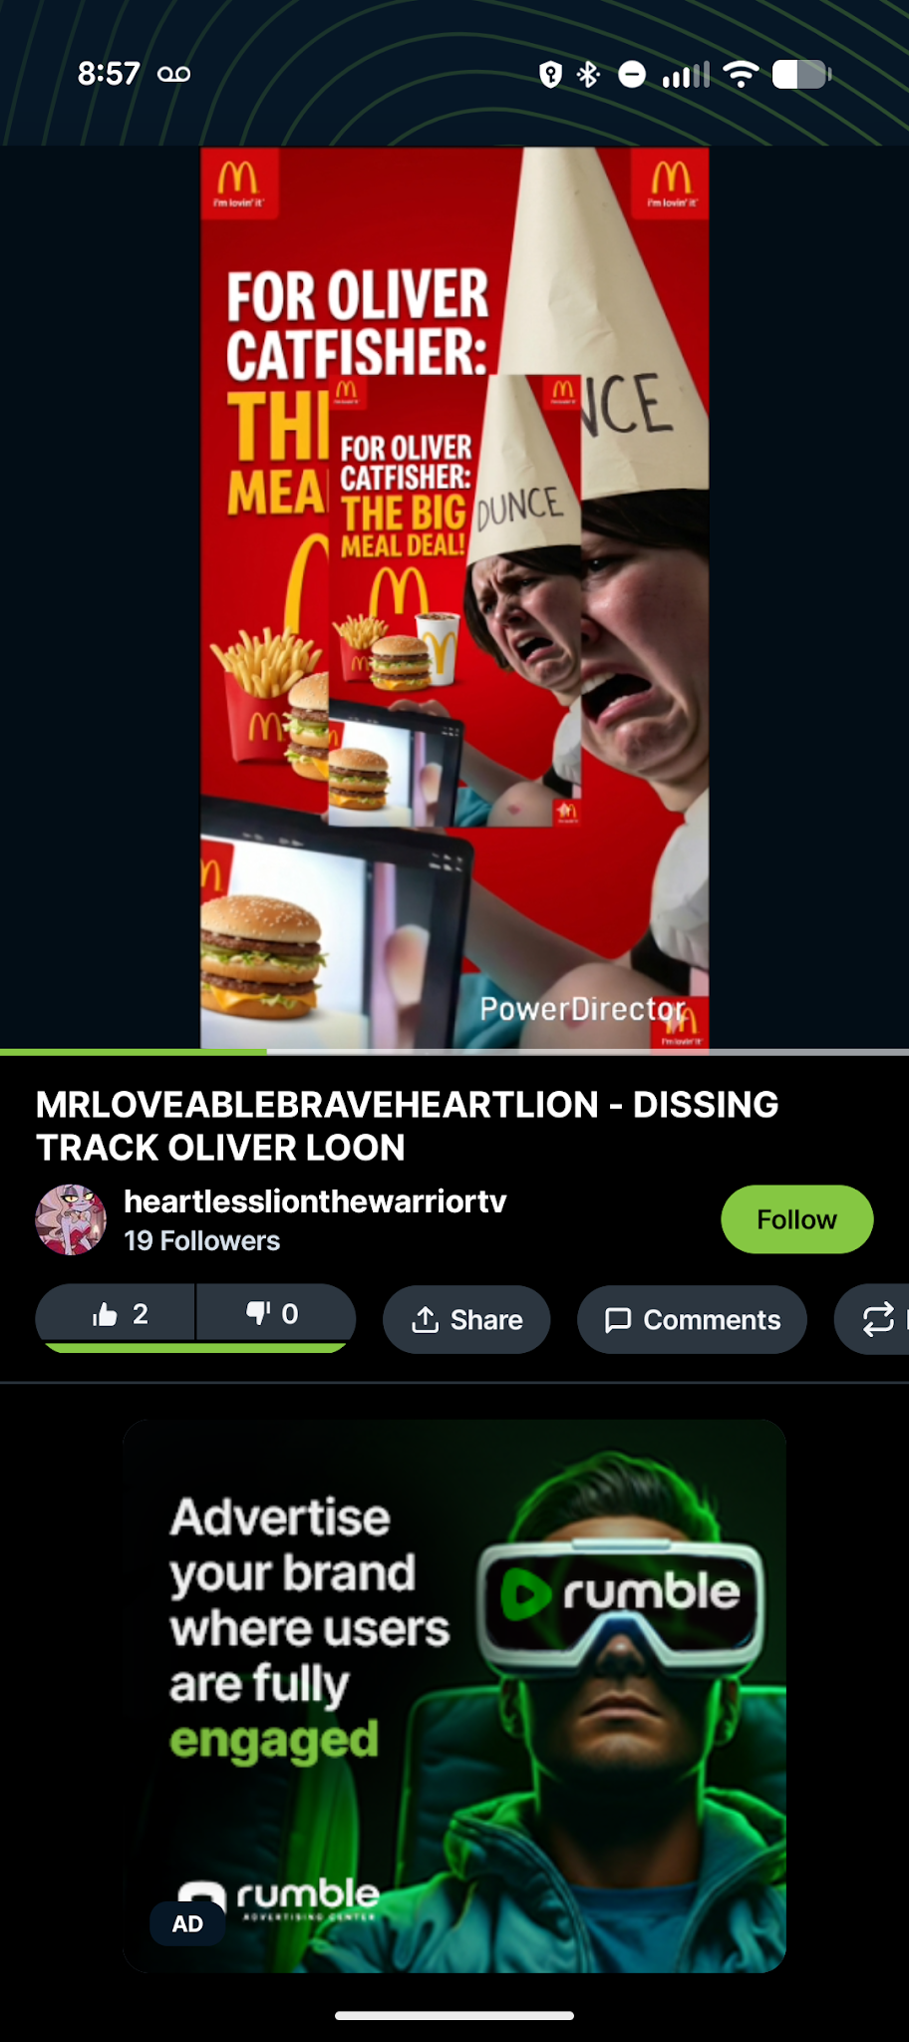

David and Ashley began to spam me with messages. Once I figured out who the real Frix was and after she told her story I knew I had to step in. So I played the role of her.

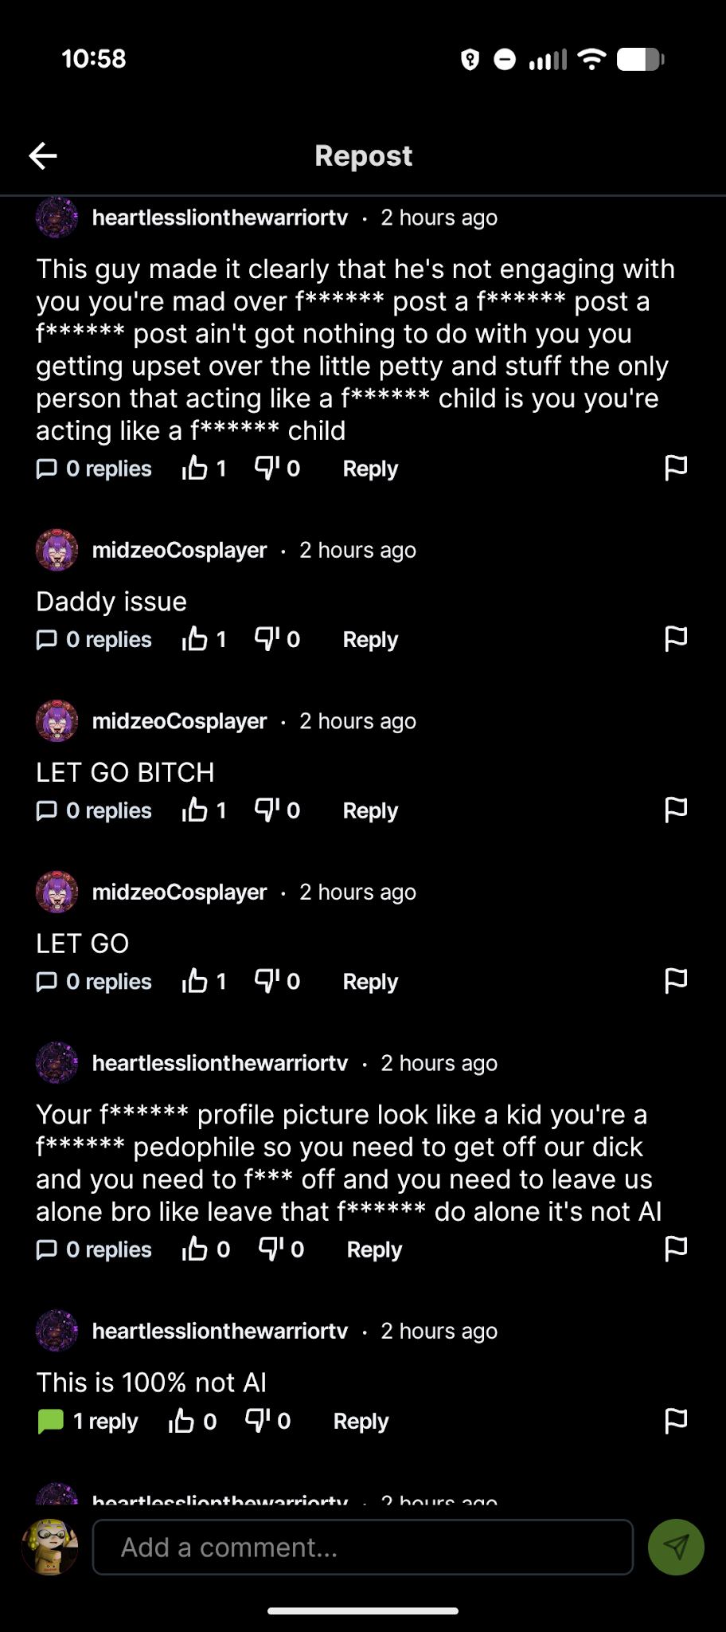
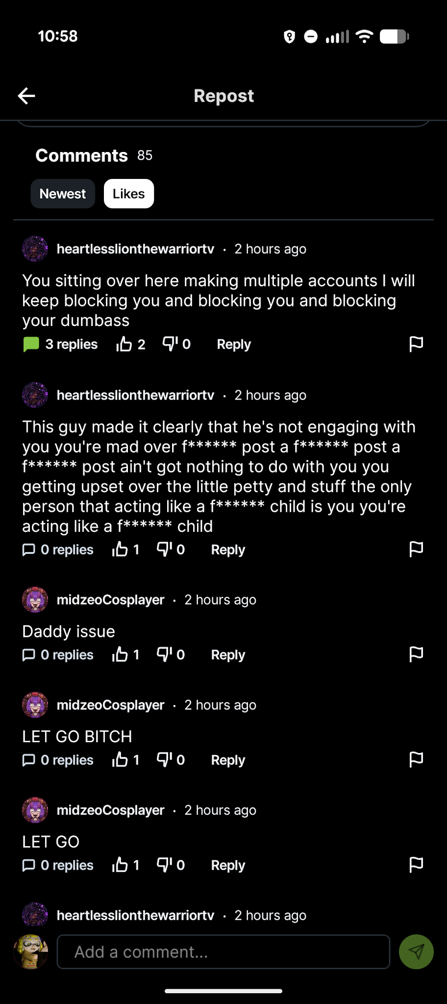

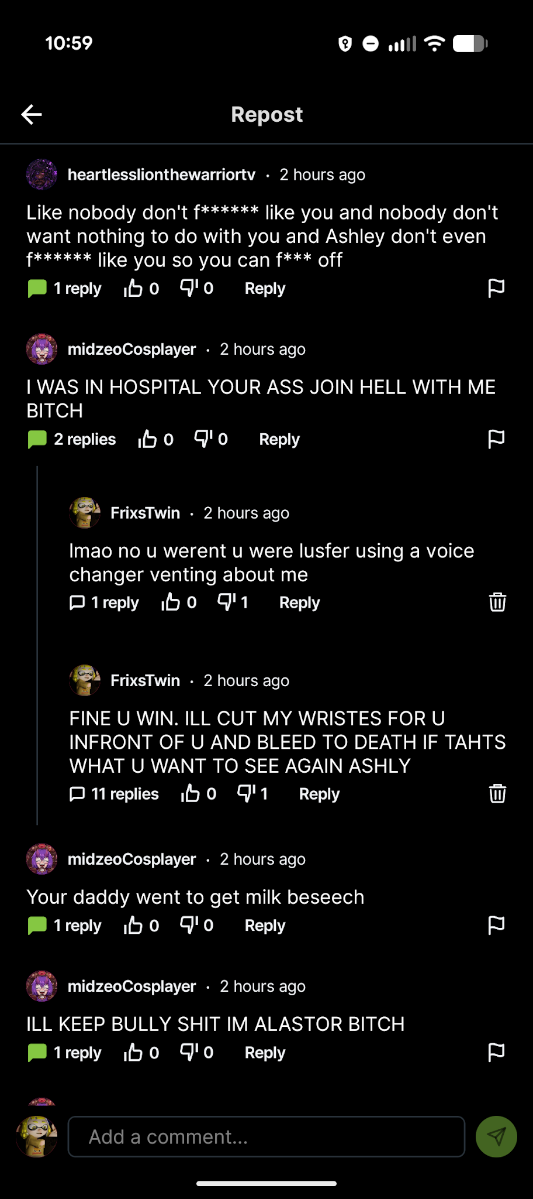
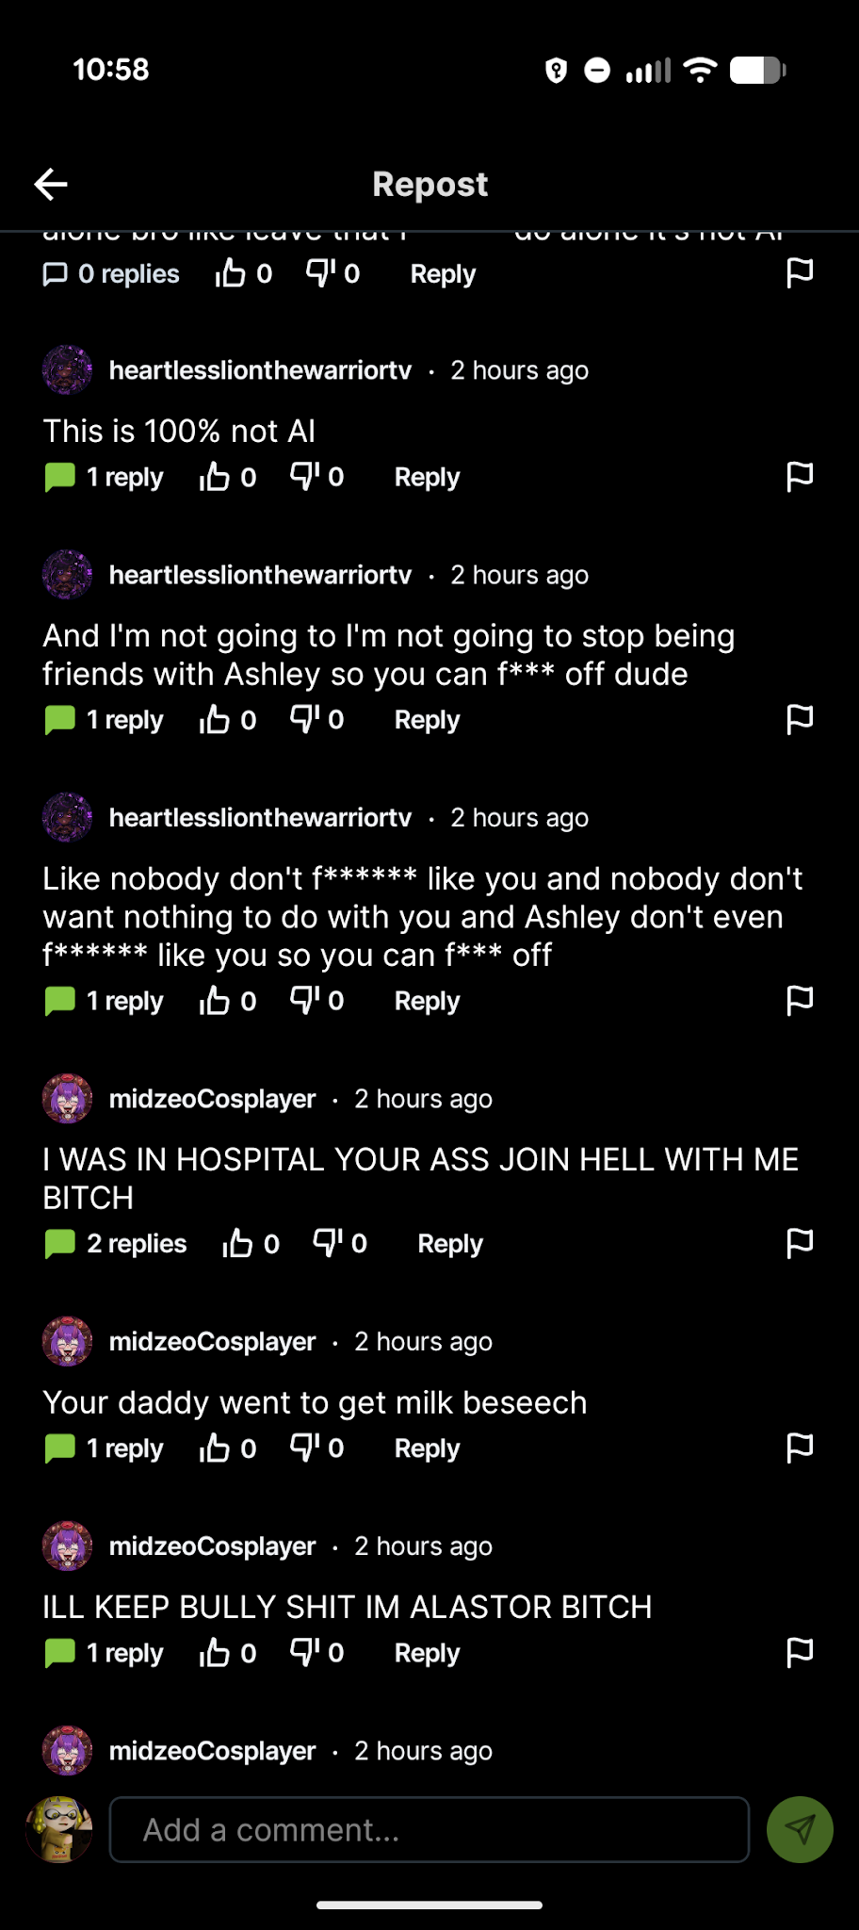

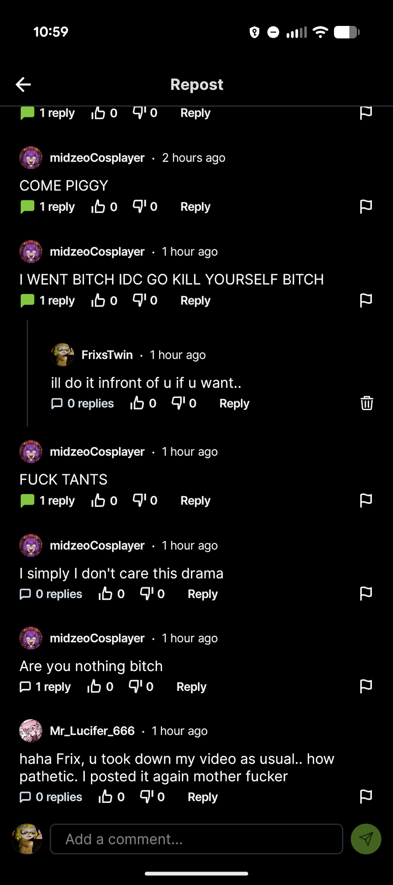
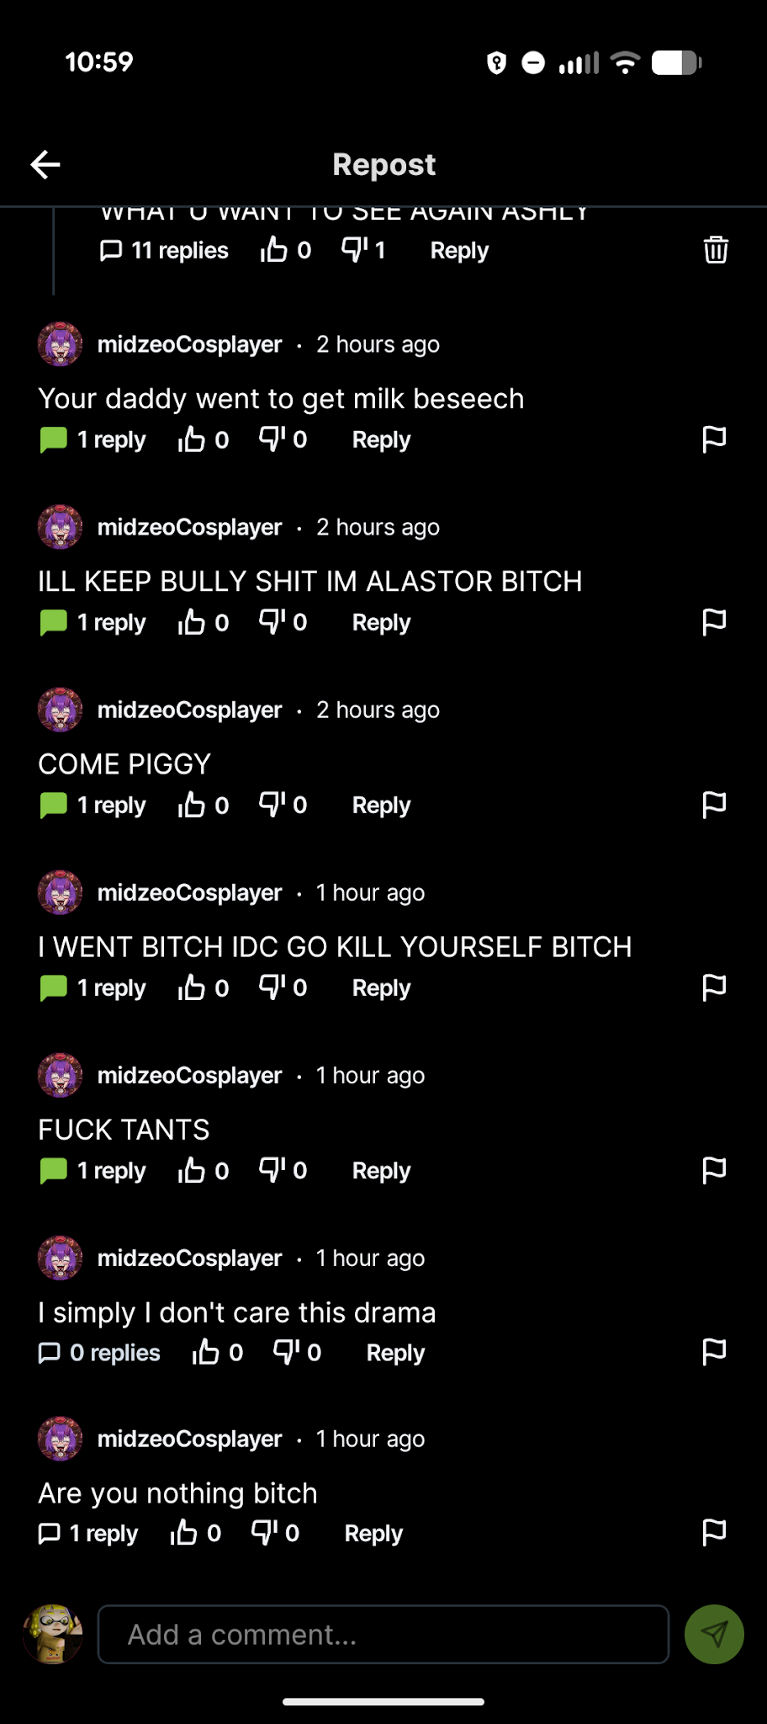

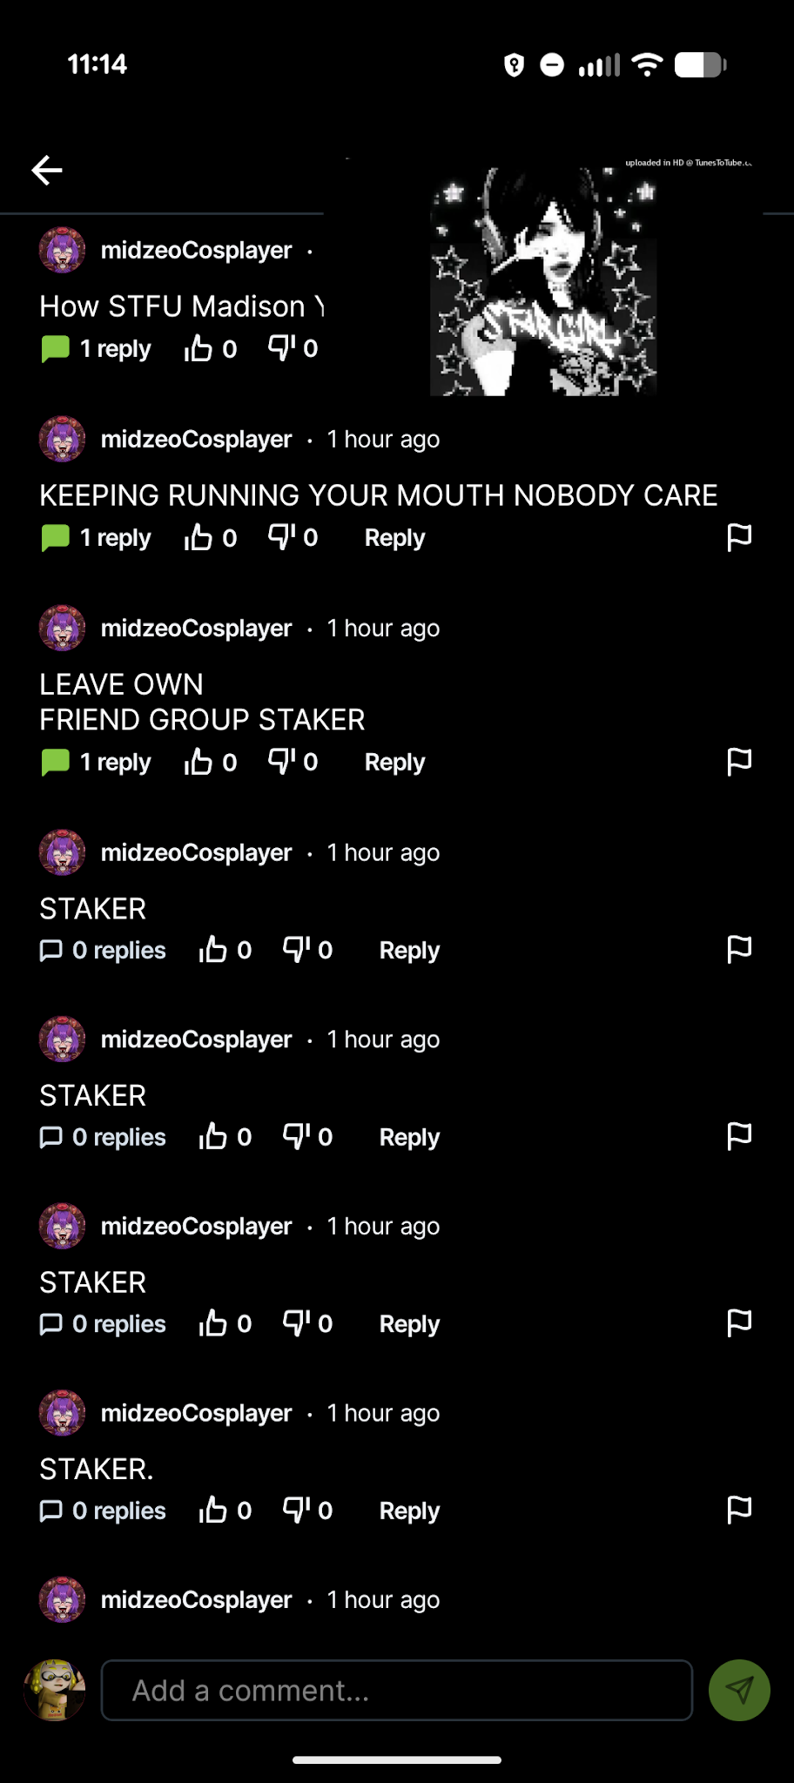
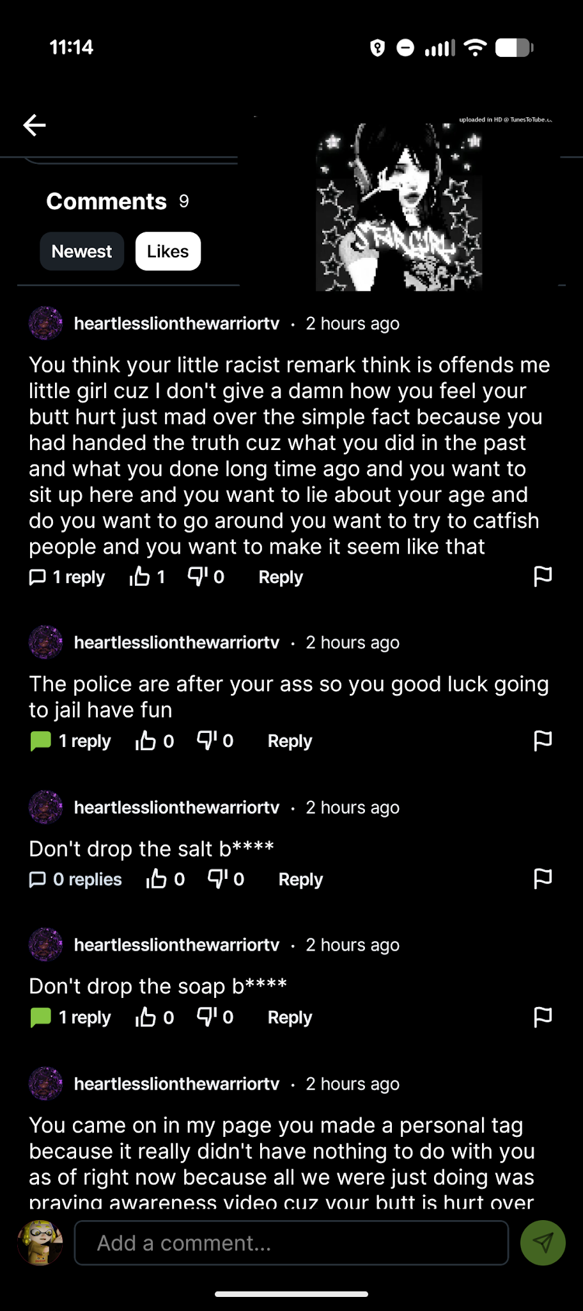

At the end of June I lost it. I was manic and couldn't think straight but all I wanted to do was to save Frix and not let her suffer after all Ashley had done. So I sent my nudes pics on Rumble to make them believe I was Frix and slit my wrists. Ashley, and David told me to kill or hurt myself, so I did it on video. Then Aubree, Randy, and David commented under my posts with abusive comments.
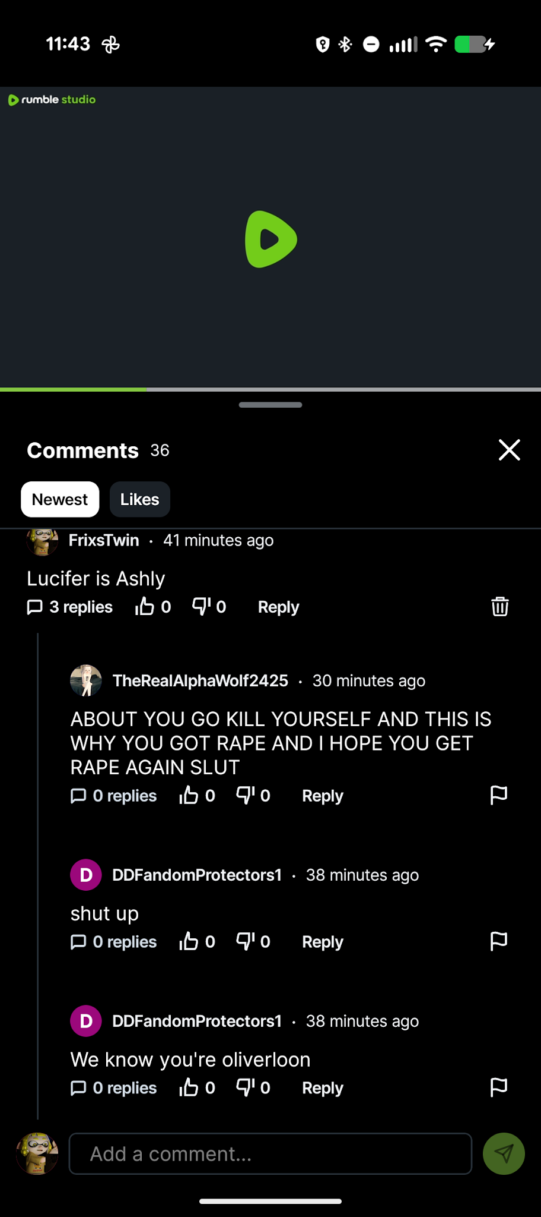

As of the most recent things that have occurred, there were two recordings that were done with the following people:
Ashley Partin Confrontation - June 16th 2026
- Ashley
- Braveheart (David)
- Doniboy
- Frix (me)
Ashley Partin Confrontation - July 3rd 2026
- Ashley
- Braveheart (David)
- Whiskey/Kei
- Frix (me)
- Brief mentions of Slick, Rose and Kon.

Ashley’s Identity “Crisis”
Strangely, something I haven’t really gone into depth about Ashley’s “DID”, or was it her “Siblings”? Either way, something that’s always fascinated me personally about Ashley is that she has so many alt accounts that she either pretends to be her “DID” alters or her “Siblings” to get her out of trouble.
I (allegedly) had an admission from Gosui, a close friend of Ashley's, about these being real people and he had (allegedly) told me that Ashley was faking being Zoey, Ashion and all the other people she was to get herself out of trouble. Ashley always used to claim that Gosui, Rose, Whiskey and others in that space had MET Ashion and Zoey in real life. However both Gosui and Whiskey both told me the contrary, that they have never met Ashion a day in their life.
In the 4 pictures below, that is Ashley’s face. Now normally I wouldn’t like to include other people’s faces; however Ashley has stolen content from other creators and claimed she was these people, stolen the identities of actual people and used these likenesses to try and get away with slimy, shitty behaviour (Allegedly). In the screenshots below her face she has tried to claim that she was all these people, 2 of them being taken from real tiktokers.
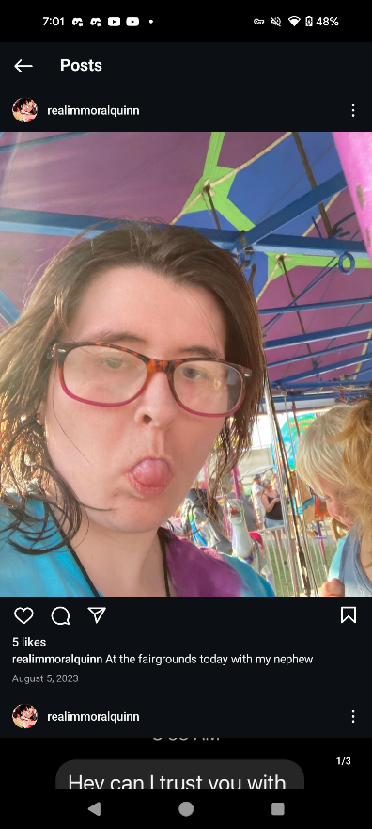
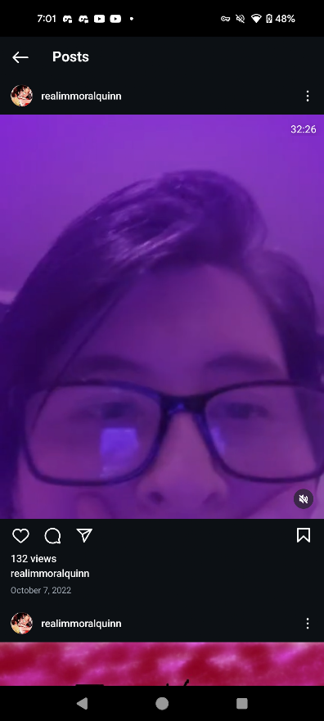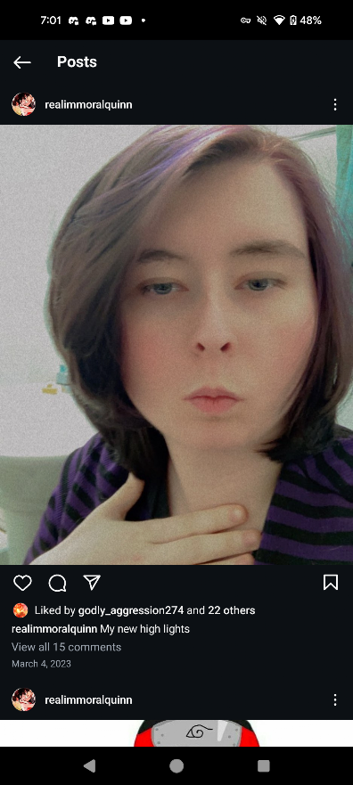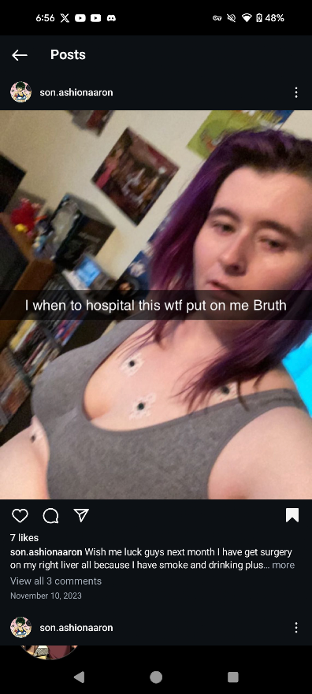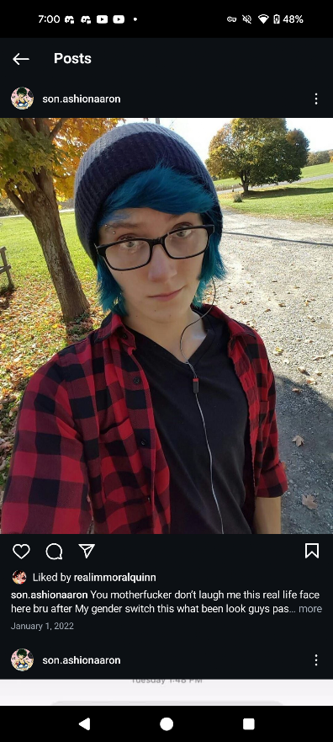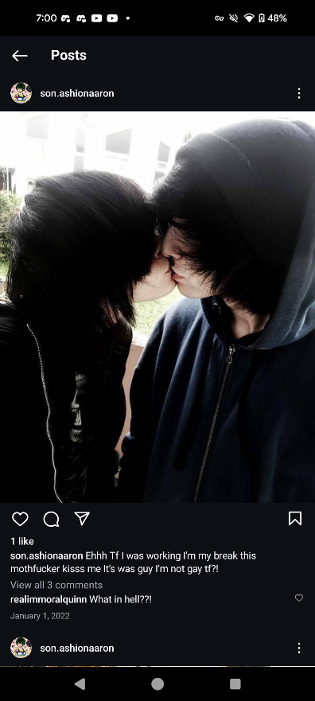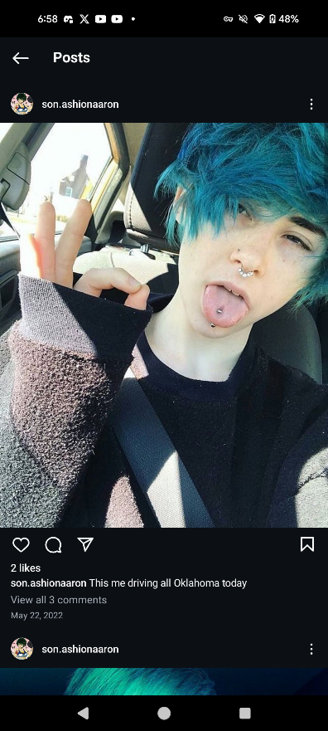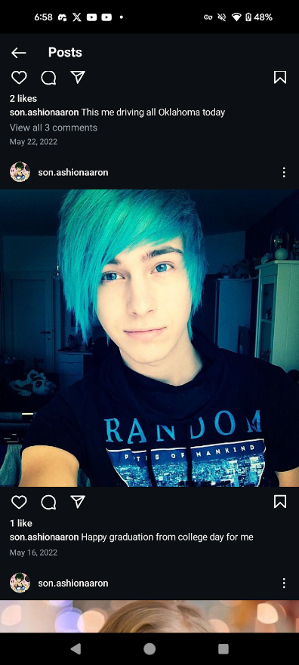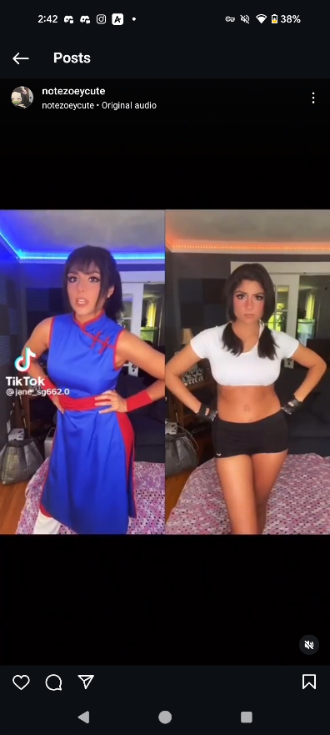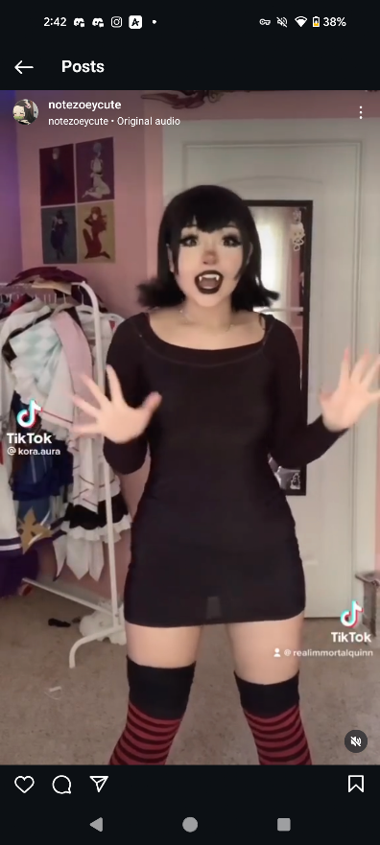

Legendary Screenshots
