Antumbra’s big class analysis! :]

[metafictional archetypes.]

My methodology:

For this analysis, I attempt to group classes not into pairs of 2, but into groups. Of 3. Each class is grouped into 2 different groups of three, one showing how the class grows and changes throughout the story, and another what they set out to do in the beginning. They are sorted into these groups using 2 sets of 2 2 answer questions, giving us 8 groups. [2^3=8] I then assign each group a characteristic and explain its implications.

The developmental quadrants.
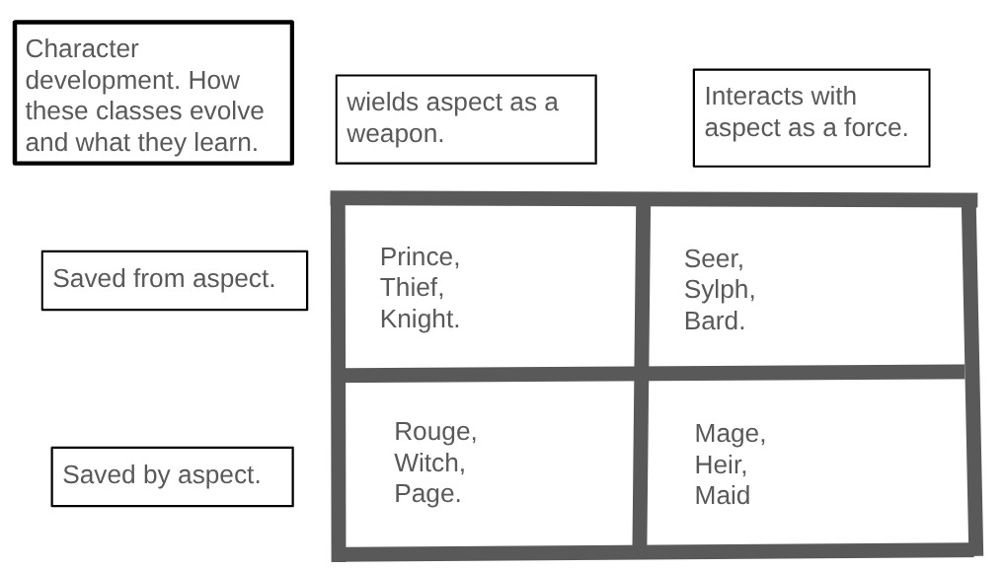

The above graph groups the 12 classes into 4 quadrants. The 4 quadrants are based on two axes. On the vertical axis, we see the classes split up between those who wield their aspect as a weapon, [prince, thief, knight, rouge, witch and page.] and those who interact with it as a force.[seer, sylph, bard, mage, heir and maid.] On the horizontal axis the classes are grouped based on whether throughout their character development they are either saved from their aspect, [prince, thief, knight, seer sylph and bard] or are saved by their aspect. [rouge, witch, page, page, mage, heir, maid.] this one’s a little harder to understand, think of it like those who are saved from their aspect, use their aspect to unhealthily cope with the world around them, or straight up have all their problems come from their aspect outright. Think of dirk’s fractured sense of self, or vriska’s obsession with constantly being in the spotlight. In both cases, the character's downfall comes from playing into their aspect too much. Classes who are saved by their aspect, which comes to their aid when they are in a tough spot. Think of it like how Tavros is initially manipulated by Vriska, only to become happier by reaching his potential as a breath player and leaving her.

The developmental trios.
Next up are the development trios. Each is made up one of the aforementioned quadrants, with each one having its own trait associated with it.
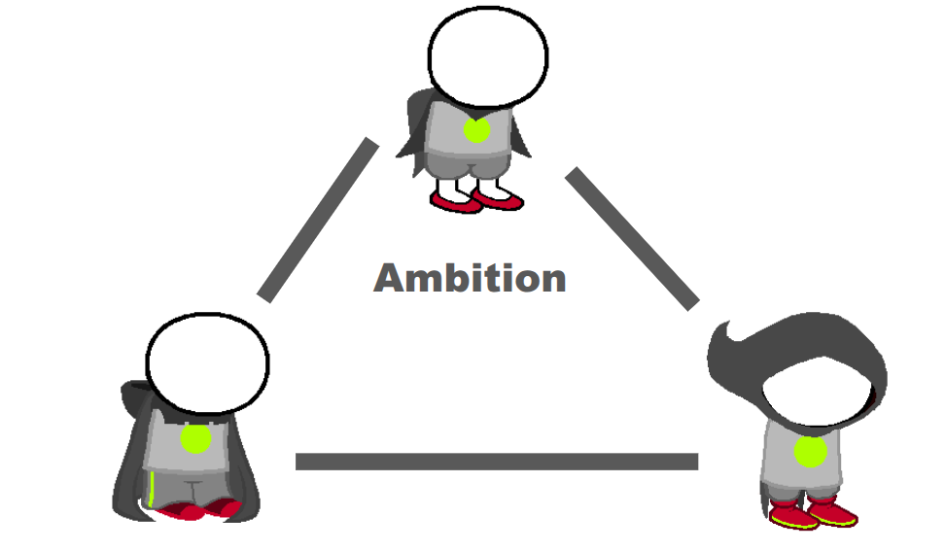
Ambition. Those who wield their aspect as a weapon, and must be saved from it. Princes, Thieves, and Knights. Ambitious classes realize that they have the potential for strength, and ceaselessly seek its realization. At their best, they are determined and skilled. At their worst, they are reckless and beholden to frequent cases of tunnel vision.
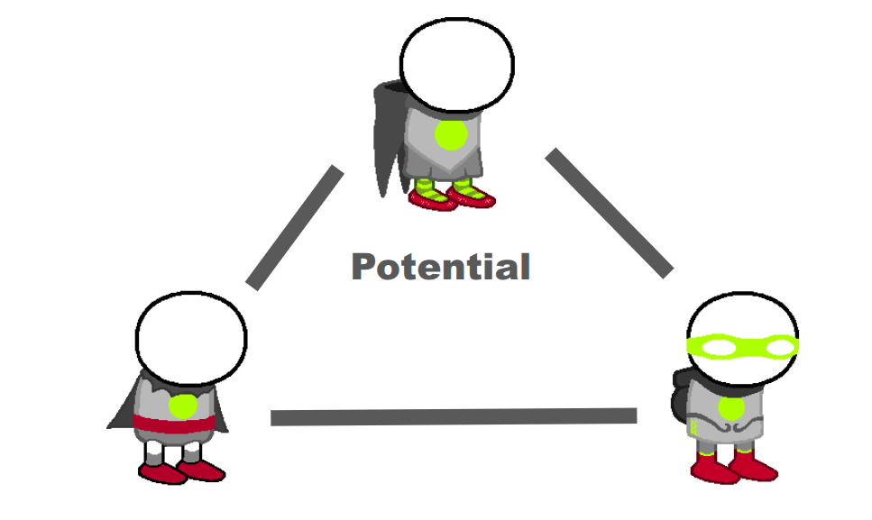
Potential. Those who are saved by their aspect, which they use as a weapon. Witches, Pages. and Rouges. Classes with potential have the ability to do great things, however they are often unaware of or even doubt their own abilities. At their best, they are competent yet humble. At their worst, they are victims of constant impostor syndrome and in a constant state of inaction.

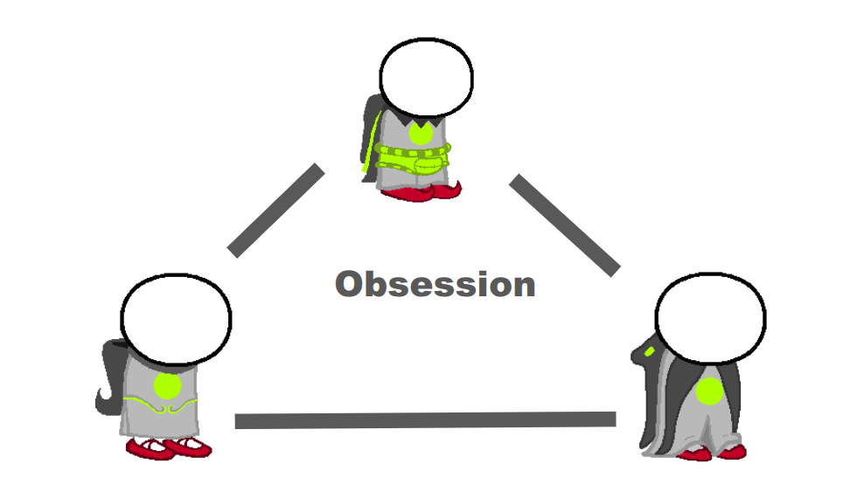
Obsession. Those who interact with their aspect as a force, and must be saved from it. Bards, Sylphs, and Seers. Those who are obsessed with their aspect see it as perfect, or at the very least universally applicable. They constantly seek it out, looking to learn and feel as much of it as they can. At their best, they can be knowledgeable, knowing the ins and outs of their aspect like the back of their own hand. At their worst, they can just be fucking insane. Applying their aspect to things where it should never be, causing chaos and allowing an aspect’s negative traits to rear their ugly head.
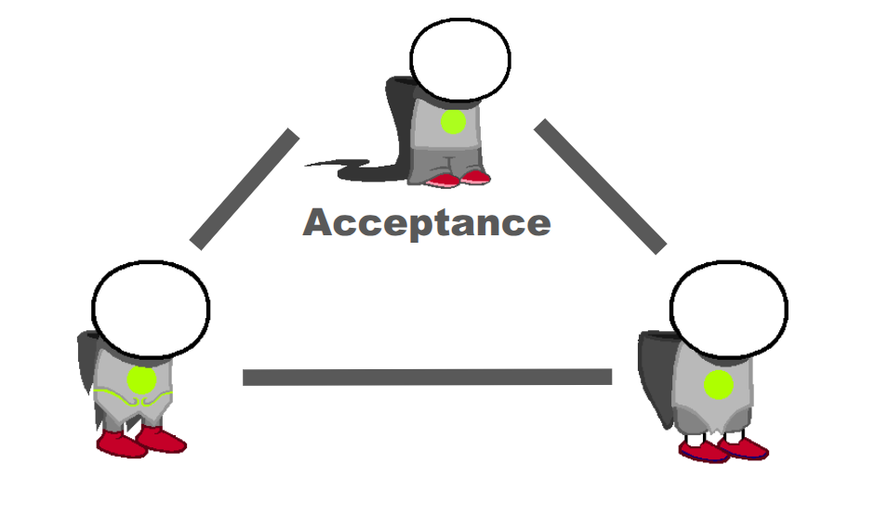
Acceptance. Those who are saved by their aspect, which they interact with as a force. Mages, Maids, and Heirs. These classes may not initially realize it, but their aspect is everywhere in their life. They need to realize that it can be a force for good, and embrace it to become happier and stronger for it. At their best, they are calm, focused, and in tune with the goings on of their aspect. At their worst, they can be uncaring and aloof, so engrossed in their aspect that the action around them becomes, in their mind, irrelevant.

The goal quadrants.
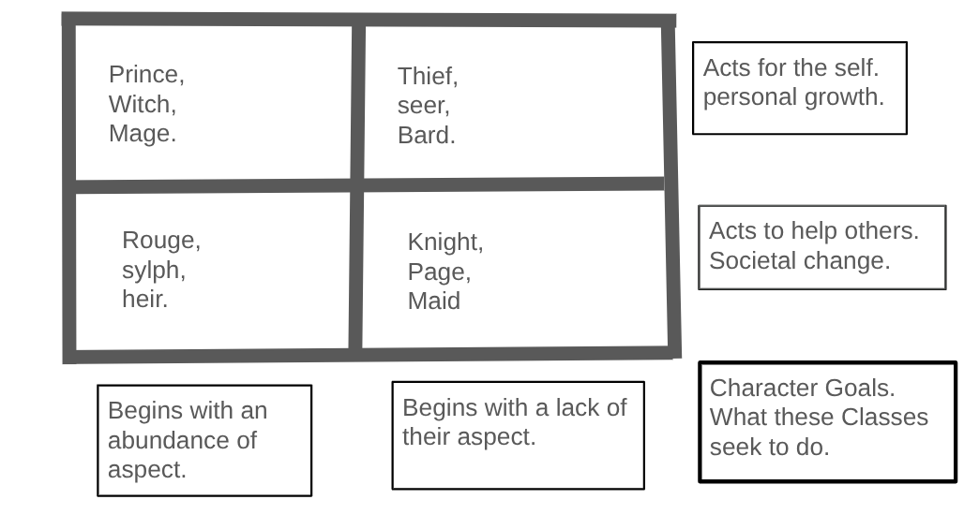
The above is a second graph, similar to the first. Instead of detailing how a character must grow to reach their best self, this instead shows what a character of that class wants to do at the beginning of their journey. It is split between 4 quadrants, like the first. The vertical axis shows whether a class begins with an abundance of their aspect in the beginning [Prince, Witch, Mage, Rouge, Sylph, Heir.] or lacks their aspect in the beginning. [thief, seer, bard, knight, page, maid.] think of how Sollux’s life is filled with doom from the start. He himself is doomed both as a lowblood and because of scrub and lord english. Meanwhile Tavros [again] starts out with very little breath [freedom] both because he is another lowblood, and because of Vriska’s influence.
The horizontal axis differentiates between those who act for themselves, seeking personal growth; [Prince, Witch, Mage. Thief. Seer, Bard] or those who act to help others, seeking societal change. [Rouge, Sylph, Heir, Knight, Page, Maid.] This one is more self-explanatory. It's very similar to the Derse Prospit split or the passive active split you may already be familiar with.

The goal trios.
Below is a second set of 4 trios, each one assigned to one of the aforementioned quadrants. Each one is its own goal/motivation for why the character acts.
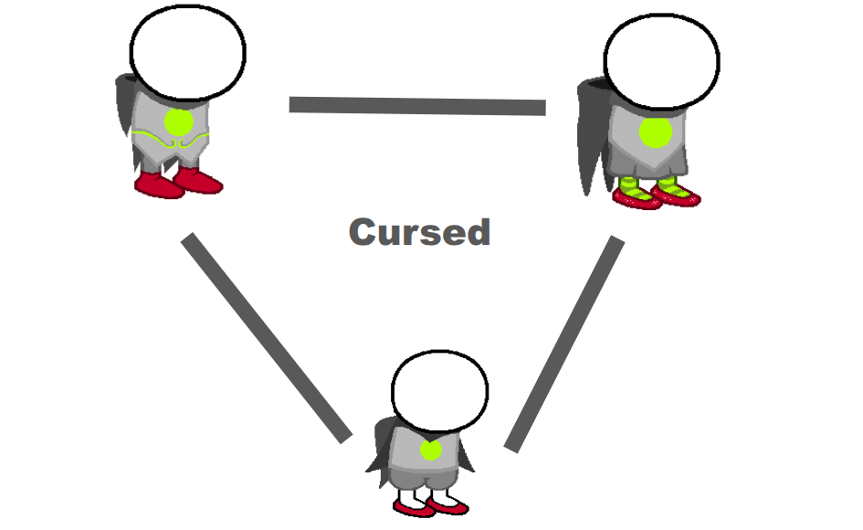
Cursed. Begins with an abundance of their aspect, acting for the self for the sake of personal growth. Witches, madges, and Princes. They see their aspect as the cause for the pain and misery in their life, seeking to change it or rid themselves of it so they can grow as a person. They are glass half empty people, often having low self esteem and or victimizing themselves. However they can also be understanding, and in touch with the negative affect of their aspect in ways others may not be.
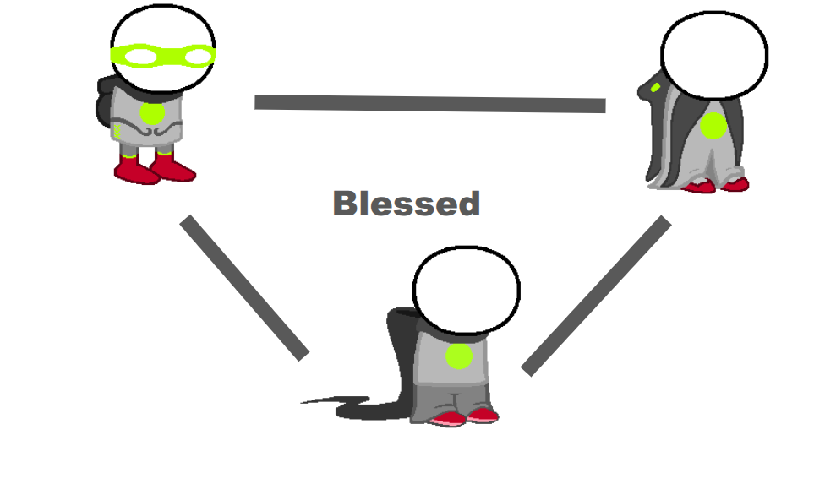
Blessed. Begins with an abundance of their aspect, acting to help others and seek societal change. Rouges, Sylphs, and Heirs. Classes who are blessed with their aspect have had a largely positive experience with their aspect, and seek to share that experience with others. They can be very kind and trusting individuals. However they can also be very naive about the negative side of their aspect, and try to force it on people who don’t want it or aren’t ready for it. They are glass half full people, who always try to look on the bright side of situations.
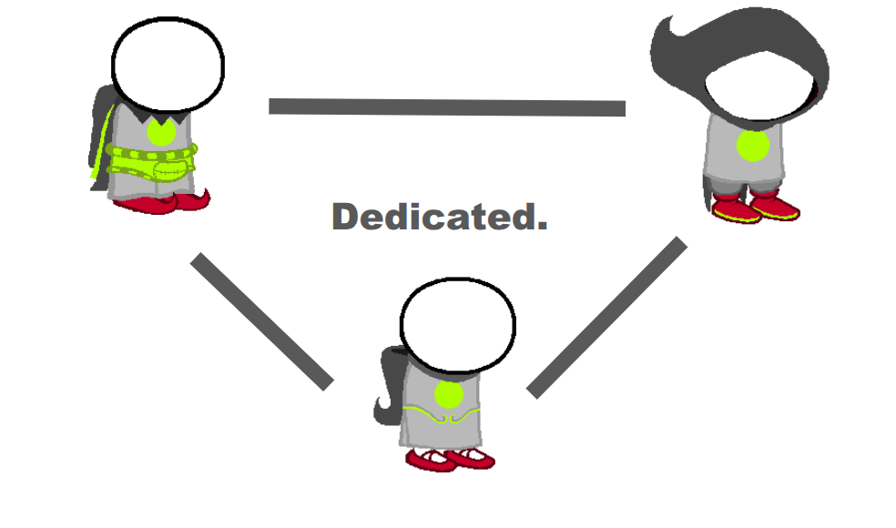
Dedicated. Begins with a lack of their aspect, acting for the self and personal growth. Thieves, Bards, and Seers. Dedicated classes believe that their aspect is present less in their life then they desire, and seek to remedy this by seeking it out whenever they can. By the end of their journeys, they are often the most in tune with their aspect, however the road to get there can often cause them to ignore their own personal needs and consideration for its effect on others. Like me at different points writing this instead of studying, eating, or sleeping.

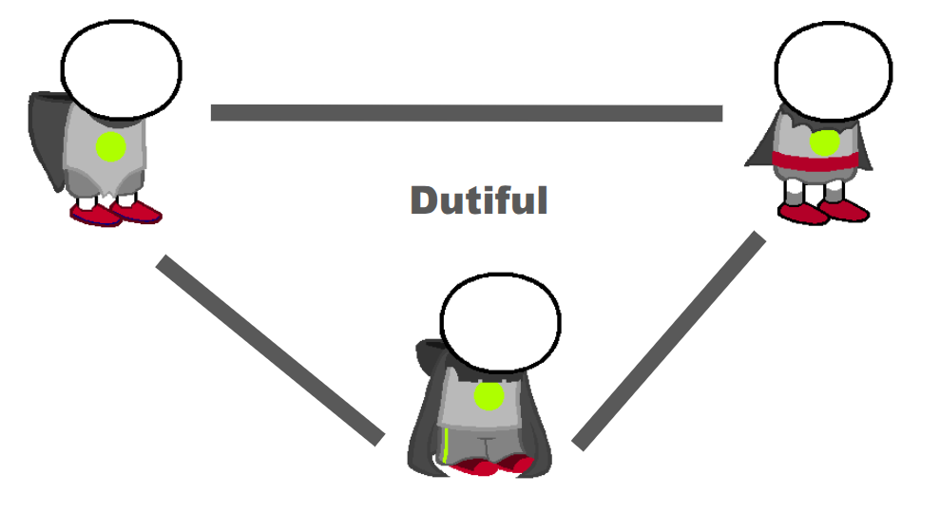
Dutiful. Those who begin with a lack of their aspect and act for others and to reach societal change. Pages, Maids, and Knights. Believes their aspect is not present enough or is not present correctly in the world/society. Seeks to remedy this, whether they enjoy the process or not. Somebody has to do it, right? They can be extremely useful allies to have, swooping in to save the day when somebody is in trouble. However they often disregard their own feelings, needs, and wants to the point where it becomes counter productive. They do this out of a belief that they are the only one who is capable of fixing the problems in the world, or at least the only one willing to.

The class chart.
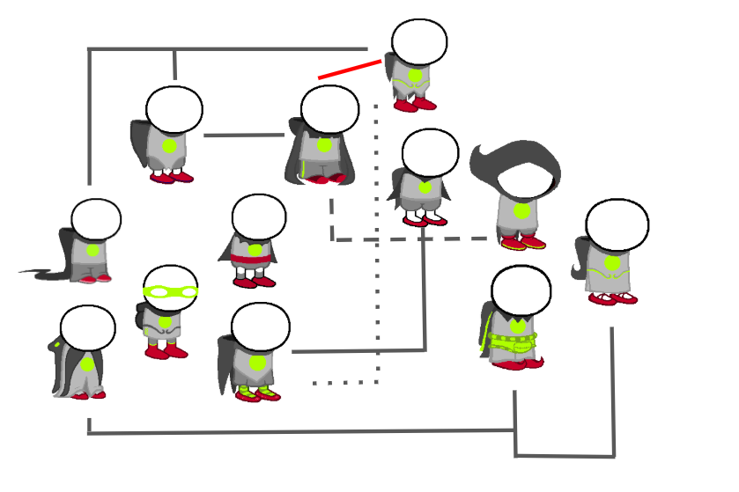
This is the class chart. Every 2 classes that are either adjacent and not connected by a red line; or not adjacent but connected by a grey line share a triangle/quadrant with each other. Pretty simple. This serves as a single visual aid for remembering how the classes interact in this theory. If 2 classes share no connections on the class grid, such as the page and the thief, they are often in opposition to each other, often forming antagonistic relationships. This does not mean they can't be friends, [just look at Karkat and Sollux or Kanaya] but if they do they will likely branch out and do their own things separate from each other. Those close to each other in the chart will often be natural allies, as their goals, ideals and experiences tend to line up. Note that the passive active pairs you may be familiar with are half the time not connected on the chart. This is because my theory is more focussed on why a class acts and what their character arc looks like then what actions they typically execute in any given moment. This theory is not necessarily intended to replace such methods of analysis, rather to stand beside it to form a more three-dimensional understanding of class archetypes.

Addressing flaws and the theoretical classes.
An observant reader may have noticed that there are two major flaws with my analysis.
- The bard and the seer are both obsessed and dedicated.
- There are 5 different combinations of arcs and goals that are not present.
- The master classes are missing.
This leaves 1 of two possibilities. Either my whole theory is horseshit [I hope not] or there are classes that should exist but do not. For this section of the analysis, I will be assuming the latter is true and throwing out some ideas on what these "theoretical classes” could be. Note that everything from here on out is just speculation and not based on anything at all.

- Ambitious, blessed. This one is weird because the blessed are typically caring, whereas the ambitious are typically focused on honing their aspect within themselves. I imagine this could be some kind of class that seeks to multiply what they already have for the perceived goal of benefiting the common goal.
- Obsession, cursed. This one is also strange because they would be obsessed with something which they also believe to be a negative influence on their life. Perhaps they would be so focused on ridding themselves of the curse that they go crazy, or have a love-hate relationship with the curse where they recognise it is a bad influence but are also fascinated by it.
- Obsession, dutiful. This one makes more sense. Obsessed with their aspect to the point where they believe it is an end all cure to every problem in the world.
- Potential, dedicated. Are always dedicated to helping the world, but initially fail. They later discover that they can help in a different way with their aspect.
- Acceptance, dedicated. They may ignore their aspect as a good possibility for the world and work towards a different path, only to realize it is good and work towards that instead.
This is cool and all, but not all of them are entirely accurate to my previous methodology or that unique compared to other classes. I considered not including this in the final draft, but I feel like this is important because it shows that the 12 class system is not perfect, more classes could be added if a need for them existed.

The dilemma of bards and seers: As previously stated, bards and seers both have the same combination; Obsessed and dedicated. The main difference between bards metaphorically and seers is that bards break things open to see what they're made up of, whereas seers look for their aspect and learn of it that way, being closer to archetypal scholars. This is one way my system is not perfect at differentiating between the classes. I still think the triangles are a helpful way to understand the classes that can work alongside a more traditional way of categorization.

What about the master classes? My opinion on the master classes is that they use the passive active scale. This may seem odd because the rest of my analysis gets rid of it. My interpretation of the master classes is that they are so active or so passive that they become objectified. Lords function like forces of nature and muses like MacGuffins. They functionally are no longer characters, rather they have become plot devices due to their extreme activity or passivity.

Essay cleared!
Thank you for reading. Have a good one. :]

Word count: 2096

Character count excluding spaces: 9964

