DESKILL ISSUE 8

www.callus.neocities.org

there is a postcard of a white, red, and brown rothko over my bed like an orthodox icon
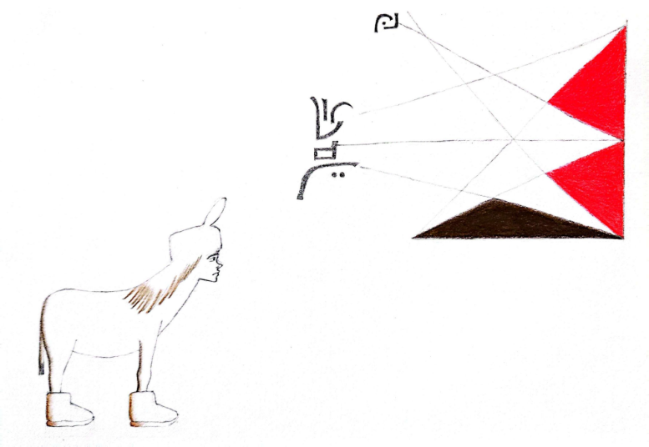

melopepon (1.5)
Today the Mule cleans. Normally, she is a brown furred donkey to her neck and a brown-haired human to her cranial crown. Today, she wears a human skin suit, a complete integumentary system that compliments her human head. It provides bipedal mobility and a height of five feet and one inch. The Mule is not troubled to walk, passing the computer to the left like normal, though her other movements are less intuitive. When she scrubs the salt dragged inside from the donkey’s hooves, one leg squats and the other sits on its knee. Her elbows rest on the floor and her chin floats close to the ground. When she dusts the kitchen wall-tiles, she lays on her back over the counter, confined under the cabinets. One moment a leg dangles from the edge, the next moment she straightens like an Egyptian corpse prepared for death. And when the Mule wipes at the bathroom sink, she kneels on a pillow, aligning the counter to eye-level.
When she’s done she sheds her human suit and circles the computer room to the left direction, re-adjusting to her quadrupedal nature. Something changes: the wall’s new growth buds of excess material disappear prematurely. Melopepon walks another circle: her fruit bowl appears refilled. After another circle, her head feels lighter: her fur hat now hangs in her closet. Another circle: her human suit lays folded over her drawer.
The Mule stops to look at the computer wallpaper. It displays a Paula Rego oil pastel of a woman hanging from the corner of a bed. One foot pulls at the bed sheets, and her other three limbs crawl on the floor. Her head looks back at the mattress between her things. A white shape appears in the corner of the monitor: a little white flower. When she looks away, the flower remains in the corner of her sight. An excitement is generated in the donkey woman. She blinks hard and fast, and the lily remains. She shakes erratically and the little white lily remains. But a force in her body suddenly grips her violently: the pink Lipid pushes Melopepon into a panic, and she rears into a counterclockwise run to the right of the computer. And as quickly as the lily fades away, Melopepon slows down to a trot. The end.
contact
You and I can meet if we follow the correct points in the chain. Use the address desk1ll@proton.me to e-mail me.

