DESKILL ISSUE 4

www.callus.neocities.org

melopepon (1.1)
Melopepon is a donkey-woman. She lives on top a mountain in Tar province, PML. It is a lone peak in a flat landscape of snow-white salts and sands: the clouds in the white sky do not cast a shadow. One lipid in the Mule names the landscape the White Court. The Mule and the Lipid live in a rock-hewn lime-stone: a kitchen and lounge to the entrance and a bath and bedroom in the back. The room in-between contains a supercomputer that feeds on a pit of dried apricot.
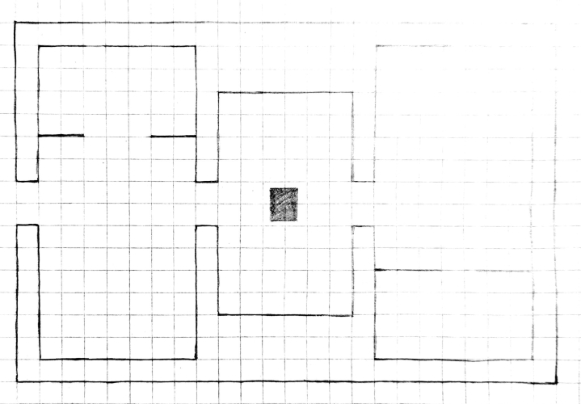
Today the Mule prunes the stone’s excesses. Curled sheets of industrial material grow from the pores of floorboards, baseboards, and drywall. They can form into unpredictable mechanisms: once a kitchen cabinet exploded after a naturally-occurring car engine and bike pump collided. Today the Mule is armed with a sticker scraper. She crosses the computer to the left side (it stands in the center), and then scrapes tin, aluminum, microfibers and mesh fabrics from the door-frame.
The Mule dispenses of the materials in a tall trench to one side of the mountain. When she nears the cliff, she kicks white salts and sands down a long fall. When she drops the first material, it glows in the dark and illuminates the ancient earth-strata. The next material is a loop of paper twisted into a non-orientable strip. It drifts down silently. The third material is a glass shard that scrapes an edge on its fall and croaks like a wooden-frog guiro. The fourth material is a strip of Velcro that returns the sound of a splash from the bottom. Melopepon offers to every material her undivided observation, naming all their qualities until the limits of her senses are passed.
Later the Mule looks at her computer wallpaper. Right now it is an El Greco of a man with too long of a head. His eyes and ears pop out in different directions, like something invisible pinches at his elongated temples. Then the Mule passes the computer to the left.

notes
The following are principles of our practical sphere:
1. Download .docx from callus.neocities.org/archive/p-i-s/deskill
2. Print (landscape, double-sided, 2 pages per sheet)
3. Fold horizontally
Contact desk1ll@proton.me with questions.

