DESKILL ISSUE 2

www.callus.neocities.org

penguin tatlin
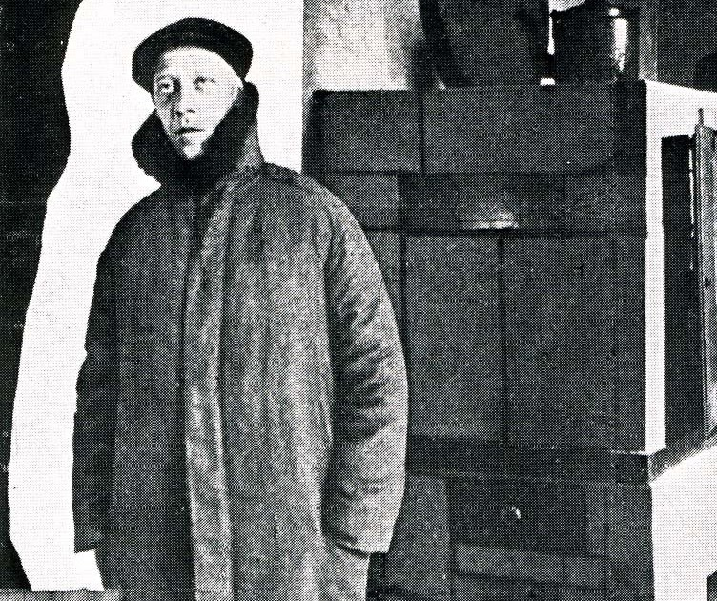
A state predicated on glue export. Adhesives and pastes are sapped from rich rubber-tree forests. But a dry climate marginalizes the glue-foliage to the borders of expansive salt flats. Alternatively, wild cows that roam the desert produce natural resins in their muscle, though, international law has rendered their harvesting as illicit poaching. Anaerobic Control Zones: the state spent nine billion after their gum-quarries were accused of environmental compromise. These kilometer-long warehouses manipulate atmospheric chemistry to promote surface glue growth. Realistically, they hide resin-cow slaughterhouses that farm for the near-entirety of the glue trade. Abroad, Vladimir Tatlin waddles to the department store, bound up in a tight coat. His constructions demand for exotic glues, and his Corner Counter-Relief is made of catgut string. The Corner Counter-Relief is a Modernist drug mule in Moscow; animal flesh posed as industrial material. At the 0, 10 Exhibition, Tatlin was quoted with the following: “all the modern things have always existed, they’ve just been waiting in a mountain for the right moment.” He died in 1953.

place de la concorde 1938-43
Deskill and the urban grid: notice I named it after De Stijl. The cubist grid purified like Kandinsky’s blue triangle, the space of a Kirchner street scene reduced to its plastic properties. Notice the issue is two columns long: it’s a micro-zine. Like the micro-videos and micro-posts that emanate from thousands of micro-lights, deskill provides [points in a series] for little commitment and little attention. Contact desk1ll@proton.me to contribute to the collective.

