DESKILL ISSUE 1

www.callus.neocities.org

highway and byways 1929
Slow, grinding, tectonic movement of North African ground. Somewhere in the strata are Paul Klee’s Lovers. Amber in sequence of Walter Benjamin’s film reels, a blue and orange Matisse segmented in-to sequences. The mechanical reproduction of Geology or the law of superposition is a single picture prescribed by the preceding ones.
the rose 1964
The Impressionists were too immediately sensuous. It’s easy and undialectical. I drink coconut water now because the diluted milk is refreshing, it softens my soft, baby skin. I saw The Rose at an exhibition and it is stored in my mind in the same place where I recall Hegel’s Phenomenology.
topology
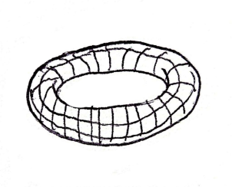
A grid interconnected by points like these: converging plates of crust, red layers of soil, the aestheticization of politics, negation dreams (Gauguin), commodity Buddha, a little orange book… They make a torus. Lacan said:
“If I wanted to give an intuitive representation of it, it seems that I would have to resort not to the two dimensionality of a zone, but rather to the three-dimensional form of a torus, insofar as a torus’ peripheral exteriority and central exteriority constitutes but one single region.
This schema represents the endless circularity of the dialectical process that occurs when the subject achieves solitude, whether in the vital ambiguity of immediate desire or in the full assumption of his being-toward-death.”
The ideal momentum of the mind occurs between the petrified interior and the indeterminate exterior; a circulation of the torus without slipping away. The difference of the interior and the exterior is not a boundary but of distance. Therefore, you and I can meet if we follow the correct points in the chain. The praxis involves a type of text-making that I call “deskilling.” Contact desk1ll@proton.me with your work for the next issue.

