Introduction
On December 15th, 2023 (or 12/15/23 for me), 0Sansey_themouse3 asked this very question: “How you get the sprites?” I was at first gonna comment Sansey my process, but now it’s an entire file lol

Image Hunting (FKA The Comment)
At first, I took pictures from Fandom Wiki pages for the selected characters and used FireAlpaca to make each image transparent. Then, I used a YouTube-adjacent site (Invidious) to rip screenshots off of shorts instead. There are many links to many versions of Invidious but my favorite is https://inv.tux.pizza/channel/UCC0aCrsMnk074Tg5JhDj8Qg/shorts, and yes it's because of the link itself (inv.tux.pizza). The process for that is that I choose a short from the first page. Why the first page? No other page worked for me. Anyways, the trick is that when going to a short/video page, (for example, https://inv.tux.pizza/watch?v=yIU60G-Hgs8) the short/video can be opened in a new tab. (This is when I had the idea to make it a file!) But remember to make the quality as high as possible! There is a button for the file (new tab or not) that says “Copy video frame.” This is very helpful for me because, for the most part, I don’t even have to download the frame to have it! Then, after I choose a frame, comes the FireAlpaca process. FireAlpaca (as you probably guessed by now) is an image editor that I use for various things, and making sprites for Comic Studios is one of them. Except Vib-Borger, I used Scratch/TurboWarp for that. You can get FireAlpaca here: https://firealpaca.com/download/ I should probably educate you on the FireAlpaca step, now. Let’s start with this frame from the example mentioned earlier
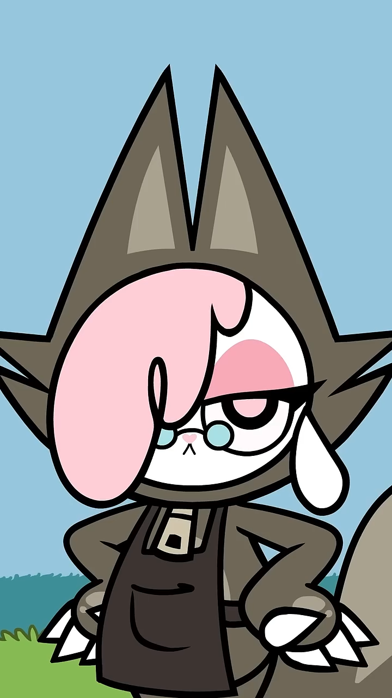
Cofi’s “Tailor Dress” (Fandom’s words)

The FireAlpaca Process
Characters like Cheezborger can be a bit of a hassle (depending on how high you crank the Bucket’s “Tolerance”). Why Cheezborger? Her tail. I usually crank it high (123, to be exact) to not get too much background leftovers around the character’s outlines and such, but for Chee’s tail, I make it lower to not suck up the colors. Not so bad when it’s a solid or gradient color, but harder with stuff like detailed backgrounds. Anti-aliasing is also used to get cleaner looks and is usually on by default. The top part of Cofi is Cake Walk. Just apply around the top half and BOOM! Done! But it’s the bottom half that could be a little more work. A little bit of grass outline is now left. Now what? Erasing! One should use a variety of sizes (For me, usually 30, 60, 2000, and 3.3 or 8.5 as needed) for various uses. Here, for me anyway, 30 or 60 should do the job. Now comes the cropping. For the layer you used, in Select, you should “Create Selection from Layer / Opacity”. Especially useful to see if there are any messy spots left. Then, in Edit, the next step is Crop. If there’s more than one thing, you should probably duplicate it enough times for each character and/or prop, and Crop more than once. Then there will be a pop-up that’ll say “Delete Cropped Area?” You can always Undo/Redo as needed, especially here when there’s more than one thing you want. Click “Yes” to crop, No and Cancel mean the same thing. Finally, the receiving portion. In File, click on “Export…” This is a little tricky, as there are more than one option, choose “PNG (Transparent PNG), then click OK. Then choose your spot where the image will be, as well as its name. If you open one of the Sprites in Chikn Nuggit + Comic Studio, you’ll see names like “Slushi_Confession” or “Fwench_Fwy_Sit”, the actual names are–well–those names without the underscores. However, names like “Chee_Sit_n_Look” are actually “Chee Sit ‘n’ Look” You can choose any name you like, but, for me at least, it’ll be “Cofi Tailor.” After the location and name is chosen, click save. Probably check if it’s actually transparent or not, because you’ll never know whether or not you forgot to set it to (Transparent PNG) or not.
It should now look like this:
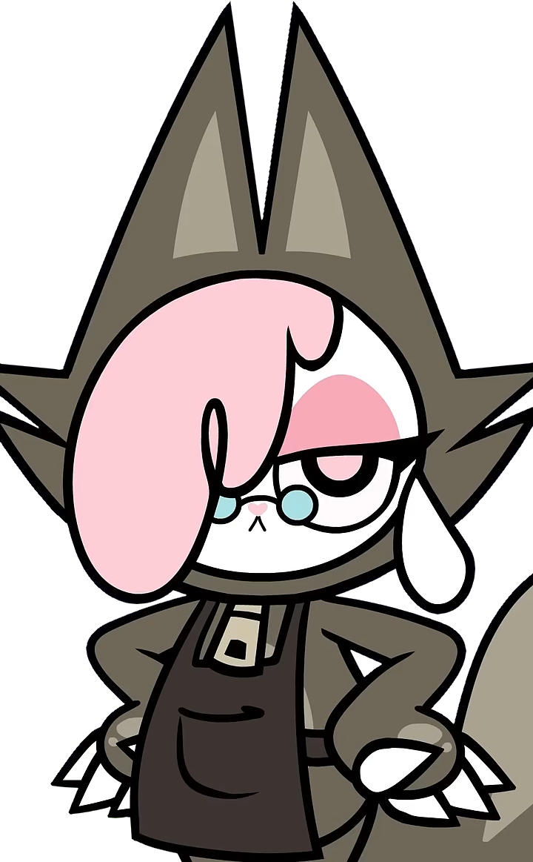
This is not the actual size, in fact,
the example image wasn’t the actual size, either..

The Last Touches at Comic Studio
Now you want to add the image to your Comic Studio. Well, you probably know that portion, but I’ll tell you the steps, anyway. But don’t close the tab, yet! You might not know about size scaling. In Comic Studio, go to manage, you probably made a Chikn Nuggit Comic Studio already, but in case you didn’t, you can press “Create Studio” to get started.
But if you did already, click manage on the Studio you want “Cofi Tailor” in. This part should be easy for the people familiar with the Comic Studio features, but, since this was made for Sansey, I’ll try to simplify things.

Highlight your mouse over the buttons, (e.g. Whipped Coffee Cookie Head) so you know what the buttons are for. Settings has features like Themes, Creator Style, (Should be 2d in this case) Character Base Height, among other things. There are Tabs to separate things. Most of these things are simple enough to figure out on your own, and beyond. So let’s just skip to what I do next.

The Size Scale (highlight)
After going to the appropriate folder in Characters, (or Props or Effects if you wanna be wild) uploading the image and such, and maybe even giving it a name/note, you might wanna adjust the size. In Options, there’s a slider. This Slider determines the size of the character. I would make Cofi smaller than the full-body outfit Cofis. The full-body Cofis are 200, so I set it to 175. Finally, hit save. Now Cofi in her Tailor Dress is there.

Final Note
I just realized I went back and forth between “I do this” and a Tutorial lol

Chikn Nuggit © Kyra Kupetsky/Buzzfeed.

